**Development Methodologies**

* When it comes to Building Software Applications, be it web, mobile or desktop apps, project managers have to consider a number of best practices or methodologies for the SDLC (Software Development Life Cycle).

* Two common ones stand out
* WATERFALL
* AGILE

* New & Emerging
* DEVOPS

**Waterfall**

* The Waterfall methodology takes a step down approach, considering the entire development of the whole application on a stage by stage basis, giving very little room for changes.
* Waterfall model lacks flexibility to accommodate customer changes leaving no room for creativity neither innovation.

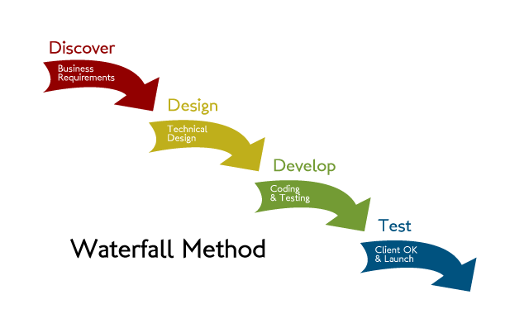

**Agile Model**

* The Agile methodology however focuses on a more collaborative development process. It prefers to build in **bits** and **bolts**,  delivering on an **incremental basis** giving room for  feedback, responding to changes rather than being restricted in order to build a software customers actually want to use.

* The agile process is extremely beneficial for innovative products.

* It is better to get everyone involved and then build small bits of it in iterations, reviewing, updating and repeating the process until a working software is delivered

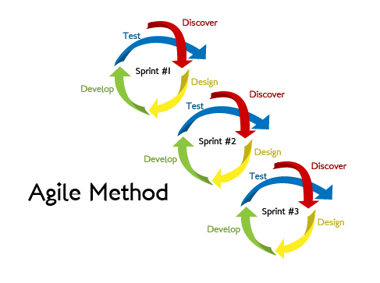

* As we saw Agile was good and making development team work on client feedback and incorporate it along with bug fixes in the next release.

* While this Agile approach brought agility to development, it was lost on **Operations** which did not come up to speed with Agile practices.

* Lack of collaboration between Developers and Operations Engineers still slowed down the development process and releases.

**Development VS Operations**

* Development is going on time, now why operations can't keep up with development ??

* This is how a typical problem arises, imagine that it's friday evening 6 PM you thought of leaving office and suddenly your IT team has got an email from Development Manager, saying here is the attached tar file or link to the file, please deploy this.

* The IT person who saw the email, tried contacting the Dev Manager Coz he have lot of questions, but Dev Manager went off.

**IT Team Questions**

* In which System we need to install this ?
* What OS do we need to use ?
* What are the dependencies for this application ?
* What database we need to use ?
* What kind of security needs to be implemented ? (like SSL ?)
* Access requirements ? (Who all need access to it ?)

**Development vs Operations**

* Again when the Dev Manager comes to office on monday, all we have is a **MUD FIGHT**.

* Dev team says you people never do what needs to be done and the IT team says you guys never give the correct requirements.

* They just blame each other and **Blame Game** continues.

**Development Team Roles**

**Development Team**

* People who involve in Development are Developers Team, Build Team and Testing Team all these together we call them Development Team
* What work they do
  + **Developers Team** - Write Code (Java, Python, Node Js etc )
  + **Build** **Team**- Building App (Maven, Ant, Gradle etc)
  + **Testing Team** - Tests the App (Selenium, Testing-viz, QTP etc)

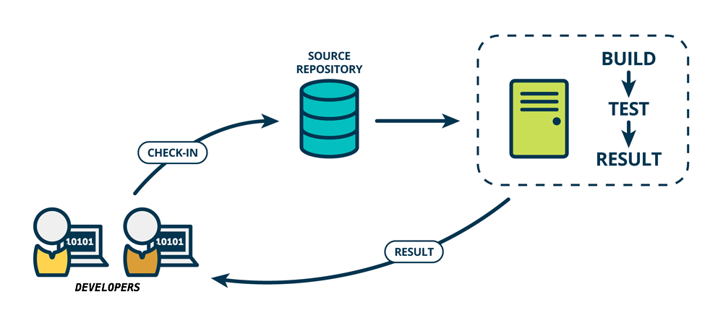

**Operations Team Roles**

* People who involve in Operations are Systems Team, Network Team, VM Teams, Storage Team and Security Team.
* So generally all together complete Ops team consists of around 5-8% of Development Team, say if you have 100 developers then you might have 5-8 Ops people
* What work they do
  + Systems Team - Desktops and Servers provisioning
  + VM Team - Virtual Servers provisioning
  + Network Team - Network provisioning
  + Security Team - Firewall Setup and App Security
* Provisioning and Maintaining the Servers is Easy if we have few Servers

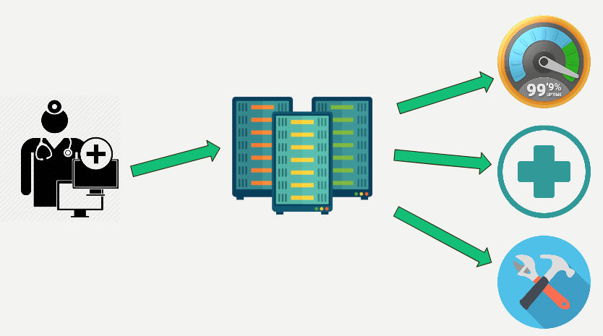

* Provisioning and Maintaining the Servers is little hard due to more no of Servers

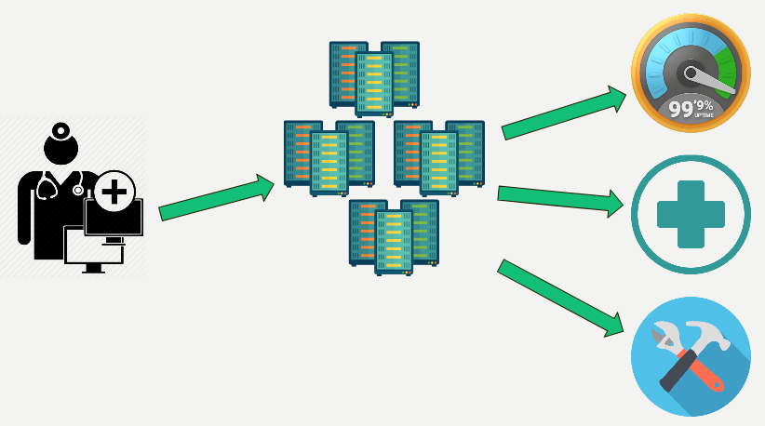

* Provisioning and Maintaining these many Servers is Very Complex that to with regularly changing requirements.

**Development - Operations - Success Metrics**

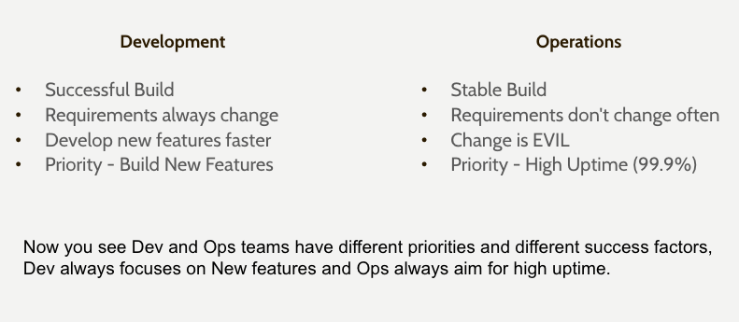

**Solution**

* You see both Development and IT team are working in silos, solutions is they need to break silos and start working together.

* Yes this is the reason why **DEVOPS** came into play.

* **DevOps** methodology was born out of this need for better collaboration and faster delivery.

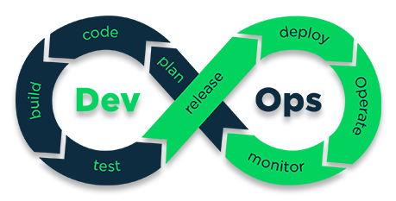

**DevOps**

* **DevOps** methodology was born out of this need for better collaboration and faster delivery.

* DevOps enables Continuous Software Delivery with less complex problems to fix and faster resolution of problems.

* While this Agile approach brought agility to development, it was lost on Operations which did not come up to speed with Agile practices, that's where **DevOps** concentrates on.

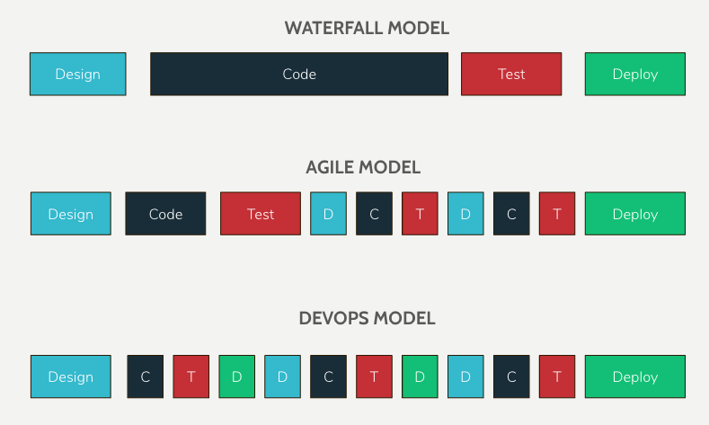

* [WIKIPEDIA](https://en.wikipedia.org/wiki/DevOps) - DevOps is a software engineering culture and practice that aims at unifying software development and software operation.

* [AWS](https://aws.amazon.com/devops/what-is-devops/) - DevOps is the combination of cultural philosophies, practices, and tools that increases an organization's ability to deliver applications and services at high velocity.

* [ATLASSIAN](https://www.atlassian.com/devops) - DevOps is a partnership between software development and IT operations that emphasizes communication, collaboration, and integration.

* General - DevOps is a set of practices that automate processes between software development teams and infra(Ops) team so they can compile, test and publish software more quickly and reliably.

<https://aws.amazon.com/devops/what-is-devops/>

<https://en.wikipedia.org/wiki/DevOps>

<https://www.quora.com/How-are-DevOps-and-Agile-different>

<https://thenewstack.io/shell-gives-new-meaning-devops-agile-scale/>

<https://devops.com/delivery-pipeline-devops-signature/>

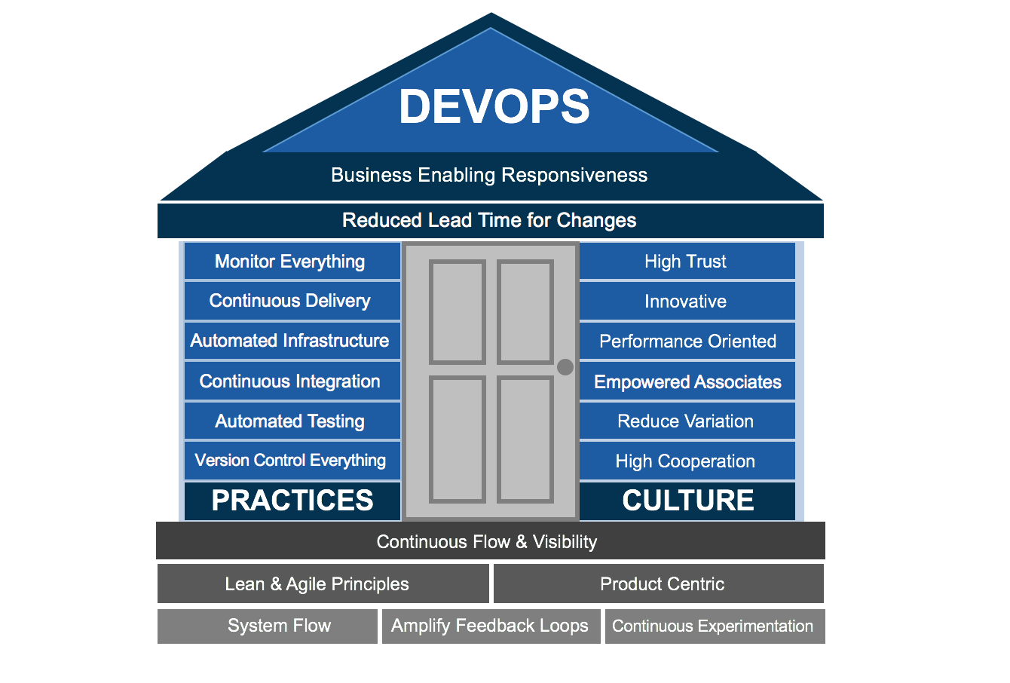

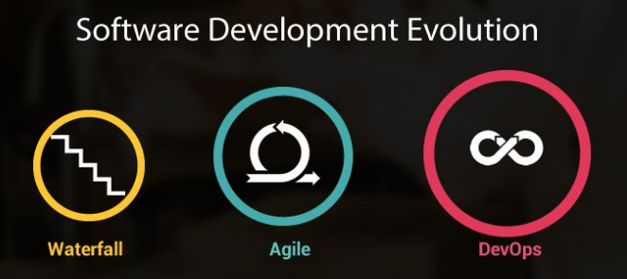

Virtualization

**Virtualization**

Virtualization is the creation of a virtual,  rather than actual version of something, such as an operating system, a server, a storage device or network resources.

You probably know a little about Virtualization if you have ever divided your hard drive into different partitions. A partition is the logical division of a hard disk drive to create, in effect, two separate hard drives.

When people talk about Virtualization, they’re usually referring to **Server Virtualization**, which means partitioning one physical server into several virtual servers, or machines.

**Pre-Virtualization World** - **Why do we need Server Virtualization ??**

In a world before virtualization, servers would traditionally run **one** **application** on      **one** **server** with **one** **operating system**. In the old system, the number of servers would continue to mount since every new application required its own server and operating system.

As a result, expensive hardware resources were being purchased, but not used. Each server would only use about **12%** of its resources. **Almost 88% of server resources were completely unutilized**.

Virtualization is possible because of a software layer called a **HYPERVISOR**.

Virtualization allows multiple operating systems to run concurrently on a single host computer.

**Hypervisor**

What is a hypervisor and how does it differ from bare metal?

A **Hypervisor/Virtual Machine Monitor** (**VMM**) is an low-level program/software that can create and run Virtual Machines (VM's) within a bare-metal server.

Let’s have a look at the representation below to better understand the difference between the two.

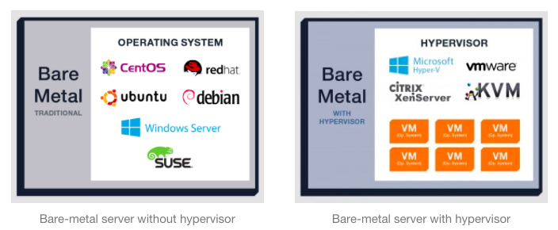

The first image above represents a traditional bare-metal server. The operating system (CentOS, Debian, Ubuntu, Windows Server, etc.) is installed directly on the server, and applications are running natively in the operating system, **A single OS owns all hardware resources**.

The first step of the virtualization process is installing the hypervisor onto a server.

In the second image above, a bare-metal server installed with a hypervisor provides the user with a management suite to create virtual machines on the server.

After the hypervisor is up and running, multiple “software containers” known as virtual machines (VMs) are built on top of the hypervisor. All of the VMs are isolated from each other.

Once the VMs have been built on top of the hypervisor:

* Applications and operating systems can be added to each VM.
* Every app and operating system placed on the server lives in a separate VM, which means if an app or operating system goes down on one VM, none of the other apps or operating systems on the other VMs are affected.

**So how do the VMs interact with the hardware resources?**

This is where the hypervisor comes in: the hypervisor is able to distribute the underlying resources based on what each VM needs. Resources (like memory, storage, processors, and networking) are pooled together so that every VM can get exactly what it needs for its ideal performance.

You can think of the hypervisor as the traffic cop that controls processor,memory, networking and storage management.

If one VM needs more memory than other apps, the hypervisor can allocate more memory for that VM. If another needs more storage, the hypervisor can allocate more storage. And so on.

Virtualization lets you run more applications on fewer physical servers. Rather than one application running on one server with one operating system, multiple VMs run multiple applications and operating systems on one physical server.

Just in case this is still muddled or confusing, here’s how I would explain virtualization.

Virtualization is like a school bus. Before the school bus was invented, every parent used their own car to drive their kid to school, using extra gas and resources—putting all of the kids into one vehicle wasn’t an option.

One day, the school bus was introduced, exposing the inefficiency of every parent driving their kid to school separately. By using the school bus, parents could use less gas and fewer vehicles, all while transporting more kids.

**Benefits of Virtualization**

* Power Savings
* Cooling Savings
* Hardware Savings
* Network savings, no need of extra network cables
* Space Savings, lower number of physical servers
* Resource Sharing, can create multiple machines on single server, which saves Money by reducing cost.
* Deploy multiple Applications & OS's
* Full utilization of Hardware resources
* Isolation, VM's are isolated from each other as if they are physically separated
* VM's can be migrated between different hosts

With Virtualization solution you can reduce IT costs while increasing the efficiency, utilization and flexibility of their existing computer hardware i.e, simplified management of Data center.

**Two types of Hypervisors**

**Type 1 Type 2**

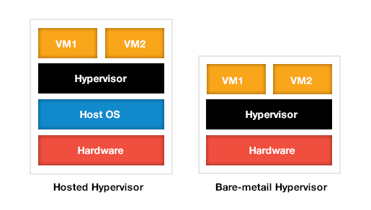

**Type-1, native or Bare-metal hypervisors**

These hypervisors run directly on the host's hardware. Examples: Xenserver, Oracle VM Server, Microsoft Hyper-V, VMware ESX/ESXi etc

**Type-2 or hosted hypervisors**

These hypervisors run on a host operating system (OS) just as other computer programs do. Examples: VMware Workstation, VirtualBox etc

Experts predict that shipping hypervisors on bare metal will impact how organizations purchase servers in the future. Instead of selecting an OS, they will simply have to order a server with an embedded hypervisor and run whatever OS they want.

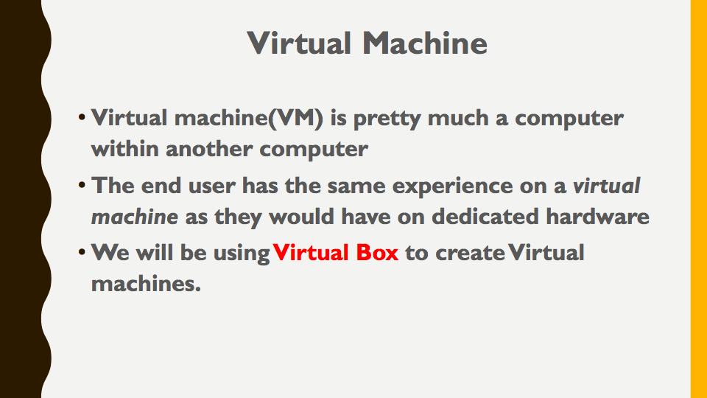

**VirtualBox**

1. Download Virtualbox (Oracle)

   https://www.virtualbox.org/wiki/Downloads

2. Enable Virtualization for windows.

{ Boot Menu -> Security -> Virtualization(Default : Disabled) }

   Enable Virtualization to get the 64Bit OS

**Setting Up OS in VB**

Go to **https://www.centos.org/download/**

Choose the type required: 32bit/64bit and download the ISO (centos_X86_64.....iso)

1. Click on New → Type the OS name →   Required RAM →  Required HDD →  Select Storage under this choose the Disc like centos 7.

Install the virtual box and open it. Click on the new to setup the new VM, select the Linux and then Red Hat, since CentOS is the clone of Red Hat and it uses the similar architecture.

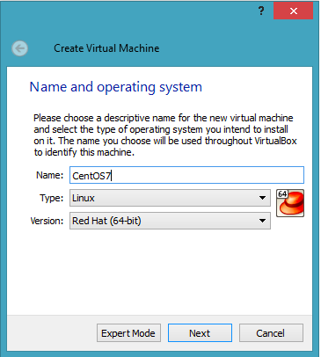

In the next window, allocate the memory size. Allocate at least 1024MB.

Create the virtual disk (VDI) and move to the next screen.

Fixed size of the disk is not recommended in any scenario because you will be downloading many packages to run various applications.

Select the dynamically allocated, make sure that your hard drive has enough free space. The 8-10GB space is sufficient enough to start with, select and then finish the setup.

The ISO image of the downloaded CentOS has to be linked to the newly created virtual machine, click on the setting →  storage →  empty  → browse the ISO image

Enable the network adapter so that it can use the internet to download the required packages.

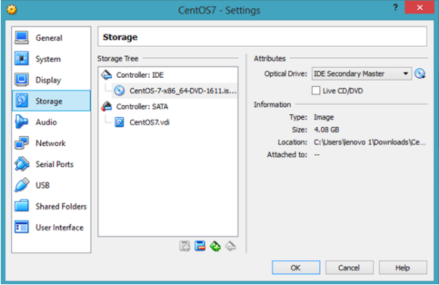

Choose the network based on the interface you want to go with,

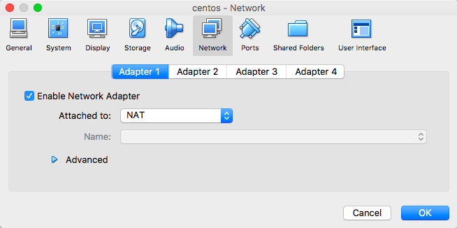

→ Start the Virtual Machine

Select the option “Install CentOS Linux 7” and hit enter. It will take time to load the packages, and you will see the opening screen of the server. It requires the basic information to set up the server, for example:

* Time zone
* Keyboard layout
* Language support
* Installation source
* **Software selection** (Important - Choose **Infrastructure Server**)
* Installation destination (Choose VDI - 8-10 GB)

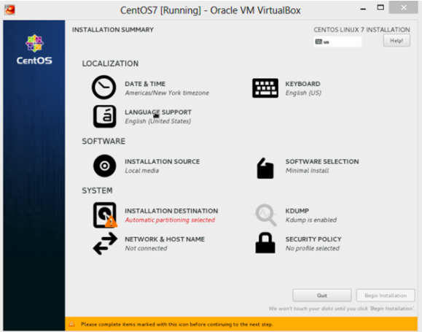

Once you have finished providing the basic information (Language, keyboard, date & time), click on the installation source to confirm the ISO image that we have linked. Verify the installation source, go back and click on the software selection option.

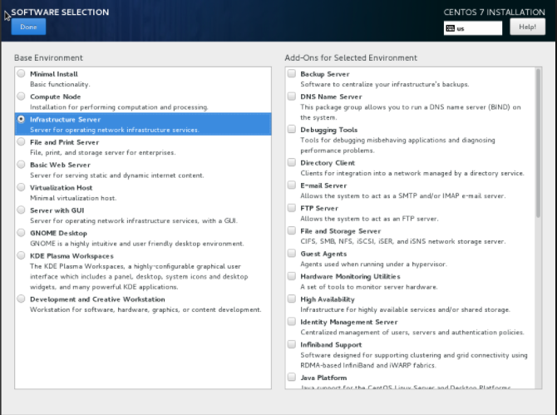

Select the desired option; for example, if you want to create an infrastructure server to run the complete network operation, select this option to get all the required packages installed.

Click on the installation destination, and select the newly created disk space. In the network and hostname setting, enable the network. You are done!

In the next screen, you will be asked to set up the root and username details. Select the strong root password and done.

It will take time, to get everything installed, once done you will get a terminal.

**Login with username: root** and provide the password.

To know the **OS** you are using:

# uname

To know the **OS-Distribution** you are using:

# cat /etc/os-release

**Setting Up USER**

   1. Login as root user

   2. useradd <user_name>   {adds a user}

**#** **useradd sysadmin**

   3. passwd <user_name>   {setup password for user}

**#** **passwd sysadmin**

   4. # usermod -aG <group_name> <user_name>  { grant **admin** privileges}

**#** **usermod -aG wheel sysadmin**

   5. # id <user_name>   {get user info & group info}

**# id sysadmin**

**Installing Gitbash**

Once [Git Bash Windows installer](https://git-scm.com/download/win) is downloaded, run the executable file and follow the steps.

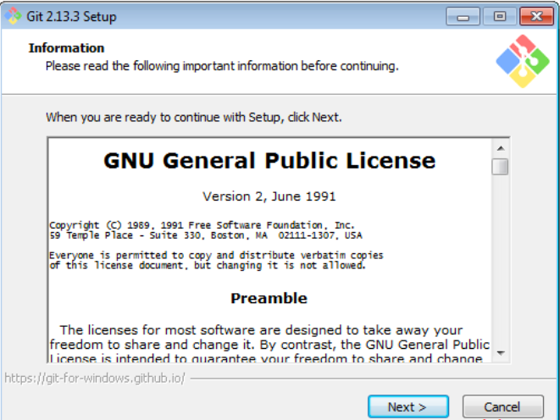

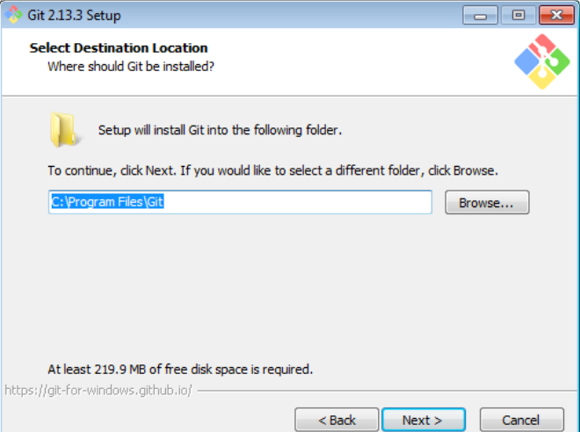

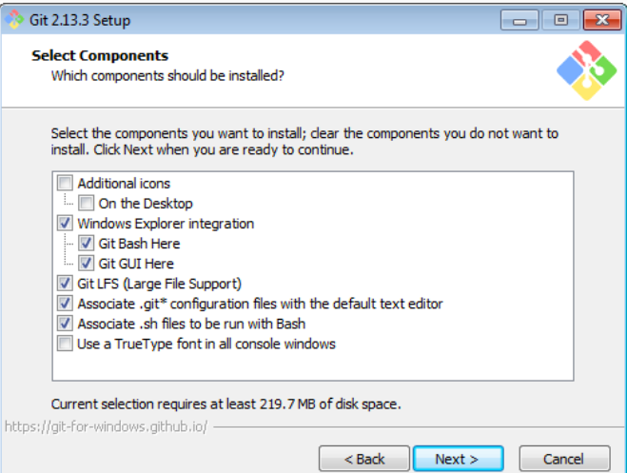

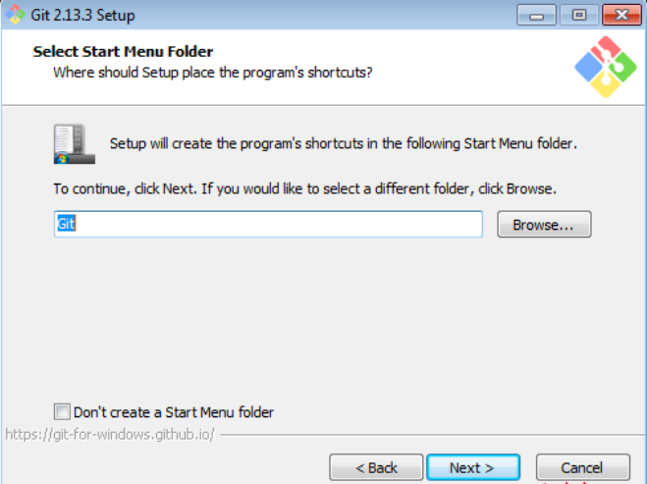

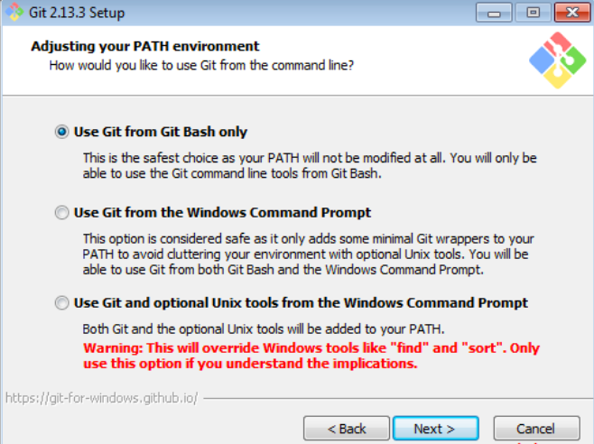

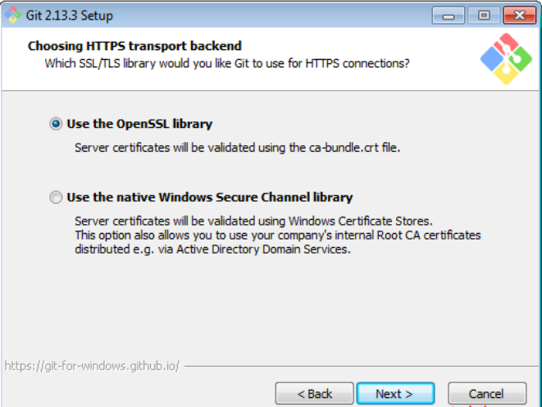

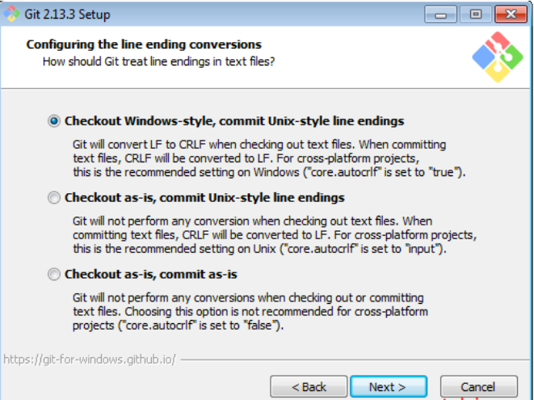

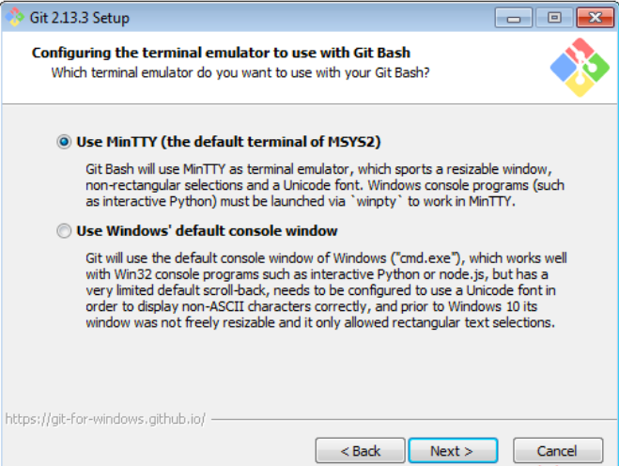

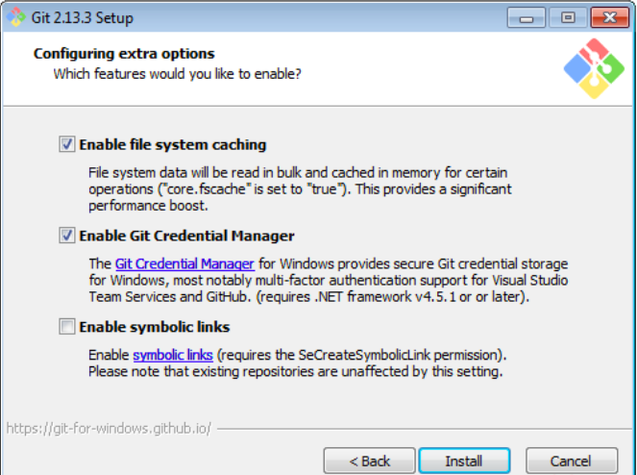

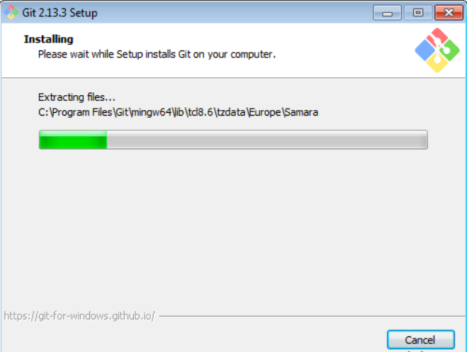

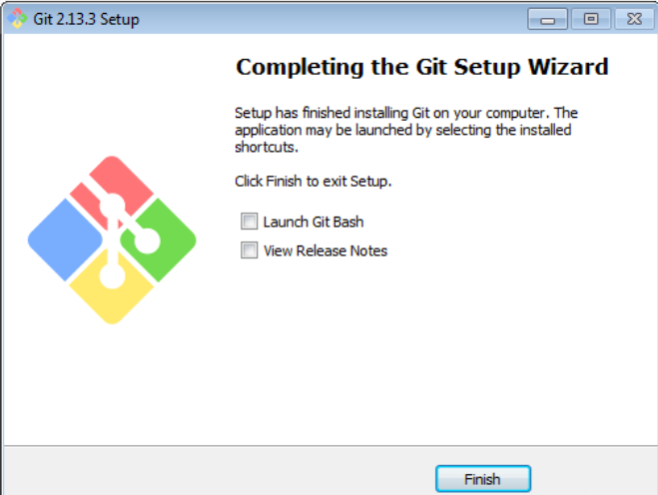

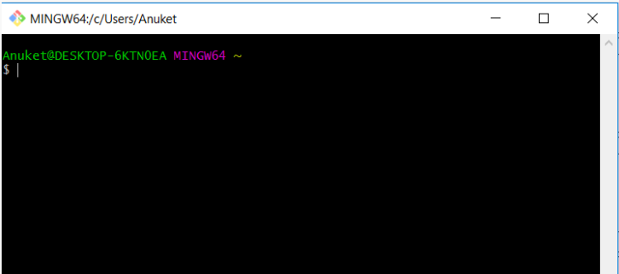

**SSH**

* SSH, or Secure Shell, is a remote administration protocol that allows users to control and modify their remote servers over the Internet.

* The service was created as a secure replacement for the unencrypted Telnet and uses cryptographic techniques to ensure that all communication to and from the remote server happens in an encrypted manner.

* It provides a mechanism for authenticating a remote user, transferring inputs from the client to the host, and relaying the output back to the client.

The Figure Below shows a typical SSH Window. Any Linux or macOS user can SSH into their remote server directly from the terminal window. Windows users can take advantage of SSH clients like **Gitbash** or **Putty**. You can execute shell commands in the same manner as you would if you were physically operating the remote computer.

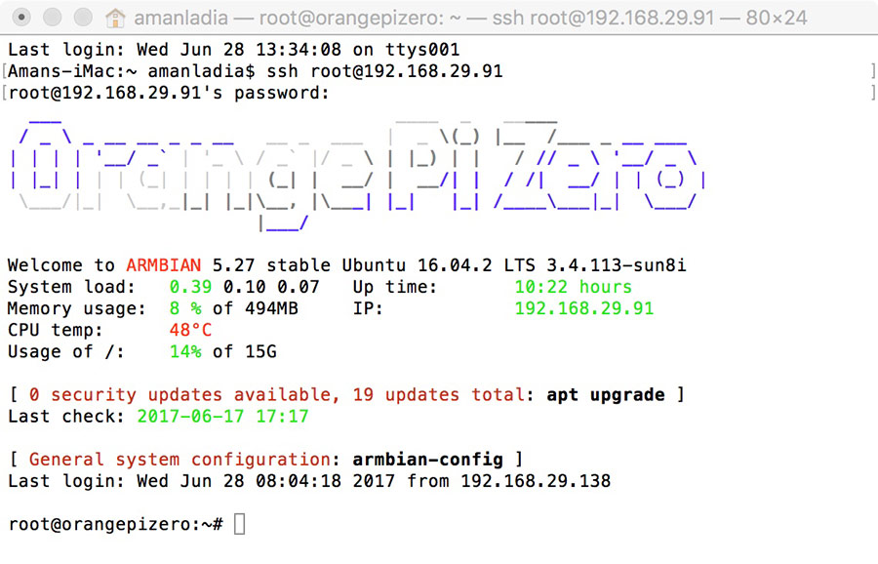

If you’re using Linux or Mac, then using SSH is very simple. If you use Windows, you will need to utilize an SSH client to open SSH connections. The most popular SSH client is **PuTTY** or **Gitbash**.

* **VirtualBox** supports several networking options for guest VMs, one of them being NAT networking. When NAT networking is enabled for a guest VM, VirtualBox automatically performs network address translation between the guest VM and hosts network, so that you do not have to configure anything on the host machine and the guest VM's networking to work.

* The implication of NAT, however, is that the guest VM is not reachable or visible from external networks as well as from the host itself. This is a problem if you want to access the guest VM from the host machine for some reason (e.g., SSH).

* If you want to access a NAT guest from the host on VirtualBox, you can enable port forwarding for VirtualBox NAT

* On VirtualBox, choose the guest VM you want to access, and open "Settings" window of the VM. Click on "Network" menu on the left, click on "Advanced" to show additional network adapter options.

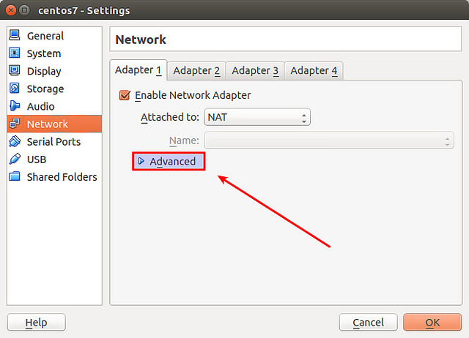

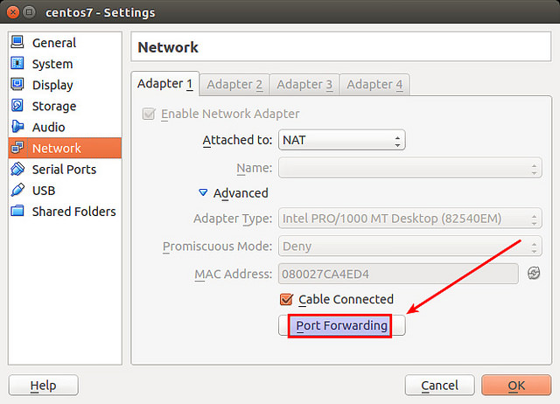

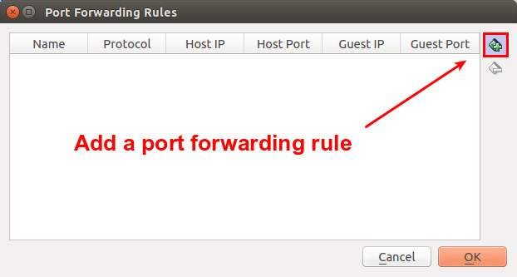

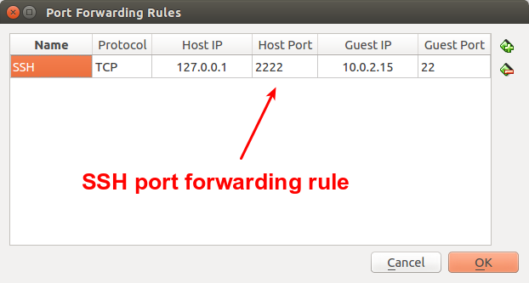

Head over to your **terminal/gitbash** program and then follow the below:

The SSH command consists of 3 distinct parts:

**ssh {user}@{host}**

**→ ssh -p 2222 sysadmin@127.0.0.1 { NAT }**

→ **ssh sysadmin@192.168.56.101 { Host-Only }**

* The SSH key command instructs your system that you want to open an encrypted Secure Shell Connection.
* {**user**} represents the account you want to access. For example, you may want to access the root user, which is basically synonymous for system administrator with complete rights to modify anything on the system.
* {**host**} refers to the computer you want to access. This can be an IP Address (e.g. 244.235.23.19) or a domain name (e.g. www.xyzdomain.com).
* When you hit enter, you will be prompted to enter the password for the requested account. When you type it in, nothing will appear on the screen, but your password is, in fact being transmitted. Once you’re done typing, hit enter once again. If your password is correct, you will be greeted with a remote terminal window.

**Authenticating the User**

* The final stage before the user is granted access to the server is authenticating credentials. For this, most SSH users use a password. The user is asked to enter the username, followed by the password. These credentials securely pass through the symmetrically encrypted tunnel, so there is no chance of them being captured by a third party.

* Although passwords are encrypted, it is **still not recommended to use passwords** for secure connections. This is because many bots can simply brute force attack or default passwords and gain access to your account. Instead, the recommended alternative is **SSH Key Pairs**.

These are a set of asymmetric keys used to authenticate the user without the need of inputting any password.

How to set up SSH keys on your local device/workstation and use the generated pair of keys for connecting to a remote server. This method is more convenient and provides a more secure way of connecting to the remote server/machine than simply using a password.

Before you begin, you’ll need the following:

* Access to your local device/workstation
* Access to the remote device.
* A terminal suitable for SSH connection.

**Step 1 — Generating the SSH keys**

You can generate and set up the RSA keys on Linux / Unix /Windows system using any kind of **Terminal/Gitbash** which your local device has.

After entering the Terminal, you will be taken to a window similar to this:

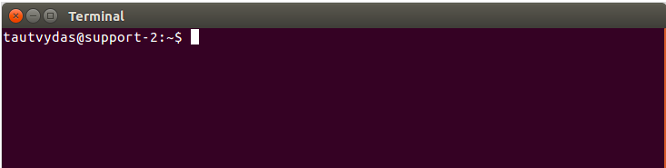

The first thing you need to do is generate the pair of keys on your local machine. You can do it with this simple command:

**ssh-keygen**

Once you enter this command, a few new questions will pop up.

Generally it is recommended to simply leave it as it is (press ENTER without typing anything) so that the key generator could create the key pair in the default location. You should see something like this in your Terminal

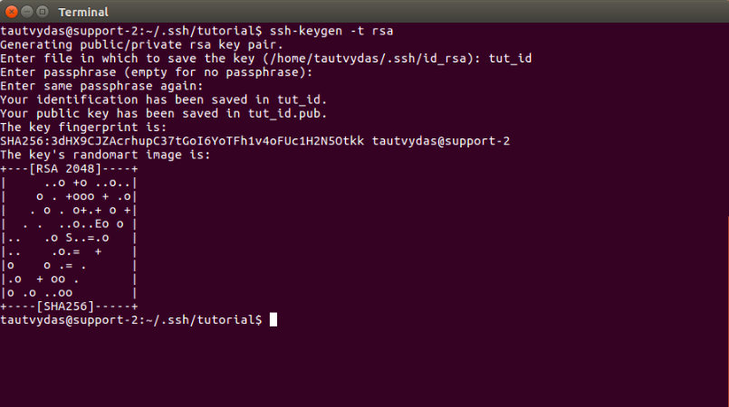

**Step 2 — Copying the Public key to your remote server**

After generating the RSA key pair, we have to put our public key to the remote virtual server.

Copy the public key content to ~/.ssh/authorized_keys

**ssh-copy-id user@serverip**

**ssh-copy-id sysadmin@192.168.56.101**

As the new public key has been added to your remote server. Now every time you log into your remote server, you won’t be prompted for a password (unless you set up a passphrase for your RSA key in the generation process).

[SSH references](https://www.tecmint.com/ssh-passwordless-login-using-ssh-keygen-in-5-easy-steps/)

Google Cloud Setup

Visit <https://cloud.google.com/> → Choose TRY IT FREE

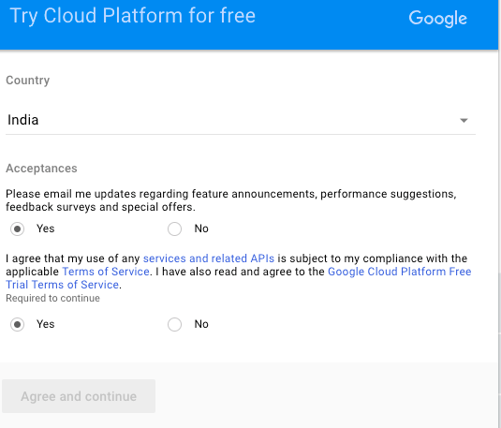

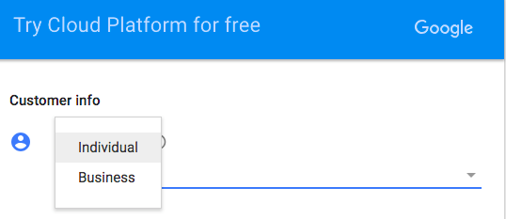

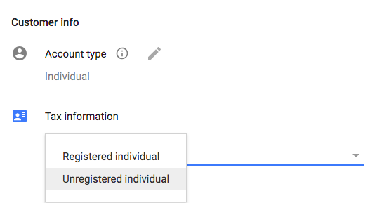

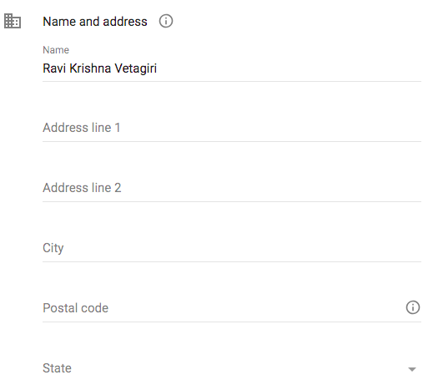

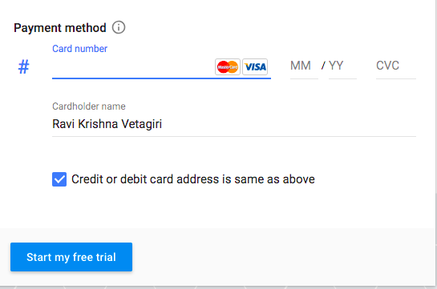

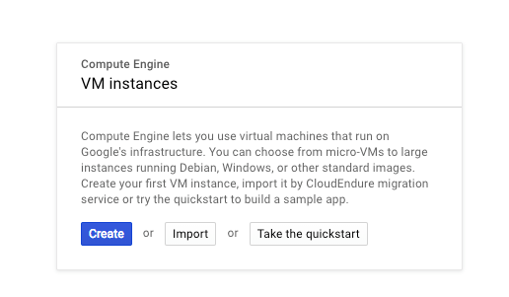

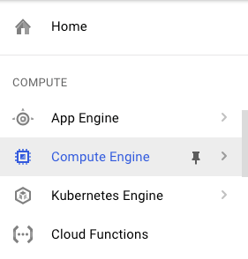

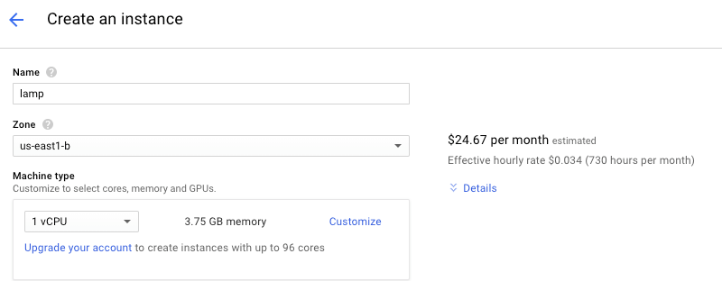

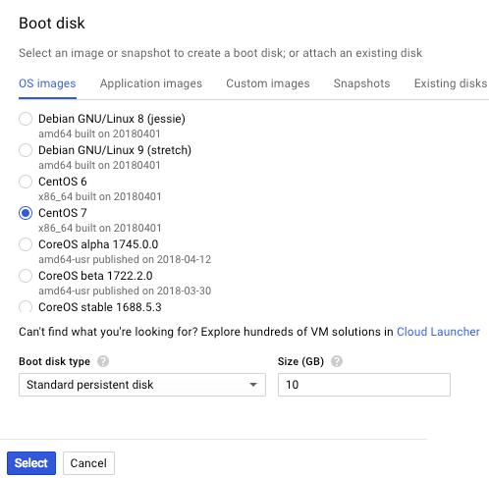

Linux Basics

**Navigation in CLI**

**# cd**    {Change your directories}

cd ; cd ~; cd ..; cd -   {home, home, exact parent dir, last working dir}

**What is Absolute Path & Relative Path**

   The path with reference to root directory is called absolute.

   The path with reference to current directory is called relative.

**# touch**    {create empty files & update the timestamp}

**# cat**  {create the files, put some data in files, view the data}

**# >**    {using redirection we can copy the data, we can create files }

**# >>**  {appending the data}

**# ls**  {list the file contents in directory}

**Metacharacters/Wildcards**

**\* - all {*.txt, ab*, *oc*, *d*}**

**? - one character specific {??.sh, ???.sh, *.??, *.???}**

**[ ]- Range of characters {[a-d]*.txt, [0-5]*.txt}**

**ls -l /etc/host\***

**ls -l /etc/p\***

**cat**

* Display file contents
* Display Multiple File contents
* Create File using cat
* Copy content from an existing file to new file
* Append one file content to another file
* Redirect multiple files content into a single file

**File & Directory Management**

**# mkdir**    {to create the directories.  :: **-p** means parent directory creation}

**# cp**    {to copy files & directories. -r }

**# mv**     {to move/rename files and directorielss}

**# rmdir**  {remove empty dirs}

**# rm**  {remove files & directories.  -r }

**Vi/VIM - Text Editor**

Cat has problems with the Navigation.

Vi/Vim can be used to edit the text files and it also provides following features:

* **Navigation Support**
* **Search Functionality**
* **Undo/Redo Operations**

   # vi <file_name>

**i - insert the data**

**a - append mode**

**esc** {to come out of insert mode}

:**wq** {save and quit}

**Navigation in Vi**

**h** - left arrow

**l** - right arrow

**j** - down arrow

**k** - up arrow

To go word by word in forward direction - **w**

To go word by 5 words in forward direction  -  **5w**

To go word by word in backward direction - **b**

To go word by 5 word in backward direction - **5b**

Page Up - **ctrl + u**

Page Down - **ctrl + d**

Beginning of the File **- gg**

End of the file **- G**

To view the line numbers **:se nu**

To go to a particular line we use **30G** (or) **:30**

To hide the line numbers **:set nonumber**

**Editing using Vi**

To go into insert mode we use "**i**"

   In insert mode commands doesn't work

   Once editing is done save changes by following:

**:wq**   { w-save/write, q-quit }

**a** - append diff is in insert mode character is placed before the cursor position in append mode character is placed after the cursor position

**I** - insert at beginning of the line

**A** - insert at the end of the line

**o** - put text in a new line below current line

**O** - put text in a new line above current line

**x** - will delete a character for you

**5x** - from cursor position next 5 characters will be     deleted

**dw** - delete word

**4dw** - delete 4 words

**dd** - delete your line

**5dd** - delete 5 lines

**:3,15d** - delete lines from 3 to 15

**u** - Undo operation

**cntrl + r** - Redo operation

**yl + p** - copying a character to paste it we use "p"

**yw + p** - copy and pastes a word {cursor position}

**yy + p** - copies and pastes current line

**5Y  + p** - copies and pastes 5 lines from cursor position

**/string** - to search for pattern in forward direction

**?string** - to search for pattern in backward direction

   say multiple occurrences are there use "n" to goto next occurence

**Utility Commands**

1. **more**  <file-name>

2. **less**   <file-name>

3. **head**   <file-name>

4. **tail** <file-name>

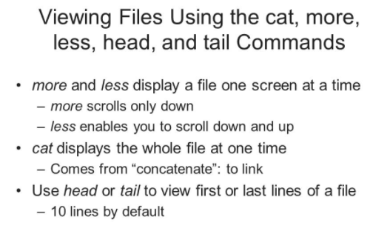

**pipe** - used to combine commands we use |

# **cat readme.txt | less**

**Wget**

   web-get is used to download a particular file/files from web.

   # wget <url_for_file>

   # wget https://wordpress.org/latest.tar.gz

**curl**

   copy url

   # curl <url_for_the_page>

   # curl <http://somewebsite.com/index.html>

**grep {global regular expression}**

===================================

whenever we want to perform a search, we generally use grep.

syntax: # grep <pattern> <file_name>

when we want to search with exact pattern we need to use -w option/flag:

# grep is <file_name> {if file already contains a word like this, it shows this pattern as well}

**# grep -w is <file_name>**

   For case sensitive search we use -i option

**# grep -i <pattern> <file_name>**

   For recursive search we use -r option, {subdir as well}

**# grep -r <pattern> <directory_location>**

   Say you need the line no where the pattern has been matched

**# grep -n <pattern> <file_name>**

**find**

   using **find** command we can search a file.

   # find <location> -name <file>

   # find / -name host

   # find / -name host*

**# find ~ -name "hello.*"**

**Archivers & Compression**

=====================

An archive is a single file that contains any number of individual files. Archives are convenient for storing files.

Archives are also convenient for transmitting data and distributing programs. In fact, most software that is distributed over the Internet is distributed as an archive that contains all related files as well as documentation.

we can bundle multiple files into a single file using tar.

This can be useful when we want to transfer files from one place to another place.

This is generally used when we are taking backups.

Creating tar file without compression

**# tar -cvf <file_name>.tar <file1> <file2>.............<filen>**

Creating tar file with compression

**# tar -cvzf <file_name>.tar.gz <file1> <file2>.............<filen>**

Viewing files inside a tar boll

**# tar -tf <file_name>.tar**

Extract the tar file

**# tar xvf <file_name>.tar**

Extract the tar file in particular location

**# tar xvf <file_name>.tar -C /var/www/html**

**zip & unzip**

**=========**

Creating a zip file

**# zip <file>.zip <file1> <file2>.............<filen>**

Viewing files inside a zip archive

**# unzip -l <file>.zip**

Extracting the zip file

**# unzip <file>.zip**

Extract the zip file in particular location

**# unzip <file>.zip -d /var/www/html**

**User & Group Management**

**User**: is an entity who will login into the system and uses system resources to do some operations.

**Types of Users**

==============

We have 3 types of users in Linux:

1. **Super user  {root user}**
2. **System user   {apache, nginx etc}**
3. **Normal user    {useradd}**

**Super/Root user**

special user who holds all kinds of permission to do any alteration to the system.

**System Users**

This kind of users are typically associated with system applications like httpd, nginx etc

**Normal Users**

This kind of users are added by sys admins by useradd command.

These users work with the system and will use system resources.

   All the user information is stored in this file    # vi /etc/passwd

   There are the 7 fields

**devops:x:1000:1000::/home/devops:/bin/bash**

   1   2   3    4  5  6      7

   1 : username

   2 : password

   3 : userid

   4 : groupid

   5 : Comment

   6 : home directory

   7 : Default shell

**# vi /etc/shadow { encrypted password location }**

**User  Management**

* # useradd
* # usermod
* # userdel
* # useradd <uname>
* # passwd <uname>
* # useradd -c "Comments"    <uname>
* # usermod -l <new_name>    <old_name>
* # usermod -u <new_id> <uname>
* # userdel <uname>
* # userdel --remove <uname>

**File Permissions**

We got two ways of changing the permissions

1. **Symbolic Mode**
2. **Absolute Mode**

**Symbolic Mode**

   + :: adds user designated permission to file/directory

   - :: removes user designated permission to file/directory

   = :: set user designated permission to file/directory

   # sudo chmod u+x <file>

   # sudo chmod g-x <file>

   # sudo chmod o=rwx <file>

   # sudo chmod u+x,g-r,o=rwx <file>

**Absolute Mode**

   Using numbers we specify permissions:

   read :: 4

   write ::   2

   execute :: 1

   # sudo chmod 755 <file>.  {rwx r-x r-x}

   # sudo chmod 644 <file>.  {rw- r-- r--}

   # sudo chmod -R 644 <file>.  {rw- r-- r--}

   # sudo chmod 700 <file>.  {rwx --- ---}

**Changing Ownership**

   # chown is used to change the ownership of the files & directories.

Changing only file owner

   # sudo chown <uname> <file>

Changing only group owner

# sudo chgrp <group_name> <file>

Changing both file & group owner in one go

# sudo chown <uname>:<group_name> <file>

# sudo chown -R <uname>:<group_name> <file>

**Package Management**

**Package:** Package refers to compressed file that containing all the files that come with a particular application.

   code file

   config file

   Manual page

   Example files

In RHEL/CentOS, the package management tool will be called RPM {Redhat Package Manager}

**What would the package management system does for u ??**

   1. Install a new package {application}

   2. Upgrade the package  {application}

   3. Erase the package {uninstall the application}

**RPM**

**To work with packages we use a command called # rpm**

   # rpm {command to work with Redhat Package Manager}

   package Format: <package_name>-<version>-<release>-<arch>.rpm

   # elinks-0.12-1.mga1.x86_64.rpm

   elinks-x.y.z   elinks-major_Version.minor_Version.build_Version

**Different options available with rpm:**

   rpm -q query

   -a = show me all packages

   -i =  show me detailed info about package

   -l = list of files inside the package

   -f = find the relation b/w a file and package

# rpm -qa → shows all packages

# wc-l → count no of lines

# rpm -qa | wc -l

# rpm -qi <pkg_name> → detailed info abt package. { i }

# rpm -ql perl → shows location of all files distributed across the        system when an application{perl} is installed

# rpm -qf /etc/hosts → gives info about, what package the file belongs to

**Using rpm command**

**Install**

   Download the rpm file {rpmfinder}

   # wget <file>.rpm

   # rpm -ivh <file>.rpm

**Upgrade**

   Download the new upgraded rpm then upgrade it

   # rpm -Uvh <new_file>.rpm

**Erase**

   # rpm -e <application>

**Taking Elinks as example**

   1. first we need to download elinks .rpm file

   # wget ftp://mirror.switch.ch/pool/4/mirror/centos/7.3.1611/os/x86_64/Packages/elinks-0.12-0.36.pre6.el7.x86_64.rpm

2. Try to install .rpm file

   # sudo rpm -ivh elinks-0.12-0.36.pre6.el7.x86_64.rpm

3. If there are any dependencies, then we need to download those dependencies as well

   # wget ftp://mirror.switch.ch/pool/4/mirror/opensuse/opensuse/distribution/12.2/repo/oss/suse/x86_64/libmozjs185-1_0-1.8.5-9.2.2.x86_64.rpm

   # wget ftp://rpmfind.net/linux/opensuse/distribution/13.2/repo/oss/suse/x86_64/libnss_compat_ossl0-0.9.2-22.1.2.x86_64.rpm

   4. Then install the dependencies also

    # sudo rpm -ivh libmozjs185-1_0-1.8.5-9.2.2.x86_64.rpm

      # sudo rpm -ivh libnss_compat_ossl0-0.9.2-22.1.2.x86_64.rpm

     5. Then once dependencies got installed, we need to install main application

     # sudo rpm -ivh elinks-0.12-0.36.pre6.el7.x86_64.rpm

In olden days to install a package there were many issues bcz of above two problems.

To erase a package we use -e option

# sudo rpm -e elinks

**Limitations through RPM**

   We need to download the package

   Need to check the dependencies if any

In olden days to install a package there were many problems bcz of above two problems.

To overcome the above problems and make the process easy, they have created a function called repository.

**What is Package Repository ?**

It is a collection of all related files, w.r.t given OS version

Yum  =============>   command to access repo

**Yum :: Yellowdog Updater, Modified**

By default we have some basic repositories for our use. But to use them:

   We need internet

   We Need to identify which package we need to work

**# man yum**

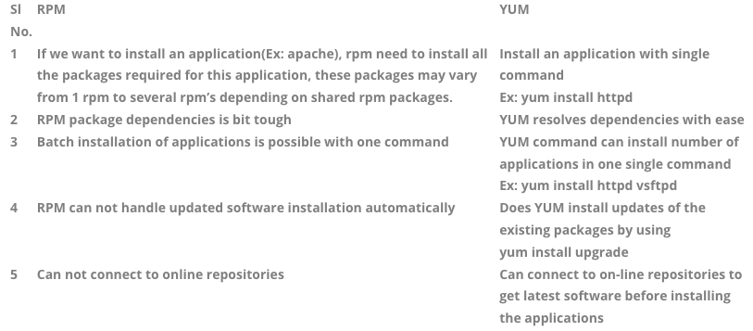

**Advantages of repo**

Speeds up the download process

It fails over to nearest repo automatically

Repos info and repos are stored in **# /etc/yum.repos.d**

we have .repo files in yum.repos.d    =======>   these are files what    contain pointer towards the actual repo

**Commands to work with repos**

# yum clean all   → to clear all clutter

# yum repolist   → to give current active repos

# yum install <package_name>   → Install package

# yum install epel-release  →  Important {epel - Extra Packages For Enterprise Linux}

**above command Installs epel repo**

**YUM {Yellowdog Updater Modified}**

* It can download the packages(rpm's) from repositories
* It can automatically update the packages
* It can download the dependencies automatically

   **** We need to have a internet connection ****

   # yum info <app>

   # yum list installed

   # yum install <app>

   # yum update <app>

   # yum remove <app>

   # yum search <app>

   # yum whatprovides <app>

   # cd /etc/yum.repos.d

Go to the particular application website and create a repo file in /etc/yum.repos.d and copy the content from website i.e app.repo

**netstat** command (network statistics) is a command line tool that can be used to check the network configuration and activity.

You can’t find this command by default.

First, we should find out which package provides ‘netstat’ command

# yum whatprovies <app> ::: yum whatprovides netstat

# yum provides */netstat

# yum install net-tools

**Install mongodb**

# yum whatprovies monogodb

# vi /etc/yum.repos.d/mongodb-org-3.4.repo

[mongodb-org-3.4]

name=MongoDB Repository baseurl=https://repo.mongodb.org/yum/redhat/$releasever/mongodb-org/3.4/x86_64/

gpgcheck=1

enabled=1   gpgkey=https://www.mongodb.org/static/pgp/server-3.4.asc

Then you will find the command to install the application:

**# yum install mongodb-org**

**Service Command**

   The service command starts or stops a service by running an initialization script.

   The SCRIPT parameter, located in /etc/init.d/SCRIPT

   For upstart jobs,

   start, stop, and status are passed through to their upstart equivilents.

   # service <service> start

**Systemctl command**

In RHEL/CentOs7 systemctl command, which is the central management tool for controlling the init system. We will cover how to manage services, check statuses, change system states, and work with the configuration files.

  # systemctl start <service>

  # stop

  # status

  # reload

  # restart

  # systemctl list-units

  # systemctl --failed

  # systemctl is-enabled <service>

  # systemctl enable <>

  # systemctl disable <>

  # systemctl kill <service>

**Linux Process Management**

In linux many services are started, when server boots up.

We can use # ps command to get an overview of all processes.

# ps -ef | wc {total no of process that are running }

**Memory Usage**

# free -m

{free size, m stands for mega byte} {swap: emulated RAM that sits on Hard disk}

**Monitoring**

# top   
# yum -y install htop

# htop

LAMP

So when it comes to LAMP we are talking about

{ **Linux, Apache, MySql & PHP** }

**LAMP** is an **open source Web development platform** that **uses Linux as the operating system**, **Apache as the Web server**, **MySQL as the relational database** management system and **PHP as the object-oriented scripting language**.

Because the platform has four layers, LAMP is sometimes referred to as a LAMP stack. Stacks can be built on different operating systems.

The same setup in windows is called **WAMP**

The same setup in mac is called **MAMP**

**Advantages Of LAMP**

* Open Source
* Easy to code with PHP
* Easy to deploy an application
* Develop locally
* Cheap Hosting
* Easy to build CMS application
  + Wordpress, Drupal, Joomla, Moodle etc

**Web Server**

A web server is a program which serves web pages to users in response to their requests, which are forwarded by their computers' HTTP clients(Browsers).

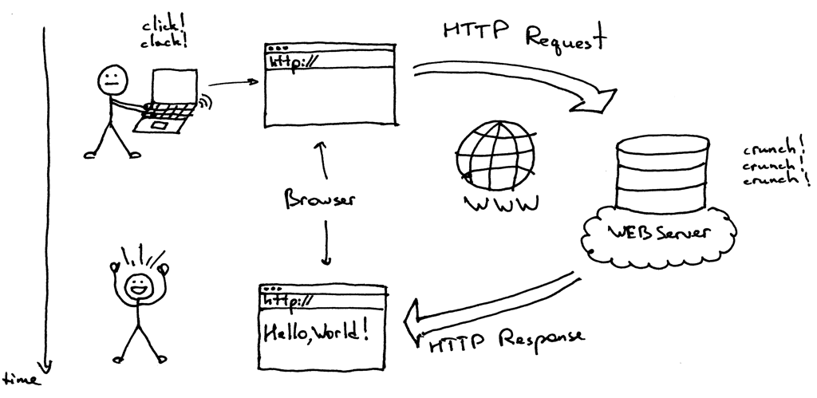

All computers that host websites must have web server program.

**Purpose of Web server**

A web server’s main purpose is to store web site files and broadcast them over the internet for you site visitors to see. In essence, a web server is simply a powerful computer that stores and transmits data via the internet.

Web servers are the gateway between the average individual and the world wide web.

**LAMP Architecture**

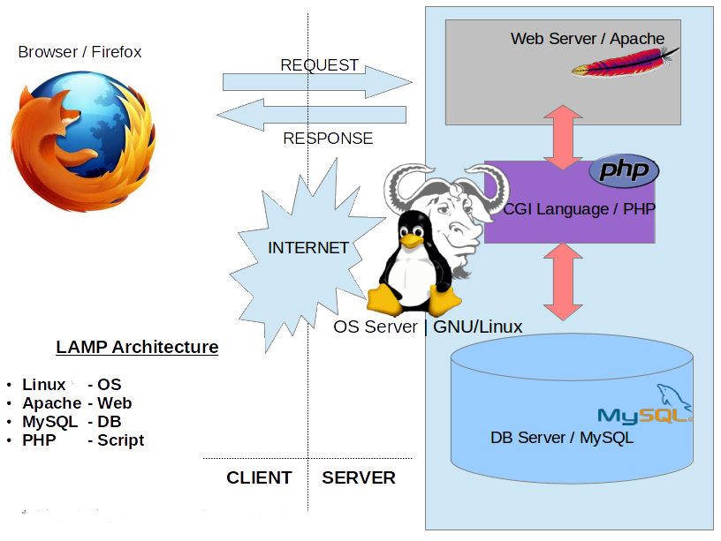

**Linux** :: We already talked about linux

**Apache Web Server**

An **open source web server** used mostly for **Unix and Linux platforms**.

It is **fast, secure and reliable**.

* An Open Source Web Server
* Apache is developed and maintained by an open community of developers under the [Apache Software Foundation](https://en.wikipedia.org/wiki/Apache_Software_Foundation).
* The Apache HTTP Server is cross-platform as of 1 June 2017, 92% of Apache Server copies run on Linux distributions.
* Apache played a key role in the initial growth of the World Wide Web.
* The Apache HTTP Server has been the most popular Web Server on the public Internet since April 1996.
* In 2009, it became the first web server software to serve more than 100 million websites.
* As of July 2016, it was estimated to serve 46% of all active websites and 43% of the top million websites.

**Parameters for Apache (httpd)**

Package - httpd

Port - 80

Protocol - http

Server Root -    /etc/httpd

Main config file - /etc/httpd/conf/httpd.conf

Document root - /var/www/html    {all our web pages }

Logs - /var/log/httpd/error_log

/var/log/httpd/access_log

**What version of OS you have**

**========================**

# cat /etc/redhat-release

# cat /etc/os-release

**Checking httpd service is running or not [Centos/Redhat 6.x - 7.x]**

6.x - Whenever you have problem with httpd {troubleshooting httpd}

# service httpd status

# netstat -ntpl | grep 80

# ps -ef | grep httpd

7.x - Whenever you have problem with httpd {troubleshooting httpd}

# systemctl status httpd

# netstat -ntpl | grep 80

# ps -ef | grep httpd

Now when you are doing server configuration, we need to be very careful while doing server configuration, coz sometimes you may do some typos and you are unaware why the server is not starting, so to confirm your config is correct use following command:

**Check configuration file (httpd.conf) is correct or not**

# httpd -t { 6.x and 7.x }

**Installing httpd service**

# rpm -qa | grep httpd

# sudo yum -y install httpd

Let’s **check status** of the web server:

# systemctl status httpd

# netstat -ntpl | grep 80

# ps -ef | grep httpd

Let’s **start the web server**:

# systemctl start httpd

# systemctl status httpd

# netstat -ntpl | grep 80

# ps -ef | grep httpd

Now we have started the service

If you see **# ls -l /var/www/html**, you have no files in there, let’s create a index.html

**# cd /var/www/html**

**# vi index.html** {put some content}

<h1>Welcome to Apache http Server</h1>

**Hosting WebSite**

Once the Web Server is up and running, follow the below approach to host websites

* Change Directory To Document Root of apache
  + cd /var/www/html/
* Download the food website
  + sudo wget <https://github.com/ravi2krishna/food/archive/master.zip>
* Unzip the archive in /var/www/html
  + sudo unzip master.zip
* Change **DocumentRoot** to /var/www/html/food-master in main configuration
  + vim /etc/httpd/conf/httpd.conf
* Change the food-master directory ownership to apache
  + chown -R apache:apache /var/www/html/food-master
* Change the selinux to permissive
  + sudo setenforce 0
  + sudo getenforce { should give permissive }
* Restart the Web Server
* Browse the Web Site on IP or Domain

Download some of the free templates and check and

<https://www.free-css.com/free-css-templates>

**Hosting PHP Sites**

* Create a php page (date.php) and host it in DocumentRoot

<!DOCTYPE html>

<html>

<body>

<?php

echo "Today is " . date("Y/m/d") . "<br>";

echo "Today is " . date("Y.m.d") . "<br>";

echo "Today is " . date("Y-m-d") . "<br>";

echo "Today is " . date("l");

?>

</body>

</html>

* Browse the page <http://ip-address/date.php>
* As you can see, the server is unable to render php tags

* By default the Apache Server can only render HTML but not PHP

* So to host the php sites we need to install PHP first, which provides the capability of rendering the php tags to the web server
  + yum -y install php
* Now restart the webserver
  + systemctl restart httpd
* Browse the page <http://ip-address/date.php>

* Now we can see the web server is able to render the php as well

**Virtual Hosting**

The term Virtual Host refers to the practice of running more than one web site (such as company1.example.com and company2.example.com) on a single machine.

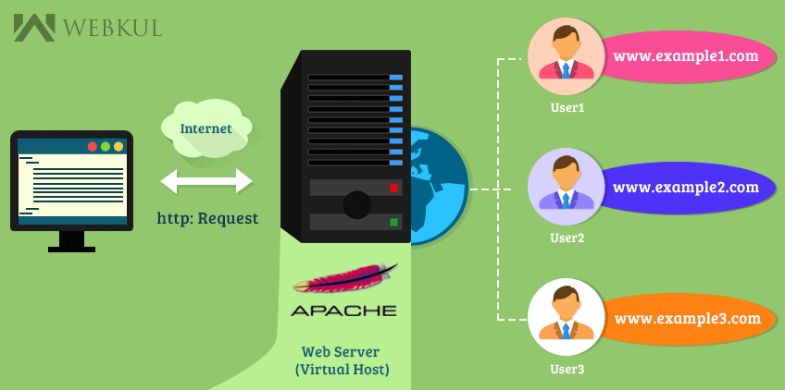

* If we are using IP's then we need to go with different port numbers like 8080
* Add Multiple Listen tags with different port numbers in configuration file
  + vim /etc/httpd/conf/httpd.conf
    - Add Listen 8080 & Listen 8081 in httpd.conf

* Now copy the food-master directory twice with names pizza and burger
  + sudo cp -R /var/www/html/food-master /var/www/html/pizza
  + sudo cp -R /var/www/html/food-master /var/www/html/burger

* Add Virtual Host tags at the end of file to /etc/httpd/conf/httpd.conf

**Port Based**

<VirtualHost *:8080>

DocumentRoot /var/www/html/pizza

</VirtualHost>

<VirtualHost *:8081>

DocumentRoot /var/www/html/burger

</VirtualHost>

**Domain** Based

<VirtualHost *:80>

DocumentRoot /var/www/html/pizza

ServerName pizza.domain.com

</VirtualHost>

<VirtualHost *:8081>

DocumentRoot /var/www/html/burger

ServerName burger.domain.com

</VirtualHost>

* Once configured check the syntax and restart the server
  + sudo httpd -t
  + Sudo systemctl restart httpd

**Nginx**

* An Open Source Web Server which can also be used as a Reverse Proxy & Load Balancer
* Nginx was released in 2004
* Nginx was found to be the Second most widely used web server across all "active" sites
* According to W3Techs, it was used by 37.7% of the top 1 million websites, 49.7% of the top 100,000 websites, and by 63.0% of the top 10,000 websites.
* NGINX is the heart of the modern web, powering half of the world’s busiest sites

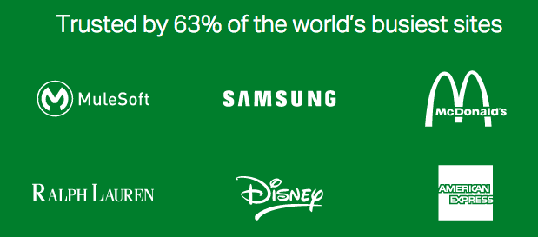

Nginx is a http server, which is used in many high traffic websites like **ibm.com**, **atlassian.com**, **bitbucket.org**, **t-mobile.com**, **upwork.com**, **coinmarketcap.com, gitlab.com,** etc.

The **3 imp features that nginx** gives is:

**Web Server,** **Load balancing** and **Reverse proxying**.

**Load Balancing**

* Load balancing refers to efficiently distributing incoming network traffic across a group of backend servers, also known as a server farm or server pool

* A Load balancer acts as the “traffic cop” sitting in front of your servers and routing client requests across all servers capable of fulfilling those requests

* Load balancing improves the distribution of workloads across multiple servers ensuring that no one server is overworked, which could degrade performance.

* If a single server goes down in server pool, the load balancer redirects traffic to the remaining online servers

In load balancing, say u have a high traffic website which  gets 1000 requests per second may be more then that, if u have only one server all the 1000 requests will be severe by the single server where the response time will be decreased.

So we put more servers and distribute the load to all the servers equally.

So the 1000 requests will be distributed to 3 servers like 300 requests for each server assuming we got 3.

**Nginx As Load Balancer**

A Load balancer performs the following functions:

* Distributes client requests or network load efficiently across multiple servers
* Ensures high availability and reliability by sending requests only to servers that are online
* Provides the flexibility to add or subtract servers as demand dictates

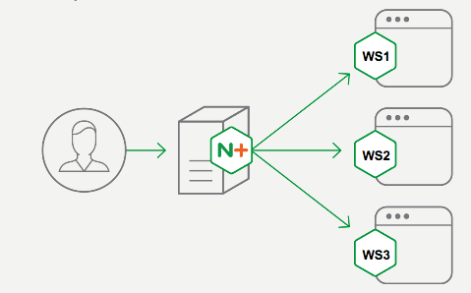

**Proxy**

* A Proxy server is a server that acts as an intermediary for requests from clients seeking resources from other servers

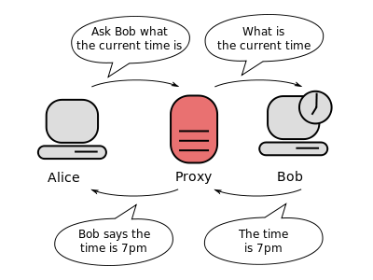

* Communication between two computers (shown in grey) connected through a third computer (shown in red) acting as a proxy. Bob does not know, to whom the information is going, which is why proxies can be used to protect privacy.

**Forward Proxy**

The word "proxy" describes someone or something acting on behalf of someone else. In the computer realm, we are talking about one server acting on the behalf of another computer.

Forward Proxy: Acting on behalf of a requestor (or service consumer)

"forward proxy" retrieves data from another web site on behalf of the original requestee.

In forward proxy we get to see 3 computers:

X = your computer, or "client" computer on the internet

Y = the proxy web site, proxy.example.org

Z = the web site you want to visit, www.example.net

Normally, one would connect directly from     X    —>   Z.

However, in some scenarios, it is better for Y —>  Z, on behalf of X, which chains as follows: X    —> Y—> Z

Reasons why X would want to use a forward proxy server

====================================================

X is unable to access Z directly because

a) Someone with administration authority over X's internet connection has decided to block all access to site Z.

Employees at a large company have been wasting too much time on facebook.com, so management wants access blocked during business hours.

Torrent downloads can be blocked by our ISP’s so to view the torrent downloads we can use forward proxy.

b) The administrator of Z has blocked X.

Examples:

The administrator of Z has noticed hacking attempts coming from X, so the administrator has decided to block X's ip address.

Z is a forum web site.  X is spamming the forum. Z blocks X.

**Reverse Proxy**

* Reverse Proxy : Acting on behalf of service/content producer

* Reverse proxy shields the origin servers. Client makes a call to the reverse proxy instead of origin sever.

* In reverse proxy we get to see 3 computers:
  + X = your computer, or "client" computer on the internet
  + Y = the Reverse proxy Server, Nginx
  + Z = the web site you want to visit, example.com

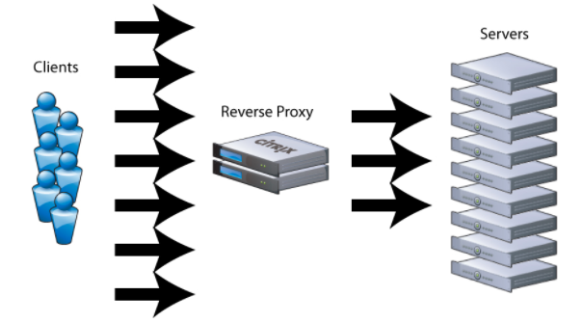

* Normally, one user wants to connect from X → Z, However in some scenarios, it's better for the administrator of Z to restrict or disallow direct access to Z, and force visitors to go through Y first.

* Reasons why Z would want to use a Reverse proxy server:
  + Z wants to force all traffic to its web site to pass through Y first
  + The administrator of Z is worried about retaliation for content hosted on the server Z and does not want to expose the main server ( Z ) directly to the public.
  + Reverse proxies can hide the existence and characteristics of an origin server.
  + Using a Reverse proxy can distribute the load from incoming requests to several servers, Z has a web site that millions of people want to see, but a single web server cannot handle all the traffic. So Z sets up many servers, and puts a reverse proxy to implement load balancing.

**Reverse Proxy Implementation**

* This implementation requires a minimum of four servers one being a Reverse Proxy server and other two being Web Servers
* Reverse Proxy Server : Nginx
* Web Servers : Apache - 3



Make sure you have four servers up and running:

Server 1 : IP-ADDRESS: 104.154.22.74

Server 2 : IP-ADDRESS: 104.198.254.34

Server 3 : IP-ADDRESS: 104.198.70.78

Server 4 [ **Nginx** ] : IP-ADDRESS: 104.198.23.42

Note: You would have different IP addresses generated for you.

Server 1 [ Web Server 1 ]

# yum -y install httpd

# systemctl enable httpd

# systemctl start httpd

# echo “<h1>Website Served from Web Server 1 ” > /var/www/html/index.html

Server 2 [ Web Server 2 ]

# yum -y install httpd

# systemctl enable httpd

# systemctl start httpd

# echo “<h1>Website Served from Web Server 2 ” > /var/www/html/index.html

Server 3 [ Web Server 3 ]

# yum -y install httpd

# systemctl enable httpd

# systemctl start httpd

# echo “<h1>Website Served from Web Server 3 ” > /var/www/html/index.html

Server 4 [ Nginx Proxy ]

# yum -y install nginx

# systemctl enable nginx

# systemctl start nginx

I am going to define a group of web servers with directive **upstream** and going to give this group a name as **backend**

**Upstream** defines a cluster that you can proxy requests to. It's commonly used for defining either a web server cluster for load balancing, or or an app server cluster for routing / load balancing.

**nginx.conf**

# vi /etc/nginx/nginx.conf   { update the new configuration }

user nginx;  
worker_processes auto;  
error_log /var/log/nginx/error.log;  
pid /run/nginx.pid;  
  
# Load dynamic modules. See /usr/share/nginx/README.dynamic.  
include /usr/share/nginx/modules/*.conf;  
  
events {  
    worker_connections 1024;  
}  
  
http {  
    log_format  main  '$remote_addr - $remote_user [$time_local] "$request" '  
                      '$status $body_bytes_sent "$http_referer" '  
                      '"$http_user_agent" "$http_x_forwarded_for"';  
  
    access_log  /var/log/nginx/access.log  main;  
  
    sendfile            on;  
    tcp_nopush          on;  
    tcp_nodelay         on;  
    keepalive_timeout   65;  
    types_hash_max_size 2048;  
  
    include             /etc/nginx/mime.types;  
    default_type        application/octet-stream;  
  
    # Load modular configuration files from the /etc/nginx/conf.d directory.  
    # See http://nginx.org/en/docs/ngx_core_module.html#include  
    # for more information.  
   include /etc/nginx/conf.d/*.conf;  
    server {  
        listen       80 default_server;  
        listen       [::]:80 default_server;  
        server_name  _;  
        root         /usr/share/nginx/html;  
  
        # Load configuration files for the default server block.  
        include /etc/nginx/default.d/*.conf;

***upstream backend {***

***server 104.154.22.74;***

***server 104.198.254.34;***

***server 104.198.70.78;***

***}***

server {  
        listen       80 default_server;  
        listen       [::]:80 default_server;  
        server_name  _;  
        root         /usr/share/nginx/html;  
  
        # Load configuration files for the default server block.  
        include /etc/nginx/default.d/*.conf;  
  
       ***location / {***

***proxy_pass http://backend;  
        }***  
  
        error_page 404 /404.html;  
            location = /40x.html {  
        }  
  
        error_page 500 502 503 504 /50x.html;  
            location = /50x.html {  
        }  
    }

}

Once the configuration is updated, restart the nginx server.

# systemctl restart nginx

**MySQL Database**

* MYSQL, is an open-source relational database management system (RDBMS)

* MySQL is a central component of the [LAMP](https://en.wikipedia.org/wiki/LAMP_(software_bundle)) open-source web application software stack

* Applications(CMS) that use the MySQL database include
  + Wordpress
  + Drupal
  + Joomla etc

* Download [MYSQL](http://repo.mysql.com/mysql-community-release-el7-5.noarch.rpm) RPM
  + wget [MYSQL](http://repo.mysql.com/mysql-community-release-el7-5.noarch.rpm)
  + Installs repo file
    - sudo rpm -ivh mysql-community-release-el7-5.noarch.rpm
  + sudo yum -y install mysql-server
  + sudo systemctl start mysqld
    - Starts on port 3306
    - ps -ef | grep mysql
  + sudo mysql_secure_installation
    - When running for first time, **hit Enter button** then set the password by **hitting Y**
  + sudo mysql -u root -p
  + show databases
  + use database;

**Content Management Systems**

* A content management system (CMS) is a computer application that supports the creation and modification of digital content

* A content management system is the front-end user interface that allows a user, even with limited expertise, to add, modify, and remove content from a website without the intervention of a developer

* Other popular content management systems include Joomla and Drupal

* Content management systems typically provide the following features:
  + Integrated and online help
  + Templating support for changing designs
  + Install and upgrade wizards
  + Reduced need to code from scratch
  + Easy to create a unified look and feel

* Based on market share statistics, the most popular content management system is [WordPress](https://en.wikipedia.org/wiki/WordPress), used by over 28% of all websites on the internet, and by 59% of all websites using a known content management system.

* Other popular content management systems include Joomla and Drupal

**CMS Advantages**

* Content management systems typically provide the following features:
* Integrated and online help
* Templating support for changing designs
* Install and upgrade wizards
* Reduced need to code from scratch
* Easy to create a unified look and feel

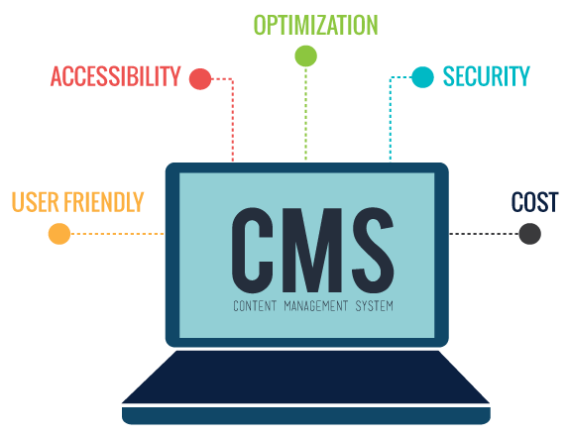

**Wordpress Setup**

* Download [Wordpress](https://wordpress.org/wordpress-4.4.16.tar.gz)
  + wget https://wordpress.org/latest.tar.gz
* Extract the downloaded file to /var/www/html & Update DocumentRoot
  1. sudo tar xvf wordpress.tar -C /var/www/html
  2. sudo vi /etc/httpd/conf/httpd.conf
     + Update DocumentRoot to /var/www/html/wordpress
     + chown -R apache:apache /var/www/html/wordpress
* Browse the site with IP Address
  1. <http://ip-address>
* Install php-mysql dependency
  1. sudo yum -y install php-mysql
  2. sudo systemctl restart httpd

* Create a database with name wordpress

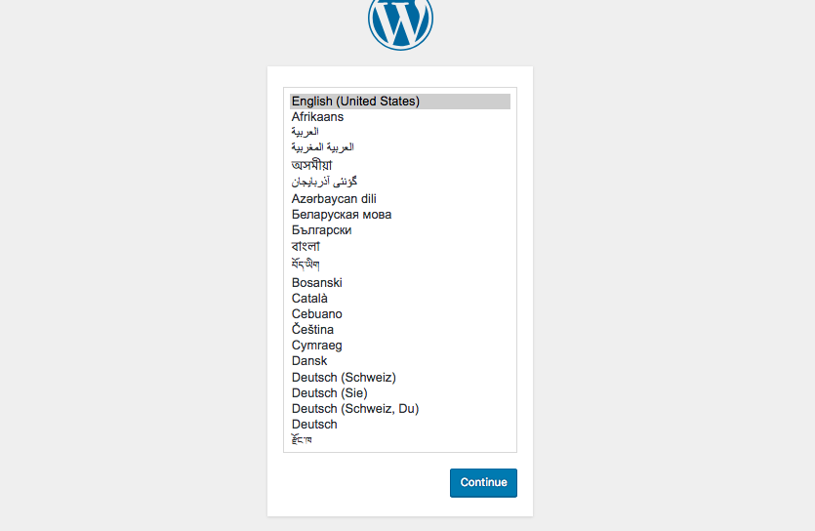

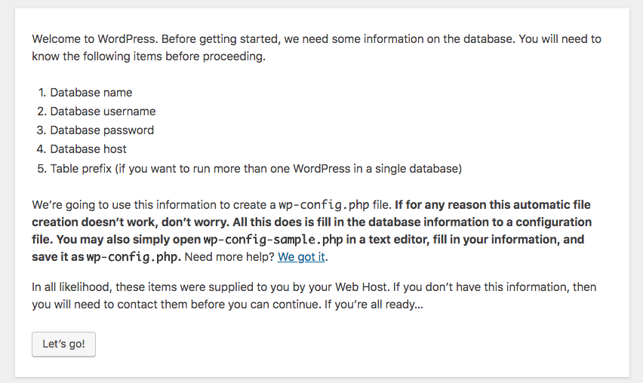

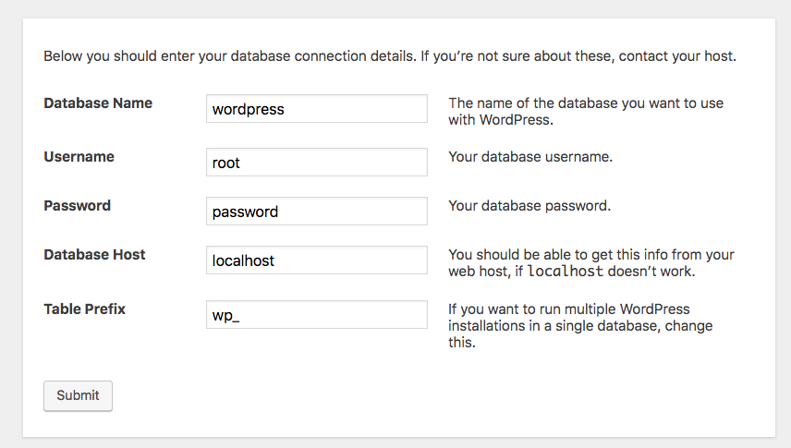

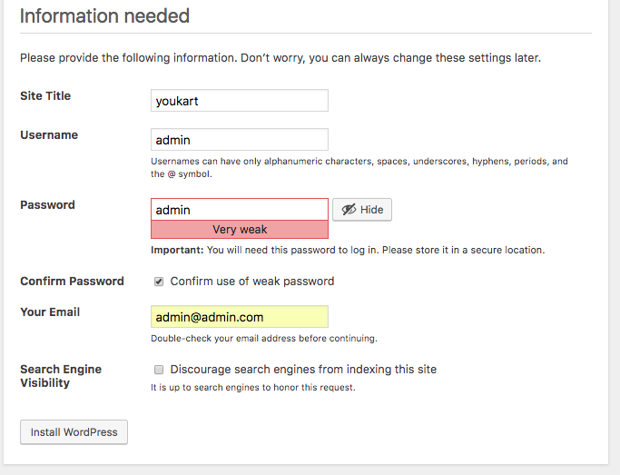

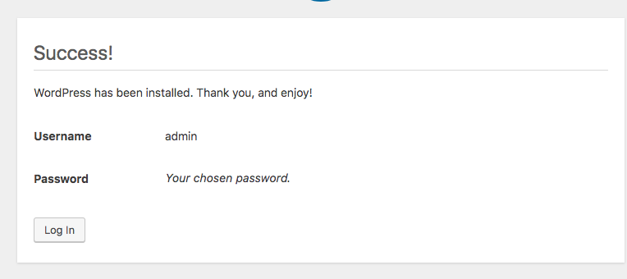

* Browse the site with IP Address
  1. <http://ip-address>

GIT

* [WIKIPEDIA](https://en.wikipedia.org/wiki/Git) - Git is a Version Control System for tracking changes in computer files and coordinating work on those files among multiple people. It is primarily used for source code management in software development,but it can be used to keep track of changes in any set of files. As a distributed revision control system it is aimed at speed,data integrity and support for distributed workflows.

* [GIT](https://git-scm.com/) - Git is a free and open source Distributed Version Control System designed to handle everything from small to very large projects with speed and efficiency. Git is easy to learn and has a tiny footprint with lightning fast performance. It outclasses SCM tools like Subversion, CVS etc

* Git Clients



**Version Control System**

* Version Control, also known as revision control or source control,is the management of changes to documents, computer programs, large web sites, and other collections of information. Changes are usually identified by a number or letter code, termed the "revision number"

* Revision control allows for the ability to revert a document to a previous revision, which is critical for allowing editors to track each other's edits and correct mistakes

* Software tools for version control are essential for the organization of multi-developer projects.

**Why Version Control System**

Have you ever -

* Made a change to code, realised it was a mistake and wanted to revert back?
* Lost code and didn’t have a backup of that code ?
* Had to maintain multiple versions of a product ?
* Wanted to see the difference between two (or more) versions of your code ?
* Wanted to prove that a particular change in code broke application or fixed a application ?
* Wanted to review the history of some code ?
* Wanted to share your code, or let other people work on your code ?
* Wanted to see how much work is being done, and where, when and by whom ?
* Wanted to experiment with a new feature without interfering with working code ?

**Advantages Of Version Control System**

* Backup
* Collaboration
* Storing Versions
* Restoring Previous Versions
* Understanding What Happened

**VCS**

* Version Control / Revision control / Source Control is is a software that helps software developers to work together and maintain a complete history of their work.

* You can think of a version control system ("VCS") as a kind of "database".

* It lets you save a snapshot of your complete project at any time you want.  When you later take a look at an older snapshot ("version"), your VCS shows you exactly how it differed from the previous one.

* A version control system records the changes you make to your project’s files. This is what version control is about. It's really as simple as it sounds.

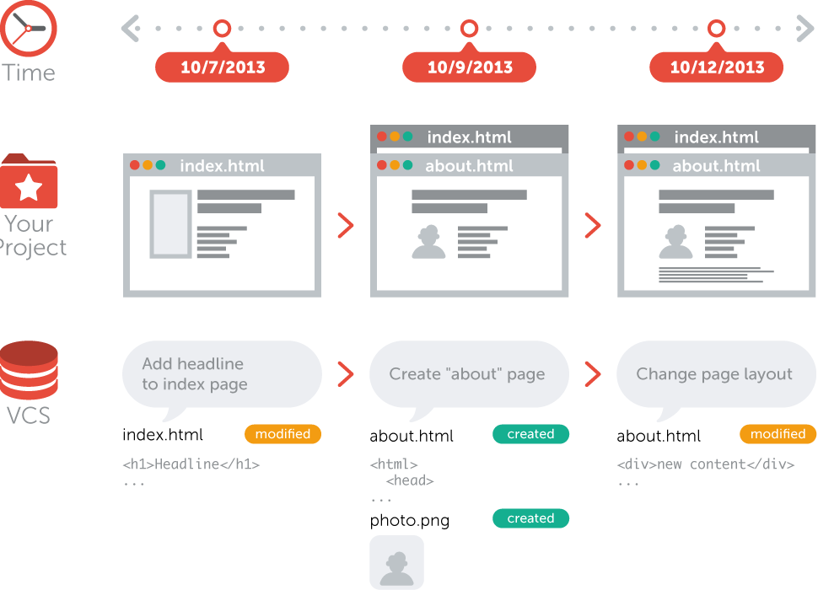

**Types Of VCS**

* **Centralized Version Control System** (CVCS)
  + Ex: CVS, SVN

** **

* **Distributed Version Control System** (DVCS)
  + Ex: Git, Mercurial

** **

**Centralized Version Control System**

* Uses a central server to store all files and enables team collaboration.

* But the major drawback of CVCS is its single point of failure, i.e., failure of the central server.

* Unfortunately, if the central server goes down for an hour, then during that hour, no one can collaborate at all.

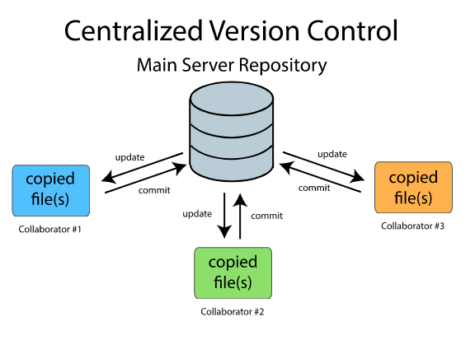

**Distributed Version Control System**

* DVCS does not rely on the central server and that is why you can perform many operations when you are offline.

* You can commit changes, create branches and perform other operations when you are offline.

* You require network connection only to publish your changes and take the latest changes.

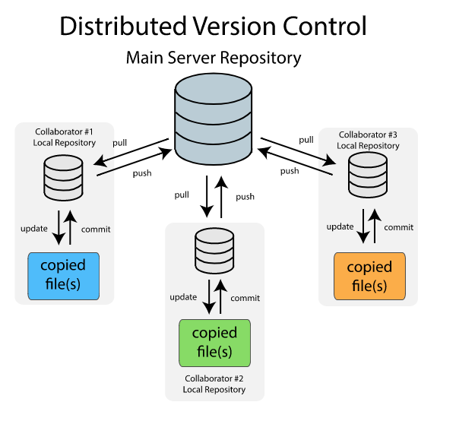

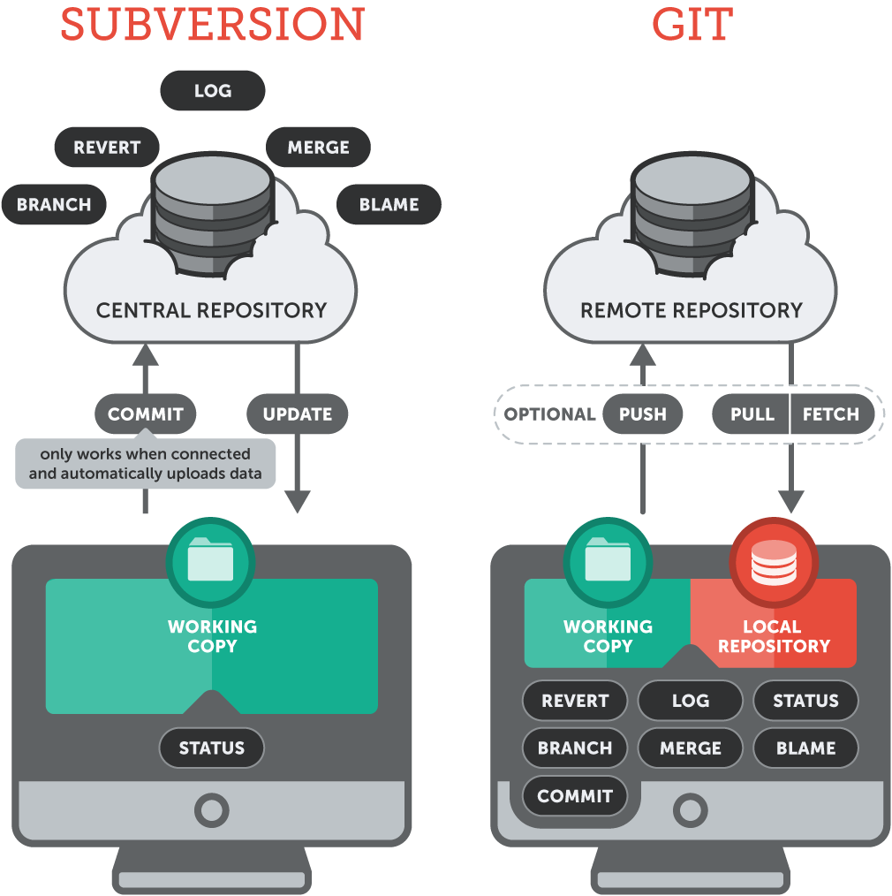

**Typical VCS Working**

A typical VCS uses something called **Two tree architecture**, this is what a lot of other VCS use apart from git.

Usually, a VCS works by having two places to store things:

1. **Working Copy**
2. **Repository**

These are our two trees, we call them trees because they represent a file structure.

**Working copy [CLIENT]** is the place where you make your changes.

Whenever you edit something, it is saved in working copy and it is a physically stored in a disk.

**Repository [SERVER]** is the place where all the version of the files or  commits,  logs etc is stored. It is also saved in a disk and has its own set of files.

You cannot however change or get the files  in a repository directly, in able to retrieve a specific file from there, you have to checkout

**Checking-out** is the process of getting files from repository to your working copy.  This is because you can only edit files when it is on your working copy. When you are done editing the file, you will save it back to the repository by committing it, so that it can be used by other developers.

**Committing** is the process of putting back the files from working copy to repository.

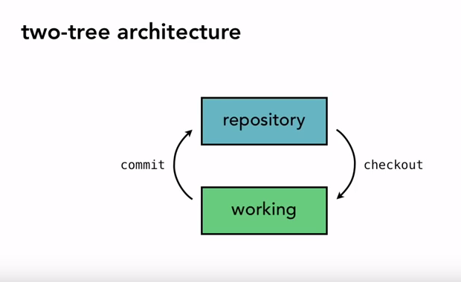

Hence, this architecture is called **2 Tree Architecture.**

Because you have two tree in there **Working Copy** and **Repository**.

The famous VCS with this kind of architecture is **Subversion** or **SVN**.

**Distributed VCS Working**

* Unlike Two tree architecture, a DVCS works by having three places to store things, so it's also called Three Tree Architecture
  + Working Copy
  + Staging
  + Repository
* As Git uses Distributed version control system, So let’s talk about Git which will give you an understanding of DVCS.
* Git was initially designed and developed by Linus Torvalds in 2005 for Linux kernel development. Git is an Open Source tool.
* For developing and maintaining Linux Kernel, Linus Torvalds used **BitKeeper** which is also one of the VCS, and is open source till 2004.
* So instead of depending on other tools, they developed their own VCS.
* Just see the wiki of Git.

**Git Architecture**

Git uses three tree architecture.

Well interestingly Git has the **Working Copy** and **Repository** as well but it has added an extra tree **Staging** in between:

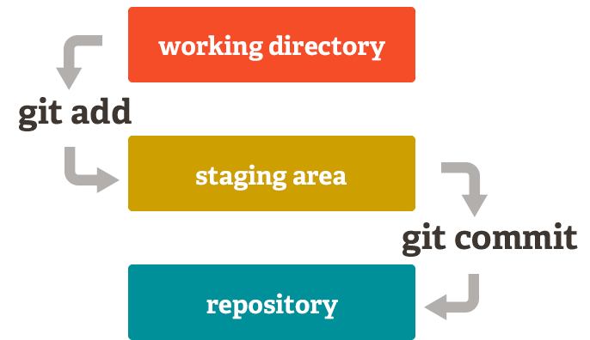

 As you can see above, there is a new tree called **Staging**.

**Staging Tree**

* This is one of the fundamental difference of Git that sets it apart from other VCS, this Staging tree (usually termed as Staging area) is a place where you prepare all the things(changes) that you are going to commit.

* In Git, you don't move things directly from your working copy to the repository, you have to stage them first, one of the main benefits of this is, to break up your working changes into smaller, self-contained pieces.

* To stage a file is to prepare it for a commit.

* Staging allows you finer control over exactly how you want to approach version control.

**Advantages Of GIT**

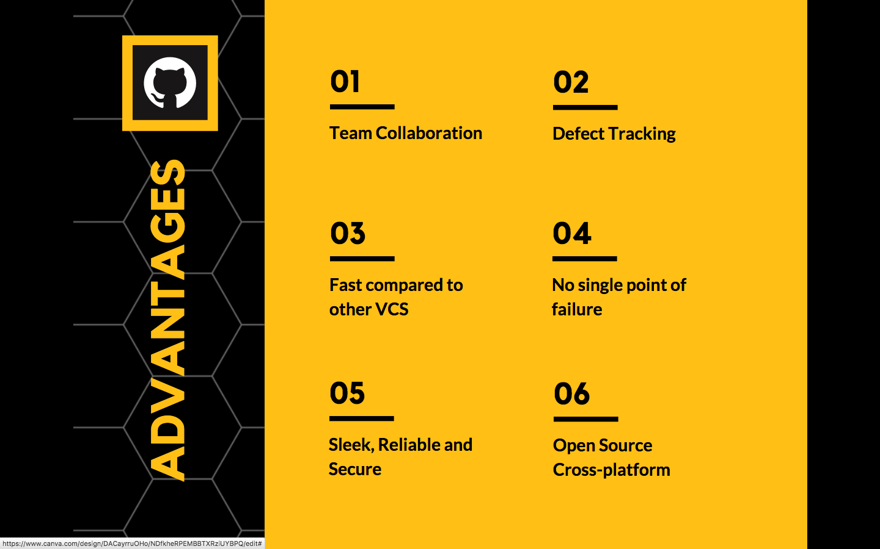

**Installing Git**

* Download Git {git website - Windows}

**To check if git is available or not use:**

**# rpm -qa | grep git**

**# sudo yum install git**

**# git --version**

**Setting the Configuration**

**=======================**

**# git config --global** [**user.name**](http://user.name) **“Ravi Krishna”**

**# git config --global user.email “info@gmail.com”**

# **git config --list**

**What is the need of git config**

**===========================**

When we setup git and before adding bunch of files, We need to fill up username & email and it’s basically git way of creating an account.

**Working With GIT**

* The purpose of Git is to manage a project, or a set of files, as they change over time. Git stores this information in a data structure called a repository.

* Let's create a directory and turn it into a repository
  + mkdir website
  + Initialize the repository
  + Make Changes i.e add files
  + Stage the files
  + Commit the changes

**Git Workflow**

* You modify files in working directory

* You stage files, adding snapshots of them to your staging area.

* You do a commit, which takes the files as they are in the staging area and stores that snapshot to your git repository.

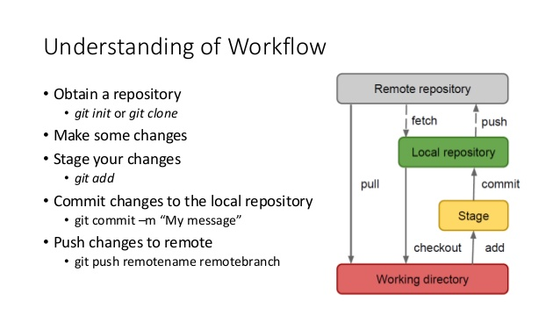

# **mkdir website**

# git init { initialize a repository }

# git status                   {By default master branch is set}

# vi index.html

{put some tags <html><title><h1><body> just structure}

# git status

# git add index.html            {staged the changes}

# git commit -m “Message”    {Commited from staging area to local repo}

# git status

Make multiple commits by creating new files and changes

**Commit History**

* To see what commits have been done so far we use a command:
  + git log, gives commit history basically commit number, author info, date and commit msg

* Commit ID is a sha1 value randomly generated which is a 40 character hexadecimal number which will be unique.

* Want to see what happend at this commit, zoom in info:
  + git show <commit number>

* Make few more changes and then commit the changes,Now check the log again:
  + git log --since YYYY-MM-DD
  + git log --author ravi
  + git log --grep index
  + git log --oneline

**Git Branching**

* In a collaborative environment, it is common for several developers to share and work on the same source code. Some developers will be fixing bugs while others would be implementing new features. Therefore, there has got to be a manageable way to maintain different versions of the same code base.

* This is where the branch function comes to the rescue. Branch allows each developer to branch out from the original code base and isolate their work from others. Another good thing about branch is that it helps Git to easily merge the versions later on.

* It is a common practice to create a new branch for each task
  + (eg. bug fixing, new features etc.)

* Branching means you diverge from the main line(master - working copy of application) of development and continue to do work without messing with that main line.

* Basically, you have your master branch and you don't want to mess anything up on that branch.

* In many VCS tools, branching is an expensive process, often requiring you to create a new copy of your source code directory, which can take a long time for large projects.

* Some people refer to Git branching model as its “killer feature” and it certainly sets Git apart in the VCS community.

* Why is it so special?
  + The way Git branches is incredibly lightweight, making branching operations nearly instantaneous, and switching back and forth between branches generally just as fast.

**Branching How it works**

When we make commits, this is how git stores them.

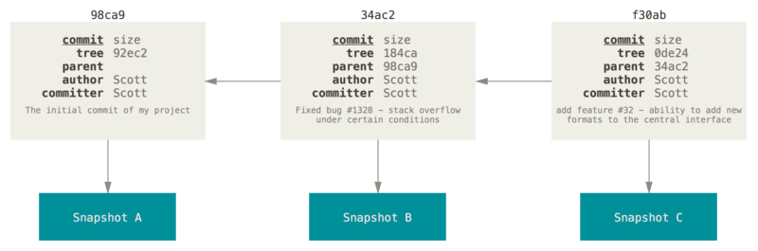

* A branch in Git is simply a lightweight movable pointer to one of these commits.

* The default branch name in Git is master.

* As you start making commits, you’re given a master branch that points to the last commit you made. Every time you commit, it moves forward automatically.

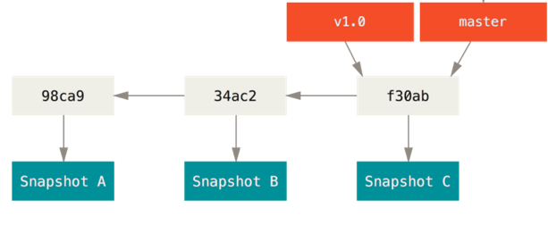

**New Branch**

* When you create a new branch, git creates a new pointer for you to move around.

* Let’s say you create a new branch called testing.
  + git branch testing

* This creates a new pointer to the same commit you’re currently on.

* Two branches are now pointing to same commit.

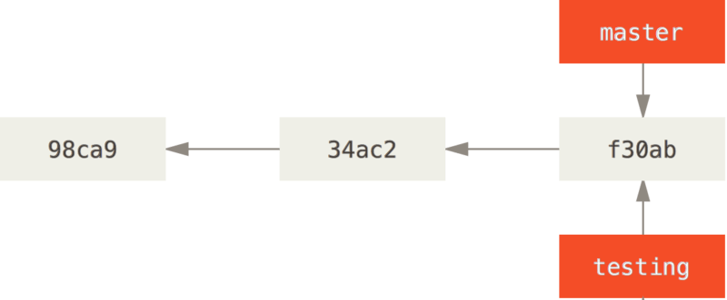

**HEAD**

* How does Git know what branch you’re currently on?

* It keeps a special pointer called HEAD

* HEAD is a pointer to the latest commit id and is always moving, not stable.
  + git show HEAD
  + In Git, head is a pointer to the branch you’re currently on i.e master. The git branch command only created a new branch but it didn’t switch to that branch. Use git branch command

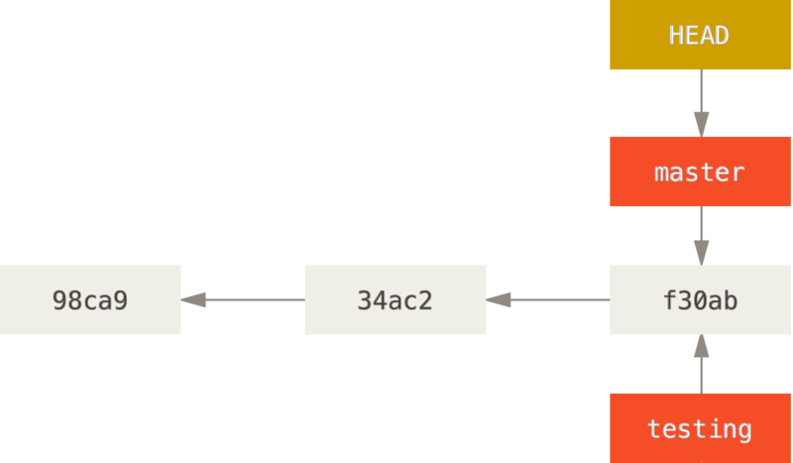

**Switching Branches**

* To switch between branches, you can use git checkout command
  + git checkout testing

* This moves HEAD to point to the testing branch

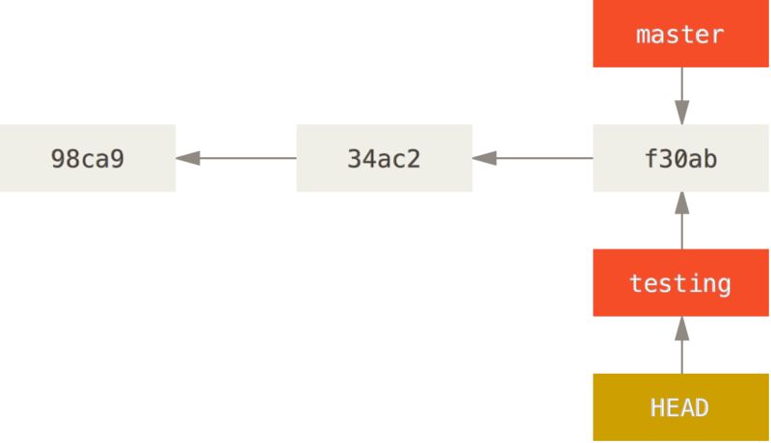

* Let's make new changes and commit

* The HEAD moves forward when a commit is made

* This is interesting, because now your testing branch has moved forward, but your master branch still points to the old commit.

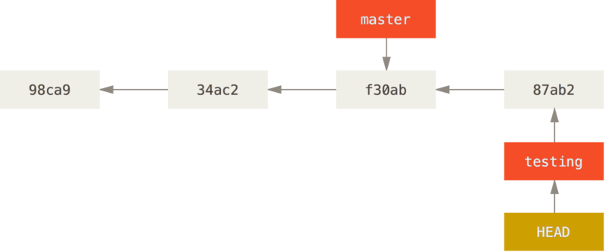

* Let’s switch back to the master branch
  + git checkout master

* HEAD moves when you checkout.

* git checkout master - it moved the HEAD pointer back to point to the master branch.

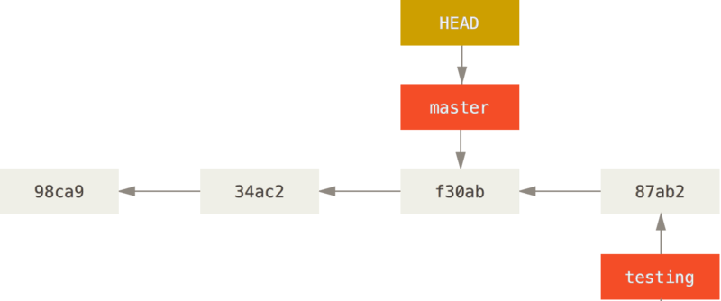

**History - Reflog**

* Let’s make a few changes and commit again in master branch

* Now your project history has diverged

* You created and switched to a branch, did some work on it, and then switched back to your main branch and did other work

* Both of those changes are isolated in separate branches, you can switch back and forth between the branches and merge them together when you’re ready

* And you did all that with simple branch, checkout and commit commands

* Divergent history, You can also see this easily with the git log command
  + git log --oneline --decorate --graph --all
  + git reflog { short logs }

**Merging**

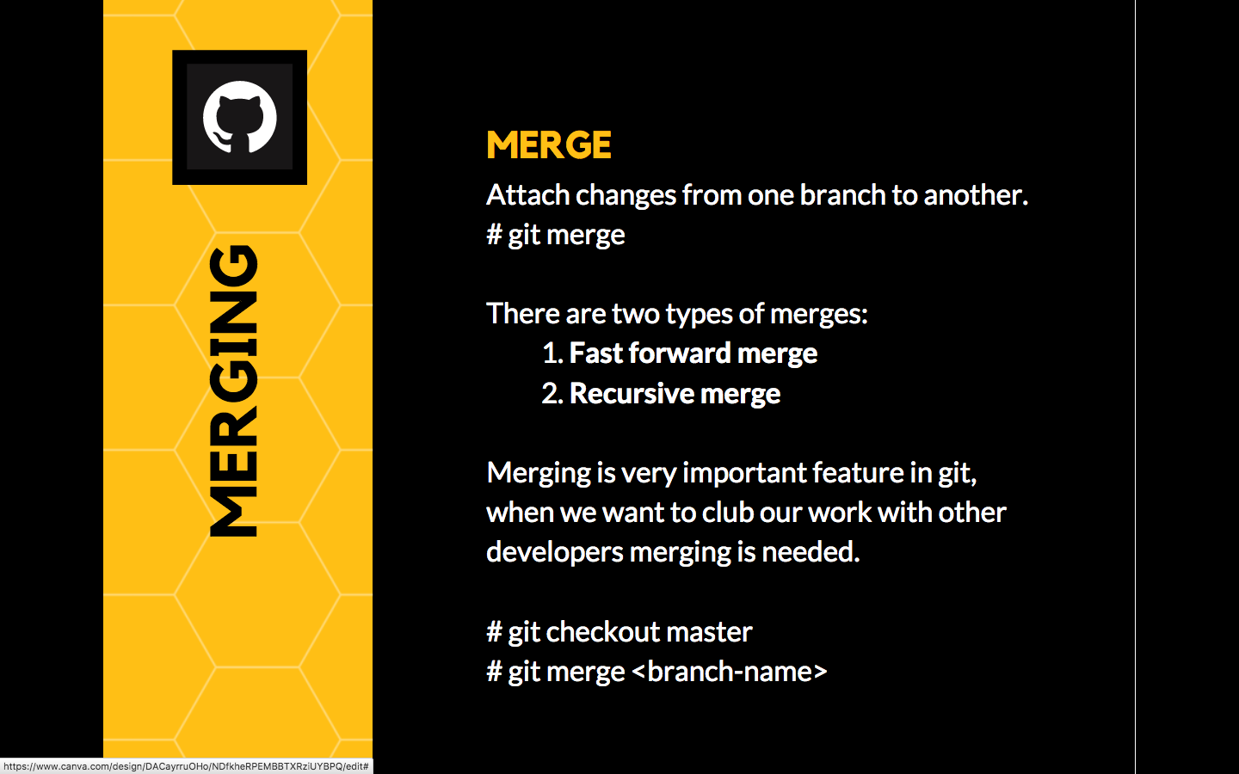

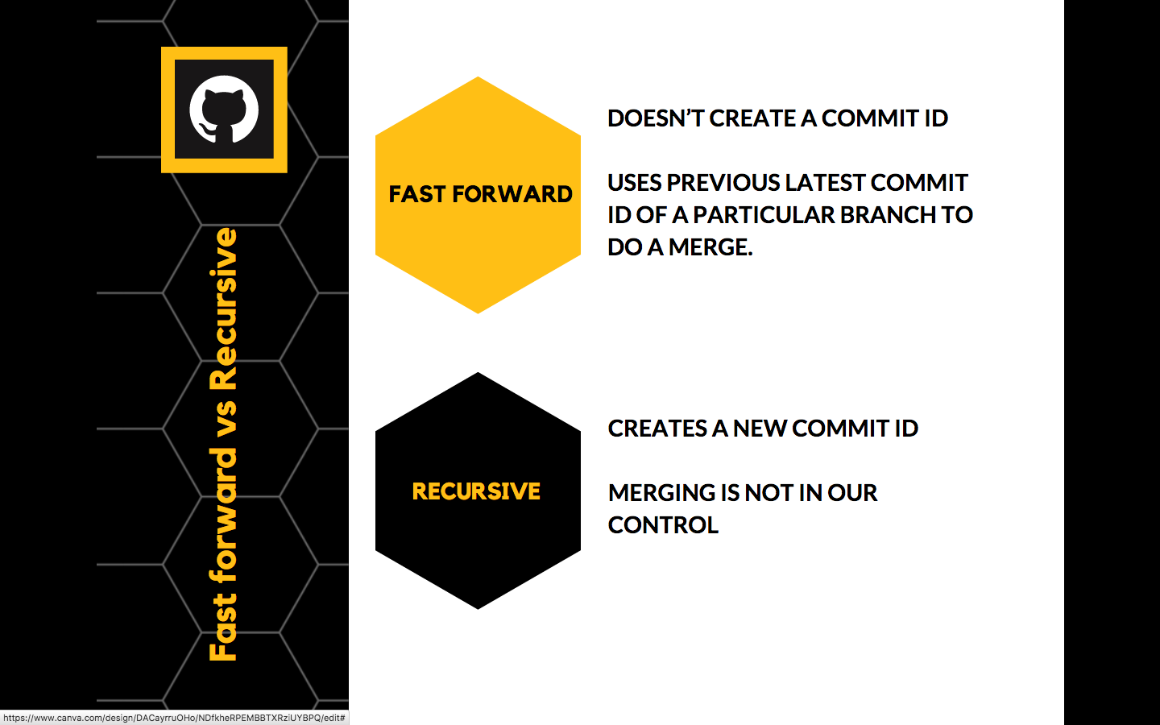

**Merge Conflict**

* A merge conflict happens when two branches both modify the same region of a file and are subsequently merged.

* Git don’t know which of the changes to keep, and thus needs human intervention to resolve the conflict.

Showing the example **R&D**, **Training** and **Consulting**.

Automatic merge failed

# On master branch

# vi services.html { Add Two Dummy services like Research & Development }

# git branch training

# git branch consulting

# git checkout training

# vi services.html { We provide training }

# git add && git commit

# git checkout master

# git merge training

# git checkout consulting

# vi services.html { We provide Consulting add in same line}

# git add && git commit

# git checkout master

# git merge consulting

Automatic merge failed

# we do get a merge conflict here, open the services.html in vi and resolve the conflicts that occurred.

# git add .

# git commit -m “Conflict resolved”

**Git Workflow commands**

<https://nvie.com/img/git-model@2x.png>

  435 mkdir ecomm

  436  cd ecomm/

  437  ls

  438  git init

  439  git status

  440  touch README.md

  441  vim README.md

  442  git addd .

  443  git add .

  444  git commit -m "updated metadata for project"

  445  git log --oneline

  446  git branch develop

  447  git checkout develop

  448  git status

  449  ls

  450  touch d1

  451  git add .

  452  git commit -m "d1"

  453  touch d2

  454  git add .

  455  git commit -m "d2"

  456  touch d3

  457  git add .

  458  git commit -m "d3"

  459  git branch f1

  460  git branch f2

  461  git branch

  462  git checkout f1

  463  ls

  464  touch nb1

  465  git add .

  466  git commit -m "nb1"

  467  touch nb2

  468  git add .

  469  git commit -m "nb2"

  470  touch nb3

  471  git add .

  472  git commit -m "nb3"

  473  ls

  474  git checkout f2

  475  touch db1

  476  git add .

  477  git commit -m "db1"

  478  touch db2

  479  git add .

  480  git commit -m "db2"

  481  git checkout master

  482  git branch hotfix

  483  git checkout hotfix

  484  ls

  485  cat README.md

  486  vim README.md

  487  git add .

  488  git commit -m "bugfix"

  489  cat README.md

  490  git checkout develop

  491  ls

  492  touch d4

  493  git add .

  494  git commit -m "d4"

  495  touch d5

  496  git add .

  497  git commit -m "d5"

  498  ls

  499  cat README.md

  500  ls

  501  git branch

  502  git merge hotfix

  503  cat README.md

  504  ls

  505  touch d6

  506  git add .

  507  git commit -m "d6"

  508  git branch

  509  git merge f1

  510  ls

  511  git branch release1.0

  512  git branch

  513  git checkout release1.0

  514  ls

  515  touch r1

  516  git add .

  517  git commit -m "r1"

  518  touch r2

  519  git add .

  520  git commit -m "r2"

  521  git checkout develop

  522  ls

  523  touch d7

  524  git add .

  525  git commit -m"d7"

  526  git branch

  527  git merge release1.0

  528  ls

  529  git checkout f1

  530  ls

  531  touch nb4

  532  git add .

  533  git commit -m "nb4"

  534  git merge develop

  535  ls

  536  touch nb5

  537  git add .

  538  git commit -m "nb5"

  539  touch nb6

  540  git add .

  541  git commit -m "nb6"

  542  git checkout f2

  543  ls

  544  touch db3

  545  git add .

  546  git commit -m "db3"

  547  touch db4

  548  git add .

  549  git commit -m "db4"

  550  git checkout release1.0

  551  ls

  552  touch r3

  553  git add .

  554  git commit -m "r3"

  555  touch r4

  556  git add .

  557  git commit -m "r4"

  558  git checkout develop

  559  ls

  560  touch d8

  561  git add .

  562  git commit -m "d8"

  563  git merge release1.0

  564  git branch

  565  ls

  566  touch d9

  567  git add .

  568  git commit -m "d9"

  569  git merge f1

  570  git merge f2

  571  git checkout release1.0

  572  ls

  573  git checkout hotfix

  574  git checkout master

  575  cat README.md

  576  git merge hotfix

  577  cat README.md

  578  git checkout master

  579  git merge release1.0

  580  ls

  581  git checkout release1.0

  582  git merge develop

  583  ls

  584  git checkout release1.0

  585  ls

  586  touch r5

  587  git add .

  588  git commit -m "r5"

  589  git checkout master

  590  git merge release1.0

  591  ls

  592  git reflog

  593  git log --decorate --oneline --graph

**Assignment**

[Link](https://drive.google.com/open?id=1nOx_H7gtHS29cLjzd3gTYf_zk7kFXGAG)

**Git Ignore**

* It’s a list of files you want git to ignore in your working directory

* It's usually used to avoid committing transient files from your working directory that aren't useful to other collaborators such as temp files IDE creates, Compilation files, OS files etc

* A file should be ignored if any of the following is true:
* The file is not used by your project
* The file is not used by anyone else in your team
* The file is generated by another process

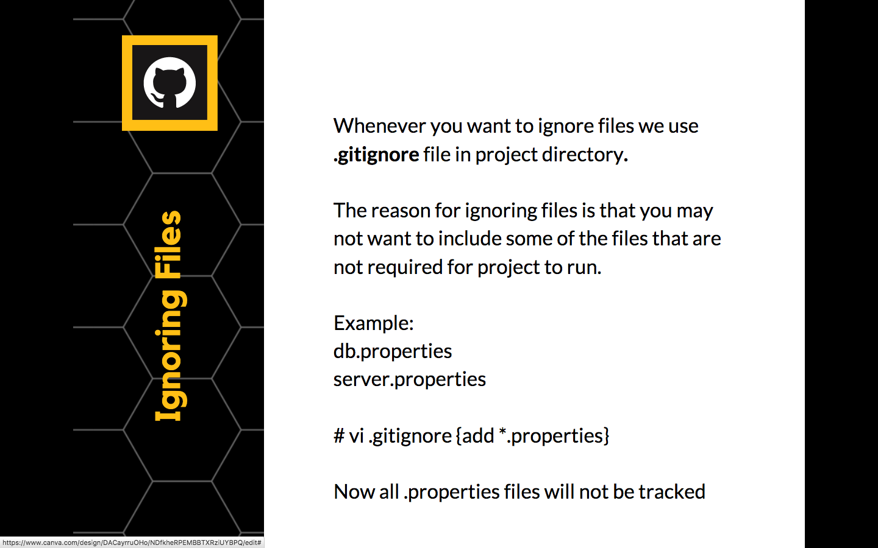

<https://www.gitignore.io/>

If you want some files to be ignored by git create a file **.gitignore**

*.class

# Ignore all php files

*.php

# but not index.php

!index.php

# Ignore all text files that start with aeiou

[aeiou]*.txt

**Assignment**

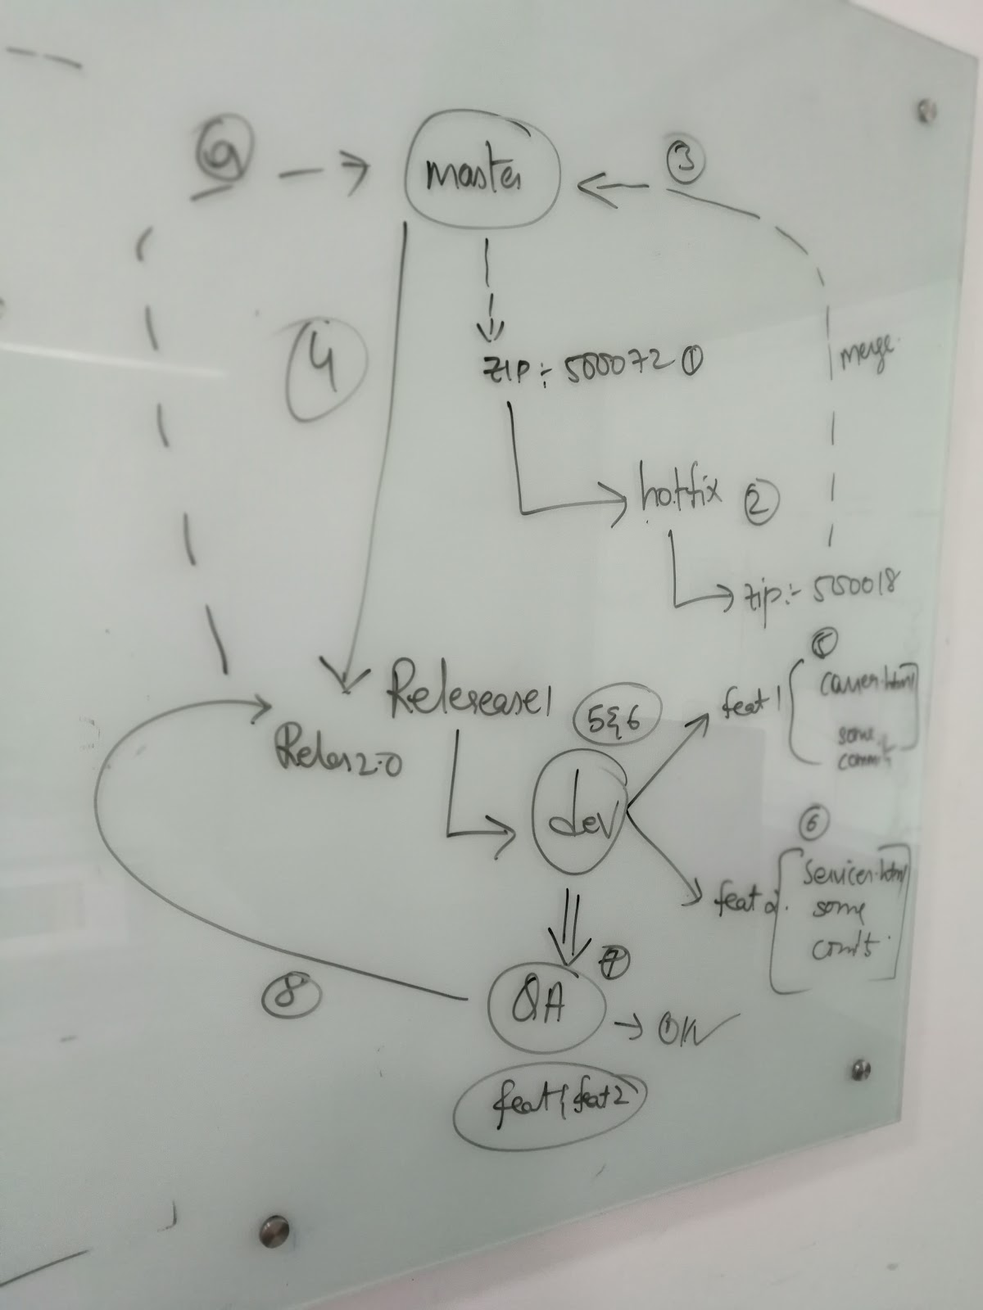

* Initialize a git repo with name assignment
* Create a page contact.html with content ZIP:500072
* Now, actually the supposed zip is ZIP:500018
  + How to name the new branch
* Now in the new branch fix the bug with zip as ZIP:500018
* From here implement a new branch : release 1.0
* From release 1.0 create a new branch dev which has sub branches feat1 & feat2
* Feat1 branch has a file carrer.html
* Feat2 branch has a file services.html
* Now this release 1.0 should have all the features i.e feat1 & feat2
* Now create a new branch qa which has bug fixes and also feat1 & feat2 along with a file test_success
* Now all these changes should be along with test_success in release 1.0
* Now merge release 1.0 with mainline

**Tagging**

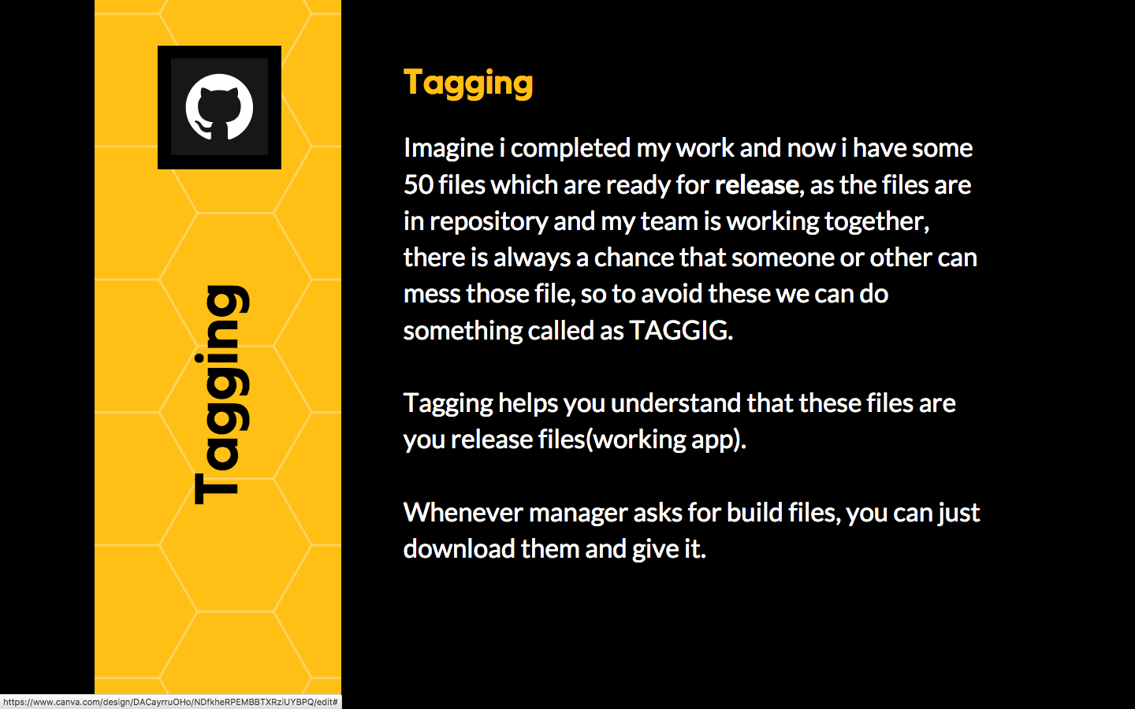

* You can tag till a particular commit id, imagine all the files till now are my working copies:
  + git tag 1.0 -m “release-1.0” <commit_id>
  + git push --tags

* Goto GitHub and see release click on it, you can download all the files till that commit.

* TAGGING helps you in release management.

**Detached Head**

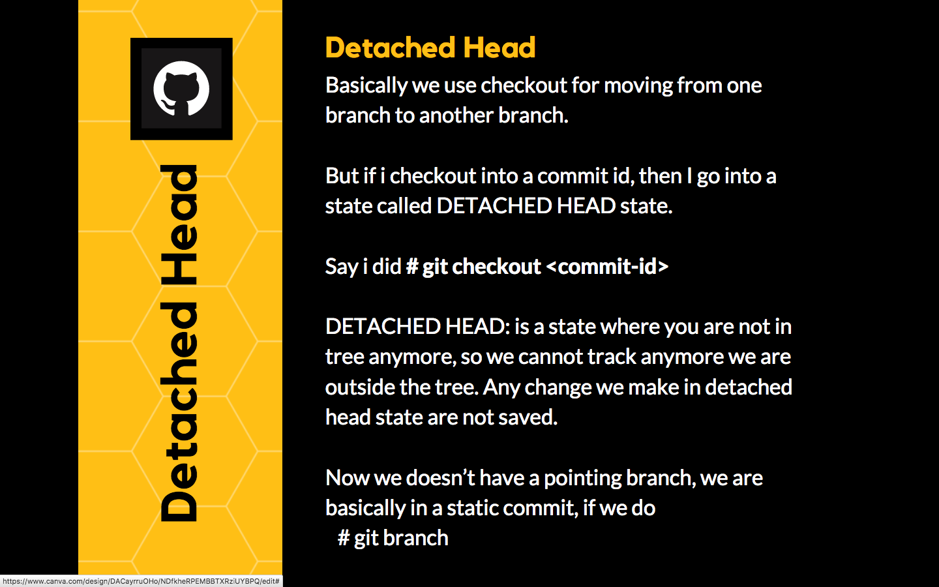

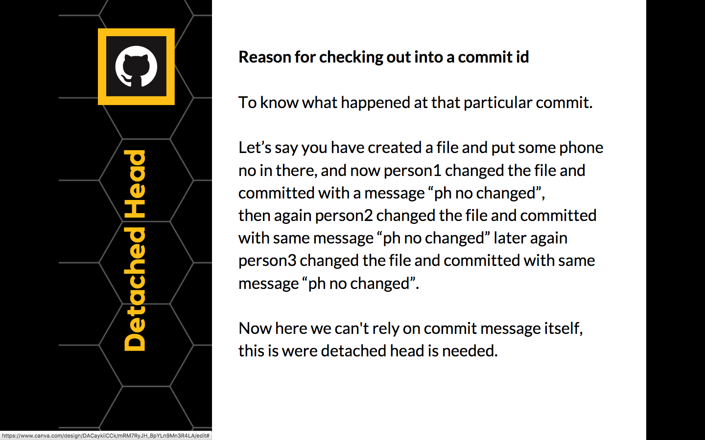

**Undo Changes**

* Made changes but didn’t stage them and commit, use -- checkout
  + Manual undo
  + git checkout -- <file>

* Made changes but staged the changes, use reset
  + git reset HEAD <file>

* Made changes, staged the changes and commited changes
  + git revert <commit>

**Github**

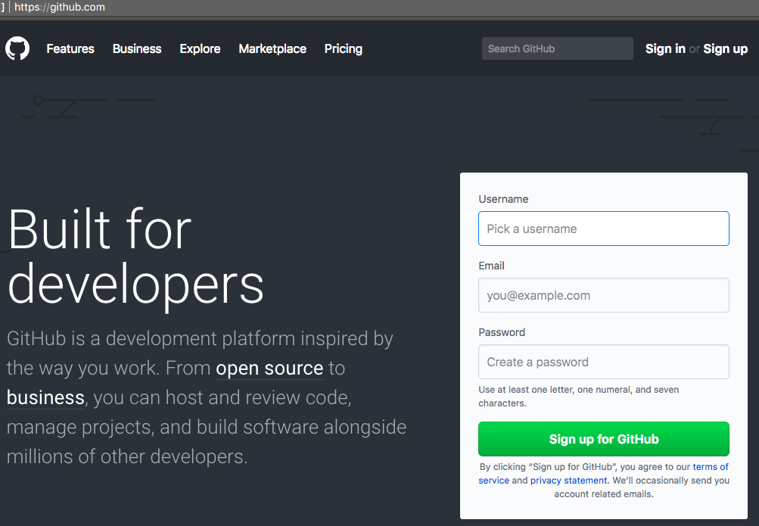

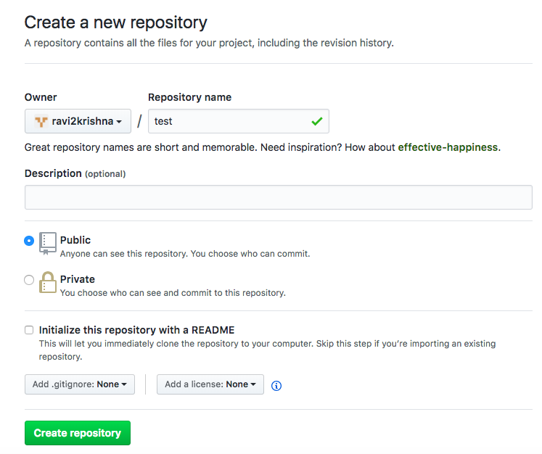

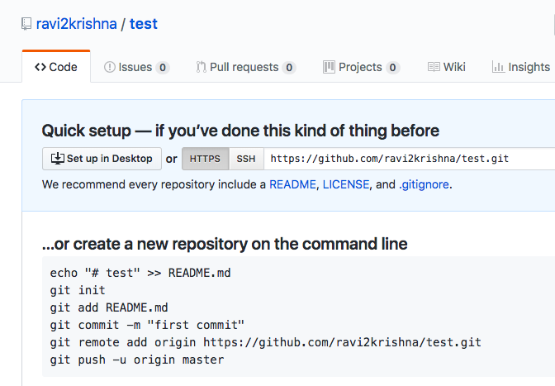

BUILD TOOLS

A VCS plays a vital role in any kind of organization, the entire software industry is built around code.

What are we doing with this code ??

* Are we seeing the code when we open the application ?? NO
* Are we seeing the code when we open the app in browser ?? NO

So we are seeing the executable format of the code, **that is called build result of the code**.

**What is Build**

* A 'Build' is an attempt to compile all of the source code for the project into a set of executable binaries, that in turn get packaged into a final product.

OR

* The term build may refer to the process by which source code is converted into a stand-alone form that can be run on a computer.

* Simply, Compiled and packaged source code ready to be shipped

* Builds are created when a certain point in development has been reached or the code has been ready for implementation, either for testing or outright release.

**What Does Build Consists of ?**

* A build consists of getting all the required source files from the revision control system, translate(compile) them and link the resulting files together into the program, that is the end product.

* This program is then run through a set of tests and if it passes, then versions of the source files that, it is made from are deemed good, i.e., these are now our common base for further development.

* Occasionally one of us commits a change that causes the program not to pass the set of tests or maybe not even translate. That is called "breaking the build".

The process of building software is usually managed by a build tool in our case it's MAVEN

**Build Tools History**

* In the beginning there was Make as the only build tool available. It came in 1976.

* Make - In software development, Make is a build tool that builds executable programs from source code by reading files called Makefile which specify how to derive the target program.

* However, since then our needs increased and, as a result, build tools evolved

* Ant was the first among “modern” build tools followed by Maven and Gradle

**Make**

* Here is a simple makefile that describes the way an executable file called edit depends on four object files which, in turn, depend on four C source and two header files. To be concrete, edit is a target, main.o, kbd.o, command.o and display.o are its dependencies, and cc -o edit main.o kbd.o command.o display.o is a system command.

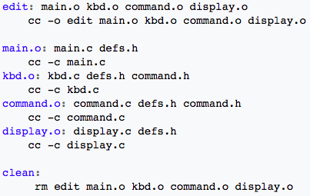

* To use this makefile to create the executable file called edit, we use command make

ANT

* Ant was the first among “modern” build tools which came in early 2000 from Apache Software Foundation

* It is similar to Make but is implemented using the Java language, requires the Java platform, and is best suited to building Java projects.

* The most immediately noticeable difference between Ant and Make is that Ant uses XML to describe the code build process and its dependencies, whereas Make uses the Makefile format.

* By default, the XML file is named build.xml and we need to create it from scratch

**build.xml**

* Below is listed a sample build.xml file for a simple Java "Hello, world" application. It defines four targets - clean, clobber, compile and jar , each of which has an associated description. The jar target lists the compile target as a dependency. This tells Ant that before it can start the jar target it must first complete the compile target.

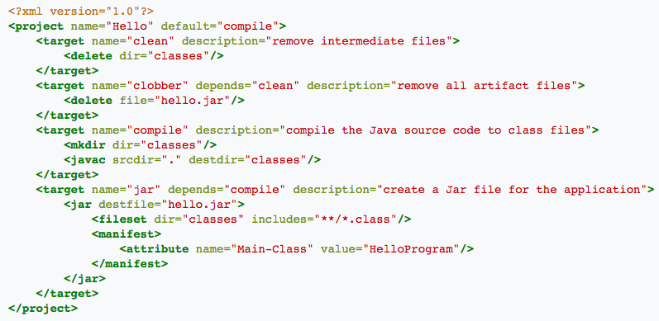

**ANT - Disadvantages**

* ANT - Ant scripts need to be written for building [ build.xml ]

* ANT - There is no dependency management

* ANT - No project structure is defined [ need to tell src & classes ]

**Setting Up ANT**

* As Ant is dependent on Java We need to setup Java first then followed by Ant
  + sudo yum -y install java-1.8.0 java-1.8.0-devel
  + java & javac
  + sudo yum -y install ant
  + ant
  + mkdir proj1
  + cd proj1
  + touch build.xml
  + mkdir src
  + touch src/HelloWorld.java

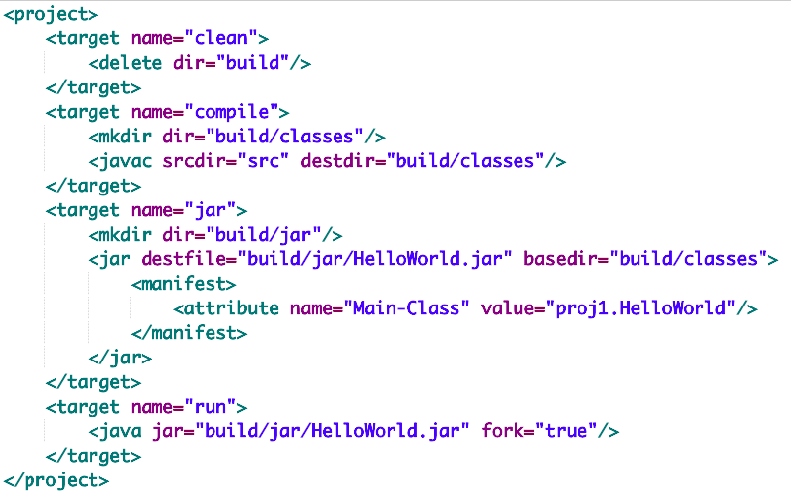

**# vi build.xml**

**<project>  
  
<target name="compile">  
<mkdir dir="build/classes"/>  
<javac srcdir="src" destdir="build/classes"/>  
</target>  
  
<target name="jar">  
<mkdir dir="build/jar"/>  
<jar destfile="build/jar/HelloWorld.jar" basedir="build/classes">  
<manifest>  
<attribute name="Main-Class" value="proj1.HelloWorld"/>  
</manifest>  
</jar>  
</target>  
  
<target name="run">  
<java jar="build/jar/HelloWorld.jar" fork="true"/>  
</target>**

**<target name="clean">  
<delete dir="build"/>  
</target>  
  
  
</project>**

**Setting Up Application Using ANT**

# vim src/HelloWorld.java

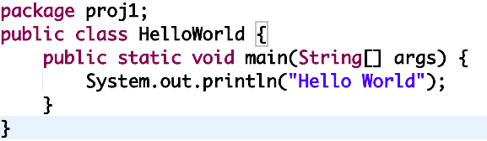

package proj1;

public class **HelloWorld** {  
  
    public static void **main**(String[] args) {  
        *// Prints "Hello World" to the terminal window.*  
        System.out.**println**("Hello World");  
    }  
  
}

* **ant compile**
* **ant jar**
* **ant run**

**Running Test Cases**

* Whenever we want to test the unit cases we need a unit testing framework like Junit

* Now Junit required libraries are present in Junit Site
  + <https://github.com/junit-team/junit4/wiki/Download-and-Install>
  + Now we need to Download the dependencies
    1. <https://github.com/junit-team/junit4/wiki/Getting-started-%E2%80%93-Ant>
  + Create the required directory structure
    1. Create a new folder junit-example and a sub-folder lib
  + Update the same in build.xml
    1. <https://github.com/junit-team/junit4/wiki/Getting-started-%E2%80%93-Ant>

* Then start building the application which is tedious task, this is where Maven Shines!!!

**ANT - Disadvantages**

* ANT - Ant scripts need to be written for building [ build.xml ]

* ANT - There is no dependency management

* ANT - No project structure is defined [ need to tell src & classes ]

All the Above problems were solved with Maven

**Comparison**

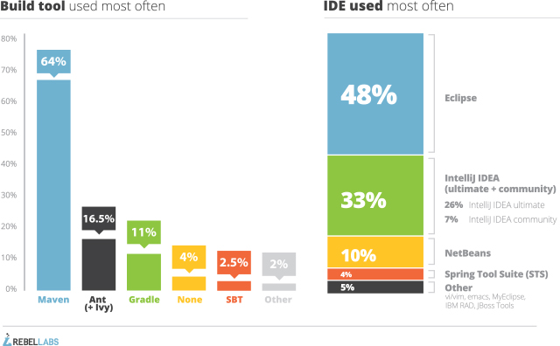

MAVEN

* Like Ant, Maven is a build automation tool from Apache Software Foundation

* Maven was introduced to address the problems that were present with ANT

* Maven addresses two aspects of building software:
  + first, it describes how software is built
  + second, it describes its dependencies.

* Unlike ANT, Maven uses convention over configuration

**Convention Over Configuration**

* For instance, with Maven, if you store your source files in src/main/java and your tests in src/test/java and then just build it, using a very minimal build script(pom.xml), it just knows to compile everything, run the unit tests, and produce a jar of the compiled classes (from src/main/java).

* With Ant, you have to tell it specifically where all of your source is, exactly what tasks are in play, and how to package everything up.

* The point is, Maven assumes reasonable conventions and defaults, and just do it, without you having to specify it.

**Maven Objectives**

* Maven’s primary goal is to allow a Developer to comprehend the complete state of a development effort in the shortest period of time. In order to attain this goal there are several areas of concern that Maven attempts to deal with:
  + Making the build process easy - Simple project setup that follows best practices - get a new project started in seconds
  + Providing a uniform build system -  Consistent usage across all projects - means no ramp up time for new developers coming onto a project
  + Superior dependency management - Transitive Dependency support
  + Providing quality project information - Dependency List, Unit Test Reports etc
  + A large and growing repository(maven central) of libraries and metadata to use out of the box
  + Instant access to new features with little extra configuration
  + Easy plugin management
  + Release management and distribution publication

**Maven Advantages**

* No script is required for building application
  + [ automatically generated - pom.xml ]

* Dependencies are automatically downloaded

* Project structure is generated by maven

* Maven is called as project management tool because apart from above, it can also
  + Generate project documentation
  + Wide Support of Plugins
  + Deploy the Applications

**Maven Central**

* Initially in any kind of a build, whenever a dependency is needed, if i’m using ANT i have to download the dependency then keep it in a place where ANT can understood.

* If i’m not giving the dependency manually my build will fail due to dependency issues.

* Maven handles dependency in a beautiful manner, there is place called [MAVEN CENTRAL](https://repo.maven.apache.org/maven2/) which  is a centralized location where all the dependencies are stored over internet.

* Let say i'm building a project and Junit is dependency for the project, whenever my build reaches a phase where it needs junit then maven will download the dependencies automatically and it will store those dependencies in Local Repository.

**Repository Types**

* [Maven Central Repository](https://repo.maven.apache.org/maven2/)
  + Centralized location where all the dependencies are stored over internet
  + [Maven Stats](http://search.maven.org/#stats)

* Local Repository
  + The maven local repository is a local folder that is used to store all your project’s dependencies . In simple, when you build a project, all dependency files will be stored in your Maven local repository.
  + Stored in local machine i.e /home/user/.m2
  + Saves bandwidth

* Remote Repository
  + Sonatype Nexus

**Maven Dependency Search**

Basically, when maven starts executing the build commands, maven starts for searching the dependencies as follows :

* It scans through the local repositories for all the configured dependencies. If found, then it continues with the further execution. If the configured dependencies are not found in the local repository, then it scans through the central repository.

* If the specified dependencies are found in the central repository, then those dependencies are downloaded to the local repository for the future reference and usage. If not found, then maven starts scanning into the remote repositories.

* If no remote repository has been configured, then maven will throw an exception saying not able to find the dependencies & stops processing. If found, then those dependencies are downloaded to the local repository for the future reference and usage.

**Plugins**

* "Maven" is really just a core framework for a collection of Maven Plugins.

* In other words, plugins are where much of the real action is performed, plugins are used to:
  + Compile code
  + Run unit test code
  + Create project documentation
  + Create jar files
  + Create war files and on and on.

* Maven is - at its heart - a plugin execution framework, all work is done by plugins.

* Almost any action that you can think of performing on a project is implemented as a Maven plugin.

**Transitive Dependency**

* Project-a depends on Project-b, which in turn depends on Project-c, then Project-c is considered a transitive dependency of Project-a.
  + Project-a → Project-b → Project-c

* Part of Maven’s appeal is that it can manage transitive dependencies and shield the developer from having to keep track of all of the dependencies required to compile and run an application.

* There are two types of Maven dependencies:
* Direct: These are dependencies defined in your pom.xml file under the <dependencies/>section.
* Transitive: These are dependencies that are dependencies of your direct dependencies.

* Take the [Junit 4.12](http://search.maven.org/remotecontent?filepath=junit/junit/4.12/junit-4.12.pom) as [example](http://search.maven.org/#search%7Cgav%7C1%7Cg:%22junit%22%20AND%20a:%22junit%22) and demonstrate the Transitive Dependency

**POM**

* A Project Object Model or POM is the fundamental unit of work in Maven. It is an XML file that contains information about the project and configuration details used by Maven to build the project.

* It contains default values for most projects. Examples for this is the
  + build directory, which is target
  + the source directory, which is src/main/java
  + the test source directory, which is src/test/java and so on

* Some of the configuration that can be specified in the POM are the project version, project dependencies, the plugins or goals that can be executed, the build profiles, and so on.

* Before creating a POM, we should first decide the project group (groupId), its name (artifactId) and its version as these attributes(GAV) help in uniquely identifying the project in repository.

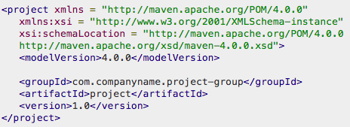

* Before creating a POM, we should first decide the project group (groupId), its name (artifactId) and its version as these attributes(GAV) help in uniquely identifying the project in repository.

* These three values form the project's fully qualified artifact name. This is in the form of <groupId>:<artifactId>:<version>.

* This is a very simple POM but still displays the key elements every POM contains, so let's walk through each of them

**POM Elements**

* project : This is project root tag. You need to specify the basic schema settings such per apache schema

* modelVersion :  indicates what version of the object model this POM is using, It's always set to 4.0.0 in Maven, at present, there is no other model.

* groupId : indicates the unique identifier of the organization, is typically based on the fully qualified domain name of your organization. For Ex: com.digital.proj1

* artifactId : indicates the unique base name of the primary artifact being generated by this project. A typical artifact produced by Maven would have the form <artifactId>-<version>.<extension> i.e project-1.0.jar

* packaging : indicates the package type to be used by this artifact (e.g. JAR, WAR)

* version : indicates the version of the artifact generated by the project

**Build Lifecycle**

* Maven is based around the central concept of a build lifecycle. What this means is that the process for building and distributing a particular artifact (project) is clearly defined.

* For the person building a project, this means that it is only necessary to learn a small set of commands to build any Maven project, and the POM will ensure they get the results they desired.

* There are three built-in build lifecycles: default, clean and site
  + **default** : lifecycle handles your project deployment
  + **clean** : lifecycle handles project cleaning
  + **site** : lifecycle handles the creation of your project's site documentation

**Lifecycle Phases**

* Each of these build lifecycles is defined by a different list of build phases, wherein a build phase represents a stage in the life cycle.

* For example, the default lifecycle comprises of the following phases
  + **validate** - validate the project is correct and all necessary information is available
  + **compile** - compile the source code of the project
  + **test** - test the compiled source code using a suitable unit testing framework. These tests should not require the code be packaged or deployed
  + **package** - take the compiled code and package it in its distributable format, such as a JAR.
  + **verify** - run any checks on results of integration tests to ensure quality criteria are met
  + **install** - install the package into the local repository, for use as a dependency in other projects locally
  + **deploy** - done in the build environment, copies the final package to the remote repository for sharing with other developers and projects.

**Archetype**

* Archetype is a Maven project templating toolkit.

* Using archetypes provides a great way to enable developers quickly in a way consistent with best practices employed by your project

* We use archetypes to try and get our users up and running as quickly as possible by providing a sample project that demonstrates many of the features of Maven, while introducing new users to the best practices employed by Maven.

* In a matter of seconds, a new user can have a working Maven project to use as a jumping board for investigating more of the features in Maven.
  + To create a new project - mvn archetype:generate

**Setting Up Maven**

* Maven needs Java, So we need to setup Java first then followed by Maven
  + yum -y install java-1.8.0 java-1.8.0-devel
  + java & javac
  + yum -y install maven
  + mvn --version

* mvn archetype:generate - to generate project templates

* Generate Stand Alone Application
* mvn archetype:generate

**Project Setup**

* The Project is generated and we can invoke the phases
  + cd JavaApp
  + We can see the Application Generated along with pom.xml source
  + View pom.xml
    - vim pom.xml

**Generate Stand Alone Application**

* mvn archetype:generate { Provide Groupid - Artifactid - Version }
* cd JavaApp
* tree
* mvn validate
* mvn compile
* mvn test { discuss dependency management with junit 4.12}
* mvn package
* java -cp target/xxxx.jar com.digi.proj1.App

**Plugins**

* We saw maven is only performing phases like validate, compile, test, package, install, deploy

* Can you see any of the phases running jar file, no right ??

* So any additional functionality we need is going to be resolved with plugins, now maven needs to execute jar file which is done by exec-maven-plugin

**Setup Web Application**

* Generate Web Application
  + mvn archetype:generate | grep maven-archetype-webapp
  + cd WebApp
  + tree
  + mvn package
  + Copy the generated war to webapps directory of tomcat
  + Browse the App Manager of Tomcat

**Apache Tomcat**

* Apache Tomcat is an application server from the Apache Software Foundation that executes Java servlets and renders Web pages that include Java Server Page coding.

* Apache Tomcat basically make our Java Web applications to run on host and server based system and it is configured on port 8080

* There are two files to load and stop tomcat
  + startup.sh
  + shutdown.sh

* Important configuration files
  + server.xml and tomcat-users.xml

**Installation**

* Download Tomcat
  + <https://tomcat.apache.org/download-70.cgi>

* Extract the tar
  + tar xf apache-tomcat-7.x.x.tar.gz
  + cd apache-tomcat-7.0.82/bin
  + ./startup.sh
  + Browse the app manager on<http://ip-add:8080>
  + Update the credentials in tomcat-users.xml
  + vim apache-tomcat-7.x.x/conf/tomcat-users.xml

<user username="tomcat" password="tomcat" roles="manager-gui"/>

* Stop and start the server back
* ./shutdown.sh
* Browse the app manager on<http://ip-add:8080>

**Tomcat Titbits**

* Port : 8080
* Start : bin/startup.sh
* Status : netstat -ntpl | grep 8080
* Status : ps -ef | grep tomcat
* Stop : bin/shutdown.sh
* GUI Role : manager-gui
* Text Role : manager-script

If everything goes good, you’ll will be seeing this page

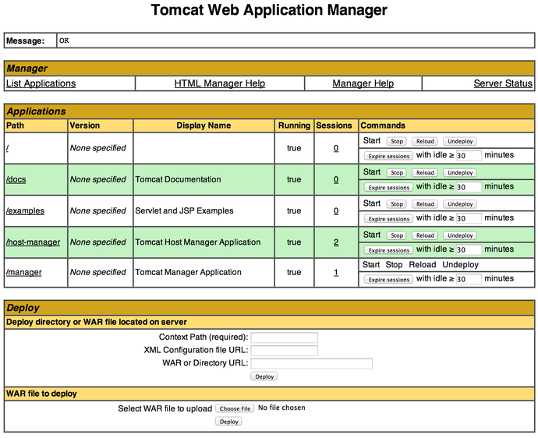

**Deploy To Tomcat using Maven**

Update pom.xml, add the following content after </dependencies>

<build>

<plugins>

<plugin>

   <groupId>org.apache.tomcat.maven</groupId>

   <artifactId>tomcat7-maven-plugin</artifactId>

   <version>2.2</version>

   <configuration>

   <url>http://ip-address:8080/manager/text</url>

   <server>TomcatServer</server>

   <path>/WebApps</path>

   </configuration>

</plugin>

</plugins>

</build>

* Provide the script manager access, change tomcat-users.xml
  + <user username="tomcat1" password="tomcat1" roles="manager-script"/>

* We Need Tomcat - Maven Authentication
  + Create settings.xml in local repository and update tomcat credentials
  + vi ~/.m2/settings.xml

<settings>

   <servers>

   <server>

   <id>TomcatServer</id>

   <username>tomcat1</username>

   <password>tomcat1</password>

   </server>

   </servers>

</settings>

To deploy the App use:

* mvn tomcat7:deploy
* mvn tomcat7:redeploy

**Build Profiles**

* So in general, what is the meaning of profile, let’s take windows as example for each user profile there would be some different settings right.

* I mean in same machine we can have different user profiles. Similarly in pom.xml, the project is same, but you can create multiple profiles, for multiple purposes.

* So for my project i want to have different profiles like dev, qa and prod env. Here the requirements are different for each and every env.

* Let’s say there 3 teams, who have different different req, now i need to create 3 projects, but instead of 3 projects, within a single project i can have 3 profiles, that’s the profile concept.

Update the same in pom.xml

</dependencies>

<profiles>

<profile>

<id>dev</id>

<build>

<plugins>

<plugin>

  <groupId>org.apache.tomcat.maven</groupId>

  <artifactId>tomcat7-maven-plugin</artifactId>

  <version>2.2</version>

  <configuration>

      <url>http://35.202.150.18:8080/manager/text</url>

      <server>TomcatServer</server>

      <path>/WebApp1</path>

  </configuration>

</plugin>

</plugins>

</build>

</profile>

* mvn tomcat7:deploy -P dev
* mvn tomcat7:redeploy -P qa

SONARQUBE

* [SonarQube](https://www.sonarqube.org/) is an open source platform developed by SonarSource for continuous inspection of Code Quality

* SonarQube offers reports on duplicated code, coding standards, unit tests, bugs and security vulnerabilities

* SonarQube provides fully automated analysis and integration with Maven and Continuous Integration tools like Jenkins

* SonarQube is a Java application that requires a Java Runtime Environment and a Database.

* Install MySQL Server
  + Download [MYSQL](http://repo.mysql.com/mysql-community-release-el7-5.noarch.rpm) RPM
  + Installs repo file → sudo rpm -ivh mysql.rpm
  + sudo yum -y install mysql-server
  + sudo systemctl start mysqld
    - Starts on port 3306
    - ps -ef | grep mysql
  + sudo mysql_secure_installation
  + sudo mysql -u root -p

**Setting Up SonarQube**

* Download SonarQube Community Edition LTS version from sonarqube downloads page
  + unzip sonarqube-6.x.zip
    - CREATE DATABASE sonar;
    - CREATE USER 'sonar' IDENTIFIED BY 'sonar';
    - GRANT ALL ON sonar.* TO 'sonar'@'localhost' IDENTIFIED BY 'sonar';
    - FLUSH PRIVILEGES;

* Change sonar configuration in sonarqube-6.x/conf/sonar.properties
  + sonar.jdbc.username=sonar
  + sonar.jdbc.password=sonar
  + uncomment sonar.jdbc.url of MySQL 5.6
  + uncomment sonar.web.host=0.0.0.0
  + uncomment sonar.web.port=9000

* Start the Sonar by ./sonarqube-6.x/bin/linux-x86-64/sonar.sh
  + cd proj-directory
  + mvn sonar:sonar
  + http://serveripaddress:9000

Now you can see the project displayed under projects section with analysis report.

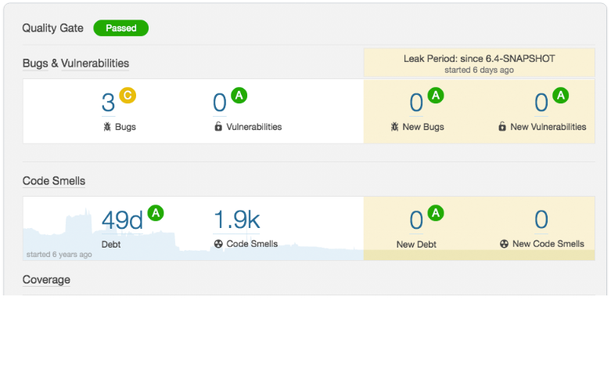

Do the Sonar Analysis for following

<https://github.com/fabric8io/fabric8-maven-plugin>

NEXUS

**Binary Repo Manager**

* A Binary repository manager is a software tool designed to optimize the download and storage of binary files used and produced in software development.

* It centralizes the management of all the binary artifacts generated and used by the organization to overcome the complexity

* A binary repository is a software repository for packages, artifacts and their corresponding metadata. It can be used to store binary files produced by an organization itself, such as product releases

* As part of the development lifecycle, source code is continuously being built into binary artifacts using Continuous Integration. This may interact with a binary repository manager much like a developer would by getting artifacts from the repositories and pushing builds there.

* The Binary repository manager we are using is [Nexus](https://www.sonatype.com/)

* Nexus manages software "artifacts" required for development. If you develop software, your builds can download dependencies from Nexus and can publish artifacts to Nexus creating a new way to share artifacts within an organization.

* While Central repository has always served as a great convenience for developers but in scenarios where you have artifacts with other developers it's tough to maintain them, this is where Nexus helps  maintaining your own repositories to ensure stability within your organization.

**Repository Types**

* [**Maven Central Repository**](https://repo.maven.apache.org/maven2/)
  + Centralized location where all the dependencies are stored over internet

* **Local Repository**
  + The maven local repository is a local folder that is used to store all your project’s dependencies . In simple, when you build a project, all dependency files will be stored in your Maven local repository.
  + Stored in local machine i.e /home/user/.m2

* **Remote Repository**
  + Sonatype Nexus
    1. Snapshot Repository
    2. Release Repository

* **Snapshots**
  + A snapshot is defined as an artifact with a version ending in -SNAPSHOT. They capture a work in progress and are used during development.
  + When deployed, the snapshot is turned into a timestamp. By definition, snapshots are mutable.
  + This is why Nexus makes you store them separately because usually you don't care if you lose snapshots.

* **Releases**
  + These are specific, point-in-time releases. Released artifacts are considered to be solid & stable. Release will have a fixed version number.
  + By definition, releases are immutable.
  + The Central Maven repository stores release artifacts.

**Setting up Nexus**

* Nexus Repository Manager is a Java application that requires a Java Runtime Environment. When you run Nexus Repository Manager, you are running a server application with a web-based user interface. The application itself runs with the Jetty servlet container.

* Nexus Repository Manager can be downloaded from [Sonatype](https://www.sonatype.com/download-oss-sonatype). Distributions are available for the 64-bit versions for Apple OSX, Microsoft Windows and Unix/Linux. They contain all necessary resources to install and run the repository manager. You can download the archive file for your operating system of a specific release version.

* Downloaded archive is suitable for installation without a graphical user interface purely using command line-based interaction.

**Nexus Installation**

* Download the [Nexus 2.X OSS](https://help.sonatype.com/repomanager2/download#Download-NexusRepositoryManager2OSS)  from nexus download page

* Once the archive is downloaded extract it
  + tar xf nexus-2.x.x.tar.gz
  + The bin folder contains the generic startup scripts for Unix-like platforms called nexus
  + ./nexus start
  + Once the repository manager is started, By default port 8081 is used. To access the web application user interface, fire up a web browser and type in the URL http://serveripaddress:port/nexus
  + netstat -ntpl | grep 8081
  + ps -ef | grep nexus
  + The repository manager installation includes an administrative user with full access. Its username is admin and the password is admin123

**Creating Repositories**

* Snapshots
  + Login to the nexus server
  + Click Repositories → Add → Hosted Repo → Repo Id: snapshotRepo → Repo Name: snapshotRepo → Repo Policy: Snapshot → Deployment Policy: Allow Redeploy → Save

* Releases
  + Click Repositories → Add → Hosted Repo → Repo Id: releaseRepo → Repo Name: releaseRepo → Repo Policy: Release → Deployment Policy: Disable Redeploy → Save
  + To publish the artifacts you can use:
    1. **mvn deploy**
  + You will get an error, fix the error by adding <distributionManagement> element in pom

Change the pom.xml file to get # mvn deploy working

</dependencies>

<distributionManagement>

<repository>

<id>releaseRepo</id>

<name>releaseRepo</name>

<url>http://192.168.56.101:8081/nexus/content/repositories/releaseRepo/</url>

</repository>

<snapshotRepository>

<id>snapshotRepo</id>

<name>snapshotRepo</name>

<url>http://192.168.56.101:8081/nexus/content/repositories/snapshotRepo/</url>

</snapshotRepository>

</distributionManagement>

**Publish Artifacts**

* To publish the artifacts you can use:
  + **mvn deploy**

* You will get unauthorized error, fix the error by adding settings.xml file in local repo
  + vim ~/.m2/settings.xml

<settings>

<servers>  
    <server>  
      <id>releaseRepo</id>  
      <username>admin</username>  
      <password>admin123</password>  
</server>

<servers>  
    <server>  
      <id>snapshotRepo</id>  
      <username>admin</username>  
      <password>admin123</password>  
</server>

</settings>

Assignment

* Create a git repository(project) with name **Calculator** and update the following code in master branch {mkdir Calculator ---> git init ---> cd Calculator}
  + vi pom.xml

<project xmlns="http://maven.apache.org/POM/4.0.0" xmlns:xsi="http://www.w3.org/2001/XMLSchema-instance"

  xsi:schemaLocation="http://maven.apache.org/POM/4.0.0 http://maven.apache.org/xsd/maven-4.0.0.xsd">

  <modelVersion>4.0.0</modelVersion>

  <groupId>com.ravi.cal</groupId>

  <artifactId>RaviCalculator</artifactId>

  <version>1.0.1-SNAPSHOT</version>

  <packaging>jar</packaging>

  <name>RaviCalculator</name>

  <url>http://maven.apache.org</url>

  <properties>

    <project.build.sourceEncoding>UTF-8</project.build.sourceEncoding>

  </properties>

  <dependencies>

    <dependency>

      <groupId>junit</groupId>

      <artifactId>junit</artifactId>

      <version>4.8.2</version>

      <scope>test</scope>

    </dependency>

  </dependencies>

</project>

* Create the following project directory structure to update the source code
  + mkdir src
  + mkdir src/main
  + mkdir src/test
  + mkdir -p src/main/java/com/ravi/cal/RaviCalculator
  + mkdir -p src/test/java/com/ravi/cal/RaviCalculator
* Create the Calculator.java which contains source for the application
  + vi src/main/java/com/ravi/cal/RaviCalculator/Calculator.java

package com.ravi.cal.RaviCalculator;

import java.util.Scanner;

public class Calculator  {

private long first;

private long second;

public long getFirst() {

return first;

}

public void setFirst(long first) {

this.first = first;

}

public long getSecond() {

return second;

}

public void setSecond(long second) {

this.second = second;

}

public long addFucn(long first, long second){

return first+second;

}

public long subFucn(long first, long second){

return second-first;

}

public long mulFucn(long first, long second){

return first/second;

}

}

**commit the code with message “implemented calculator”**

* Create the CalculatorTest.java which contains test cases for the application
  + vi src/test/java/com/ravi/cal/RaviCalculator/CalculatorTest.java

package com.ravi.cal.RaviCalculator;

import org.junit.Test;

import static org.hamcrest.CoreMatchers.is;

import static org.junit.Assert.assertThat;

public class CalculatorTest {

    @Test

    public void twoAndThreeIsFive() throws Exception {

        final long result = new Calculator().addFucn(2, 3);

        assertThat(result, is(5L));

    }

    @Test

    public void threeMinusTwoIsOne() throws Exception {

        final long result = new Calculator().subFucn(2, 3);

        assertThat(result, is(1L));

    }

    @Test

    public void threeXThreeIsNine() throws Exception {

        final long result = new Calculator().mulFucn(3, 3);

        assertThat(result, is(9L));

    }

}

**commit the code with message “implemented test cases”**

# Now run the test cases using maven and see the result  {mvn test}

As you can see there is a bug in mulFucn in Calculator.java

* vi src/main/java/com/ravi/cal/RaviCalculator/Calculator.java
* Search for mulFucn
* /mulFunc

return first/second;

It should be return first*second;

* Now create a **hotfix** branch and update mulFucn to return first*second;
  + vi src/main/java/com/ravi/cal/RaviCalculator/Calculator.java

package com.ravi.cal.RaviCalculator;

import java.util.Scanner;

public class Calculator  {

private long first;

private long second;

public long getFirst() {

return first;

}

public void setFirst(long first) {

this.first = first;

}

public long getSecond() {

return second;

}

public void setSecond(long second) {

this.second = second;

}

public long addFucn(long first, long second){

return first+second;

}

public long subFucn(long first, long second){

return second-first;

}

public long mulFucn(long first, long second){

**return first*second;**

}

}

# commit the code with message “product bug fixed”

**# Update the Bug Fix to master branch**

* Now create another branch **dev** which should have bug free code, so implement the following code which is free from bugs:
  + vi src/main/java/com/ravi/cal/RaviCalculator/Calculator.java

package com.ravi.cal.RaviCalculator;

import java.util.Scanner;

public class Calculator  {

private long first;

private long second;

public long getFirst() {

return first;

}

public void setFirst(long first) {

this.first = first;

}

public long getSecond() {

return second;

}

public void setSecond(long second) {

this.second = second;

}

public long addFucn(long first, long second){

return first+second;

}

public long subFucn(long first, long second){

return second-first;

}

public long mulFucn(long first, long second){

return first*second;

}

public static void main(String[] args) {

Calculator cc = new Calculator();

Scanner sc = new Scanner(System.in);

System.out.println("Enter the first numeric value ");

long first = sc.nextLong();

cc.setFirst(first);

System.out.println("Enter the second numeric value ");

long second = sc.nextLong();

cc.setSecond(second);

System.out.println("The sum of two numbers is: "+cc.addFucn(first, second));

System.out.println("The difference of two numbers is: "+cc.subFucn(first, second));

System.out.println("The multiples of two numbers is: "+cc.mulFucn(first, second));

}

}

# Now package the application {mvn package} and see if everything works out with the command:

* java -cp target/RaviCalculator-1.0.1-SNAPSHOT.jar com.ravi.cal.RaviCalculator.Calculator

Now perform sonar analysis for the same app:

* Sonarqube should be downloaded in home directory not project directory. {cd  }
* Wget URL
* Unzip file name
* Cd sonarqube x.x.x
* Cd bin
* Cd linux-x-x-x
* ./sonar.sh start
* Netstat - tulpn | grep 9000
* Ipadress of tour machine:9000
* Login in sonarqube browser
* Login:admin
* Password:admin
* Go to project directory
* Cd Calculator
* Mvn sonar:sonar

Make a release for the calculator and Store the release artifact to Nexus, no need of Snapshots.nexus should be downloaded in home directory not project directory. {cd  }

* Wget URL
* Unzip file name
* Cd nexus x.x.x
* Cd bin
* Cd linux-x-x-x
* ./nexus.sh start
* Netstat - tulpn | grep 8081
* Ipadress of your machine:8081
* Login in neus browse
* Login:admin
* Password:admin123
* Create repository and give details and save it
* Go to project directory
* Cd Calculator
* Mvn deploy
* Error {check for nexus setting up section to clear the errors}

Now push only the source code but not the intermediate files that got generated inside the target directory to your respective github accounts with remote repository  name as JavaCalculator

* Go to github
* Add repository
* Take url
* Git remote add origin URL
* Tree
* mvn clean (to clean unnecessary files, we need push only src files)
* Tree
* Git status (to check if some files are not commited, we can commit it)
* Git push --all
* Add tag to the version

* When i clone your github repo i should be able to see the working calculator

JENKINS

* [WIKIPEDIA](https://en.wikipedia.org/wiki/Jenkins_(software)) - Jenkins is an open source automation server written in Java. Jenkins helps to automate the non-human part of the software development process, with Continuous Integration and Continuous Delivery.

* [Jenkins](https://jenkins.io/doc/) - Jenkins is a self-contained, open source automation server which can be used to automate all sorts of tasks related to building, testing and delivering software.

* Now jenkins can do a lot of things in an automated fashion and if a task is repeatable and it can be done in a same way over time, jenkins can do it, not only doing it but it can automate the process

* Traditionally, development makes software available in a repository, then they give a call to operations and then operations builds and deploys that software to dev environment, once this is done, there is usually a QA team which loads and executes tests on that build and makes it ready for production.

* So what jenkins does is a lot of these are repeatable tasks, which can be automated by using the jenkins.

* Jenkins has a large number of plugins which helps in this automation process.

**Continuous Integration**

* Continuous Integration is a development practise that requires developers to integrate code into a shared repository several times per day (github).

* Continuous Integration emerged as a best practice because software developers often work in isolation, and then they need to integrate their changes with the rest of the team’s code base. Waiting days or weeks to integrate code creates many merge conflicts, hard to fix bugs

* Continuous Integration requires the development team’s code be merged to a shared version control continuously to avoid these problem

* In Continuous Integration each check-in is then verified by an automated build, allowing everyone to detect and be notified of problems with the build immediately

**Build Pipeline**

* Pipeline is an automated manifestation of your process for getting software from version control into the hands of your users.

* The pipeline should provide feedback to the team and visibility into the flow of changes to everyone involved in delivering the new features.

* There is no such thing as The Standard Pipeline, but a typical CD pipeline will include the following stages: build automation, continuous integration, test automation and deployment automation.

* Tools that are effective in automating multiple phases of these processes (like Jenkins) become more valuable in organizations where resources, time or both are at a premium.

**Jenkins Setup**

* Jenkins requires Java environment to run
  + java & javac
  + sudo yum -y install java-1.8.0
  + sudo yum -y install java-1.8.0-devel

* Now we need to add jenkins repo, to our repository list, so that we can pull down and install jenkins package.
  + sudo wget -O /etc/yum.repos.d/jenkins.repo [https://pkg.jenkins.io/redhat-stable/jenkins.repo](https://pkg.jenkins.io/redhat/jenkins.repo)
  + We will run a key so that we can trust this repo and pull down jenkins package
  + sudo rpm --import https://pkg.jenkins.io/redhat-stable/jenkins.io.key

* Now our key has been imported we can install the jenkins
  + sudo yum -y install jenkins

* Now let’s enable the service
  + sudo systemctl enable jenkins

* Now let’s start the service
  + sudo systemctl start jenkins

* Jenkins runs on port 8080
  + netstat -ntpl | grep 8080

* Access jenkins on<http://ip-address:8080>

* To unlock “Jenkins”, you will need the administrator password, using the below code on “Terminal” to figure it.
  + sudo cat /var/lib/jenkins/secrets/initialAdminPassword
  + Copy the password that's shown in CLI and paste it to move to next step

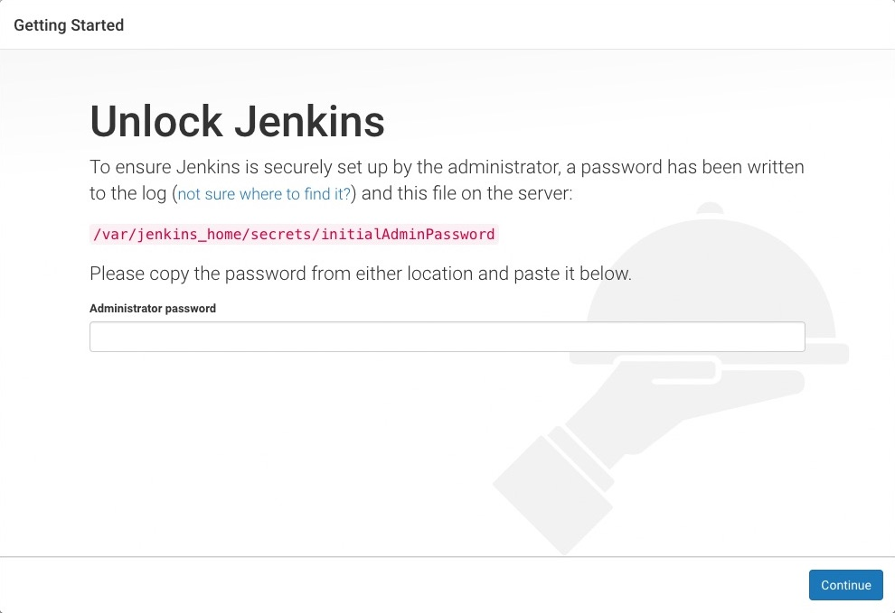

* Click on “Install Suggested Plugins”, and it will start to install the required plugins.

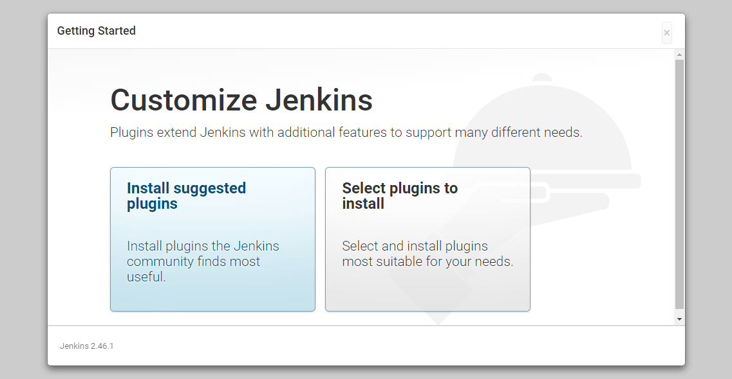

* Once all plugins are installed, it will prompt to create the first Admin user

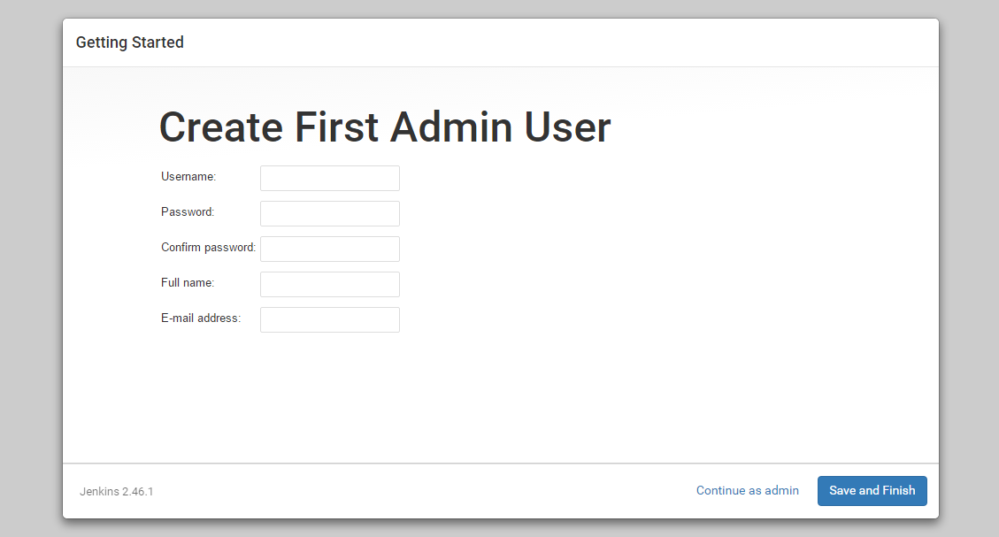

* Once you create the “Admin” user, you will be able to see “Jenkins is ready”, you are almost done, click “Start using Jenkins”.

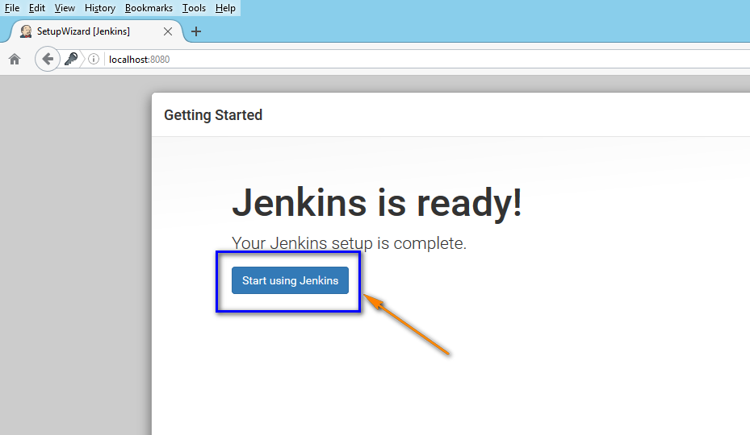

**Jobs**

* Build jobs are at the heart of the Jenkins build process.

* Simply put, you can think of a Jenkins build job as a particular task or step in your build process. This may involve simply compiling your source code and running your unit tests. Or you might want a build job to do other related tasks, such as measuring code coverage or code quality metrics, generating technical documentation, or even deploying your application to a web server.

* A real project usually requires many separate but related build jobs.

**Creating Jobs**

* Build jobs are at the heart of the Jenkins build process.

* Simply put, you can think of a Jenkins build job as a particular task or step in your build process. This may involve simply compiling your source code and running your unit tests. Or you might want a build job to do other related tasks, such as measuring code coverage or code quality metrics, generating technical documentation, or even deploying your application to a web server.

* A real project usually requires many separate but related build jobs.

**JOB1**

* On Jenkins Dashboard → Click New Item → Select FreeStyle Project → Item name (OS-Version) → Ok → Description : Prints the OS Version → Go to Build Section by Clicking on the Build Tab → Click on the Drop Down → You got multiple options, but as we are using Linux OS, choose Execute Shell(cat /etc/os-release) → Save.  
    
  On jenkins home page, you can see the new job that is configured → Click on Job → In the left side there is an **Build Now** option click on it.  
    
  Once the job has been executed, you can see the Job Status in the Left side, showing the option BLUE - Success and it it’s RED - Failed.

**JOB2**

* On Jenkins Dashboard → Click New Item → Select FreeStyle Project → Item name (Ram-Status) → Ok → Description : Ram Usage → Go to Build Section by Clicking on the Build Tab → Click on the Drop Down → You got multiple options, but as we are using Linux OS, choose Execute Shell(free) → Save.  
    
  On jenkins home page, you can see the new job that is configured → Click on Job → In the left side there is an **Build Now** option click on it.

* Now i want to check the RAM status frequently, so i need to run the job multiple times, in this kind of scenarios jenkins provides you with Build Triggers option, which can automate the job with cron schedules.

* Click on Job → Configure → Go to Build Triggers Section → Select Build Periodically → Give * * * * * → Save

* Now we don’t need to Click on Build Job every time, automatically the job runs for every 1 min

**JOB3**

* On Jenkins Dashboard → Click New Item → Select FreeStyle Project → Item name (Host-WebSite) → Ok → Description : Deploy website from Github → Go to Build Section by Clicking on the Build Tab → Click on the Drop Down → You got multiple options, but as we are using Linux OS, choose Execute Shell then give the following commands → Save.
  + sudo yum -y install httpd
  + sudo systemctl start httpd
  + sudo git clone <https://github.com/ravi2krishna/food.git> /var/www/html/

* On jenkins home page, you can see the new job that is configured → Click on Job → In the left side there is an **Build Now** option click on it.

* Now you will be getting some errors, as jenkins by default doesn’t have sudo access and no tty so modify the jenkins behavior
  + sudo usermod -aG google-sudoers jenkins
  + sudo vim /etc/passwd
    - Change the /bin/false to /bin/bash to jenkins user

* Now restart the jenkins
  + sudo systemctl restart jenkins

* Build the job again

* Now apply build trigger for the same job, coz when the content is updated in github it should deploy those content changes to server again

**Assignment**

Fork the following repo

<https://github.com/ravi2krishna/food/blob/master/index.html>

Configure a job to deploy the website

Take new changes which are done by developers and update the same to website

**Change the code in Line : 110**

**HINT : Use Build Trigger Option**

**Securing Jenkins**

* In Jenkins you have the ability to setup users and their relevant permissions on the Jenkins instance. In latest versions of Jenkins, "Logged in User can do anything".

* Create multiple users
  + developer and tester

* Now if i login with one of the users i can do anything

* Now let's setup the authorizations, basically who has access to what.

* Go to Manage Jenkins → Configure Global Security → Now in the Authorization section → click on ‘Matrix based security’

**Matrix Based Security**

* If you don’t see the user in the user group list, enter the user name and add it to the list. Then give the appropriate permissions to the user.

* Click on the Save button once you have defined the relevant authorizations.

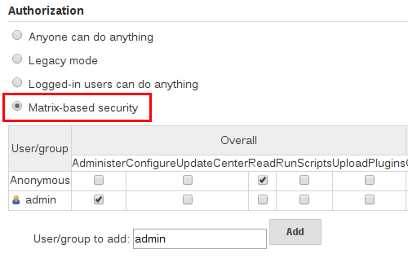

**Project Based Matrix Authorization**

* Now let's set up the authorizations, based on Projects

* Go to Manage Jenkins → Configure Global Security → Now in the Authorization section → click on ‘Project-based Matrix Authorization Strategy'

* Add admin user and check all the checkbox to grant all permission to admin user

* Then add other users and only give them "Overall Read" permission then save

* Now go to Project, say "PROJECT1" and select "Configure". Check  the "Enable Project based security" to enable project based security and give access to user you want

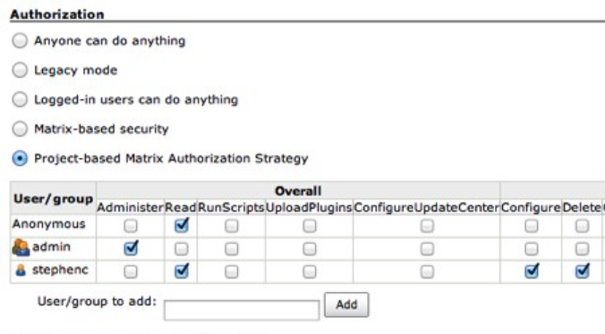

**Role Based Strategy Plugin**

* Role-based strategy is not preinstalled. We need to  install it before we can use it.

* Manage Jenkins → Manage Plugins → Available → search the plugin "Role-based Authorization Strategy" → Install without restart

* This plugin adds a new role-based strategy to ease and fasten users management. This strategy allows:
* Creating global roles, such as admin allowing to set Overall permissions on a global basis.
* Creating project roles, allowing to set only Job and Run permissions on a project basis.
* Assigning these roles to users.

* Using the plugin is fairly simple
  + Activate the Role-Based Strategy by using the standard Manage Jenkins → Configure Global Security → Authorization, now we can see the new option [Role-Based Strategy](https://plugins.jenkins.io/role-strategy).  Select the Role-Based Strategy → Apply → Save.
  + Now if i login with the tester or developer user i won’t have access, i can only access with the admin user.

* Now let’s see how we can create some of the roles and based on roles we can grant the access to users:
* Manage Jenkins → Manage and Assign Roles → Manage roles → In the global role add a role like employee and just give access to read

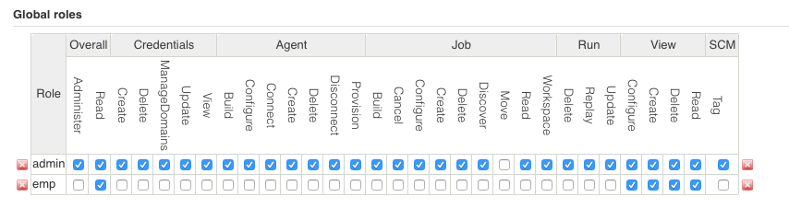

* Now let’s see how we can create some roles specific to projects
* Manage Jenkins → Manage and Assign Roles → Manage roles → In the project role →  add a role like developers & testers and add users developer and tester to relevant roles with pattern to go with like dev.* or test.* and give complete access

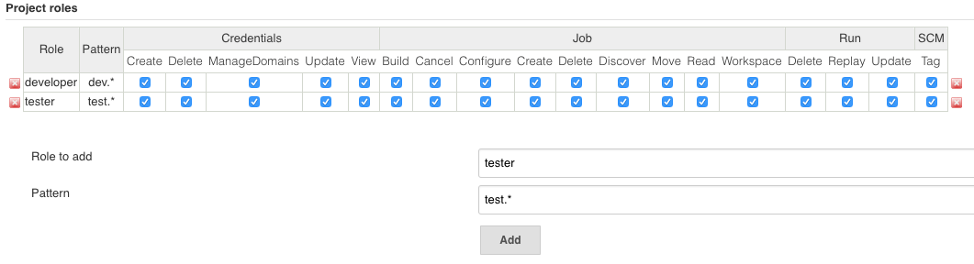

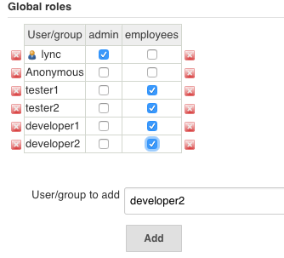

**Jenkins Master Slave Configuration**

Sometimes many build machines are required if there are instances wherein there are a larger and heavier projects which get built on a regular basis. And running all of these builds on a central machine may not be the best option. In such a scenario, one can configure other Jenkins machines to be slave machines to take the load off the master Jenkins server.

Sometimes you might also need several different environments to test your builds. In this case using a slave to represent each of your required environments is almost a must.

To address the above stated needs, Jenkins distributed architecture was introduced.

**Jenkins Distributed Architecture**

Jenkins uses a Master-Slave architecture to manage distributed builds. In this architecture, Master and Slave communicate through TCP/IP protocol.

In master-slave architecture of Jenkins, master represents basic installation of Jenkins and it handles all tasks for build system.

Jenkins master is used to handle following things:

* Scheduling build jobs.
* Dispatching builds to the slaves for the actual execution.
* Monitor the slaves (possibly taking them online and offline as required).
* Recording and presenting the build results.
* A Master instance of Jenkins can also execute build jobs directly.

A slave is a computer that is set up to offload build projects from the master and once connection is established between master and slave , tasks distribution is done automatic. Each slave runs a separate program called a “slave agent” . There is no need to install the full Jenkins on a slave.

Following are the characteristics of Jenkins Slaves:

* It hears requests from the Jenkins Master instance.
* Slaves can run on a variety of operating systems.
* The job of a Slave is to do as they are told to, which involves executing build jobs dispatched by the Master.

Below diagram shows the sample master slave connection. It consists of a Jenkins Master which is managing two Jenkins Slave.

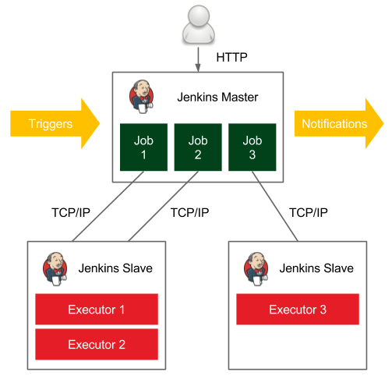

**Changing Jenkins Master User Behavior**

We know we have user jenkins, who has no shell and this user is the owner of jenkins application but beyond that it’s a normal user. So what we are going to do is manage the global credentials.

Now we should make a decision that when we run jobs either locally or remotely we are going to run them with the jenkins user using ssh so that we can control slaves.

So on our system(master) we are going to change jenkins user, so that we can login with jenkins user, let’s go and do it

# vi /etc/passwd {jenkins change **/bin/false** to **/bin/bash**}

# sudo su jenkins

Make sure our jenkins user is a sudoer

# usermod -aG google-sudoers jenkins

# vi /etc/sudoers or # sudo visudo

Switch to jenkins user

# sudo su jenkins

# cd { make sure you are in jenkins home /var/lib/jenkins}

# ssh-keygen

Click on Credentials on homepage of jenkins → Click on Global credentials → Adding some credentials → Kind (select SSH username with private key) → Scope (global) →

Username (jenkins) → Private Key (From jenkins master ~/.ssh) → Ok

Now this sets jenkins user account to be available for SSH key exchange with other servers. This is imp coz we want the ability so that single jenkins user can be in control to run our jobs remotely so that master can off load its jobs to slaves.

**Slave**

**=====**

Now create a new centos server(machine) where you will be getting new ip {1.2.3.4}

Preparing slaves using ssh key follow the same steps:

Now Copy the jenkins master public key and paste it in slave machine authorized keys so that it can verify our identity.

**OR**

Create a user jenkins **# useradd jenkins**

# usermod -aG google-sudoers jenkins

# sudo su jenkins -

# cd { make sure you are in jenkins home /home/jenkins}

# ssh-keygen

Now do password less authentication steps on both machines :

# vi authorized_keys (add public key of other machine)

# chmod 700 ~/.ssh

# chmod 600 ~/.ssh/authorized_keys

Now if everything is good then you should be able to login into the slave machine without password from jenkins master.

# ssh jenkins@jenkins-slave-ip

**Slave Prerequisites**

* Create a Jenkins user in Slave, where access should be granted to master jenkins user
* JRE (Java Runtime Environment ) need to installed on every slave machine

**NOTE**: Slaves should have all the prerequisites in place first, let say you are building a maven job, where the source code is available in Github, then in the slave machine you should have set of following applications installed:

* Git
* Java
* Maven

**Configuring Node/Slave**

**So we talked about this a lot, that we don’t want to do builds much on master.**

We are going to create dumb slave nodes, slaves doesn’t need to know anything about implementation they should be able to just run jobs and be controlled by master.

We are going to use this slave nodes in order to off-load the build processing to other machines so that the master server doesn’t get CPU, IO or N/W load etc in managing large number of jobs across multiple servers multiple times a day.

So we are going to **create a slave node**:

# Now make sure there is handshake exchange b/w both the machines.

* # **Manage Jenkins** (scroll down) → **Manage Nodes** → Master (Now master is always going to be included by default  here if we click on master) →  Configure → Usage : Only build jobs with label matching nodes(for the most part we want master only to use for controlling jobs we have setup) → Save

# Manage Jenkins (scroll down) → Manage Nodes → New Node → Node name : Remote slave 1 → # of executors : 2 (up to 2 concurrent jobs) → Remote root Directory: (/home/jenkins) Labels: n1 →  Usage: (as much as possible) → Launch method: Launch slave via SSH → Host: ip of slave → Credentials: Service acc(Give settings of **Kind**: SSH username with private key **&&** Private key: From jenkins master ~/.ssh) → Availability: Keep online as much as possible → Save

**Install java and javac on all slaves.**

Then click on node and see the **log**.

Now if i goto jenkins home i can see both master and slave.

**Building JOB On Node**

New job → Under General (**✅** Restrict where this project can run)(Label expression: n1 or expression we gave while creating slave) → Build → Execute Shell → in command give # pwd # uname -a # hostname → Save → Run build.

Now you can see the job being executed on node1

NAGIOS

* Nagios is a monitoring tool.
* In your organization, you will be working on different different environments like dev, test, pre-prod, prod etc.
* Now let's say you have 1000 systems in your infrastructure, so daily it's a tedious task to go and understand what is the status of these 1000 devices.
* For monitoring all these servers we use NAGIOS.

**Parameters to monitor**

   CPU

   RAM

   Storage

   Network etc

**NAGIOS SETUP**

**NAGIOS CORE**

Goto [nagios.com](http://nagios.com/) and [nagios.org](http://nagios.org/)

   On [nagios.org](http://nagios.org/) →  Downloads →  Nagios Core

   # mkdir nagios-software

   # cd nagios-software

copy link of nagios-core.tar.gz

      # wget <nagios-core-link>

      # extract the tar

**Install the Prerequisites**

# sudo yum install httpd php php-cli gcc glibc glibc-common gd gd-devel net-snmp openssl-devel wget unzip -y

Now, let's create a user and group for Nagios to use

# sudo useradd nagios

# sudo groupadd nagcmd

# sudo usermod -a -G nagcmd nagios

# sudo usermod -a -G nagcmd apache

Start the setup

# cd nagios-4.x  
# ./configure

# make all

# sudo make install

# sudo make install-init

# sudo make install-config

# sudo make install-commandmode

# sudo make install-webconf    

Creating a password for nagiosadmin

# sudo htpasswd -c /usr/local/nagios/etc/htpasswd.users nagiosadmin

Start the Nagios and Apache

# sudo service httpd start

# sudo service httpd start

Access the Nagios Dashboard

# ip-address/nagios

# Give Credentials and Login and see Services

By default, we don’t have any services shown, so we need to update the nagios plugins.

**NAGIOS PLUGINS**

On [nagios.org](http://nagios.org/) →  Downloads →  Nagios Core Plugin

# wget <link-nagios-plugins>.tar

# extract the <link-nagios-plugins>.tar

# tar xf <link-nagios-plugins>.tar

# cd nagios-plugin-x

# sudo ./configure

# make

# sudo make install

Now after a while, you’ll be seeing the changes, now one by one service will be activated.

VAGRANT

**Vagrant**

Vagrant is a tool for building and managing virtual machine environments.  
With an easy-to-use workflow and focus on automation, Vagrant lowers development environment setup time, increases production parity, and makes the "works on my machine" excuse a relic of the past.  
Vagrant is suitable for development environment.

**Why Vagrant ?**Vagrant provides easy to configure, reproducible, and portable work environments built on top of industry-standard technology and controlled by a single consistent workflow to help maximize the productivity and flexibility of you and your team.

To achieve its magic, Vagrant stands on the shoulders of giants. Machines are provisioned on top of VirtualBox, VMware, AWS, or any other provider. Then, industry-standard provisioning tools such as shell scripts, Chef, or Puppet, can automatically install and configure software on the virtual machine.  
  
**For Developers**

If you are a **developer**, Vagrant will isolate dependencies and their configuration within a single disposable, consistent environment, without sacrificing any of the tools you are used to working with (editors, browsers, debuggers, etc.). Once you or someone else creates a single Vagrantfile, you just need to vagrant up and everything is installed and configured for you to work. Other members of your team create their development environments from the same configuration, so whether you are working on Linux, Mac OS X, or Windows, all your team members are running code in the same environment, against the same dependencies, all configured the same way. Say goodbye to "works on my machine" bugs.

**For Operators**

If you are an **operations engineer** or **DevOps engineer**, Vagrant gives you a disposable environment and consistent workflow for developing and testing infrastructure management scripts. You can quickly test things like shell scripts, Chef cookbooks, Puppet modules, and more using local virtualization such as VirtualBox or VMware. Then, with the *same configuration*, you can test these scripts on remote clouds such as AWS or RackSpace with the *same workflow*. Ditch your custom scripts to recycle EC2 instances, stop juggling SSH prompts to various machines, and start using Vagrant to bring sanity to your life.

**For Everyone**

Vagrant is designed for everyone as the easiest and fastest way to create a virtualized environment!

**What is the meaning of setting up environment ??**

Let’s say you need web server

Let’s say you need db server

Let’s say you need app server

Let's say you need some machine for R & D purpose quickly, configure that machine quickly and able to use that machine very quickly, now using vagrant we can reduce installation time.

Typically when we setup OS, you may take around 30-45 min to go along with that.

But with vagrant you can spin up the development environment very very quickly.  
  
**Now how to spin up the environment ??**

lets see how it can be done

Goto the official website of vagrant vagrantup.com

We see something like find boxes right, let’s understand some terminology:

So when we are going with Base Installation of Linux, we need couple of things

* You need a CD or ISO image
* You need a physical machine
* You define some CPU & RAM
* Storage
* Network

So whenever we are going with installation we need to go with all these steps always.

So if we are working with cloud we have some images like CentOS, ubuntu etc

* AMI (Amazon Machine Images)
* Virtualization Layer
* CPU    {how much CPU i need}
* RAM {how much RAM i need}
* Storage {how much storage i need}
* Network

I need to configure all the above

So in vagrant, we call these pre-installed Images/OS as **BOXES**

Now you can easily download these boxes, and can spin up the virtual machines easily.

As i told to setup the OS it takes around 30-45 min, but using the vagrant it hardly takes 5 min depending on internet speed.

**Download and Install vagrant**

Vagrant supports on following platforms: WIN/MAC/LINUX

But there is another dependency to vagrant, which is the **virtualization layer**.

So in our laptop/desktop, what is the virtualization layer we use:

* **Oracle Virtual Box**

Once virtualization layer is ready, we need to setup Vagrant

Download Vagrant from <https://www.vagrantup.com/downloads.html>

Once Vagrant is installed, it will be available in Terminal/CMD

* **vagrant --version**

Now i don't have any box right, let’s download the box:

**# goto vagrantup.com**

**# find BOXES {gives list of all boxes}**

So once you go to find boxes, it shows what’s the virtualization layer is and the diff boxes available.

There is provider, lets understand the terminology

Here **Virtualbox →    Provider**

**Provider**: tool which is giving you the virtual layer, But we have diff providers available which provides virtualization layer.

**Getting Started**Wewill use Vagrant with [VirtualBox](https://www.virtualbox.org), since it is free, available on every major platform, and built-in to Vagrant.  
But do not forget that Vagrant can work with many other providers.

**Providers**While Vagrant ships out of the box with support for VirtualBox, Hyper-V, and Docker, Vagrant has the ability to manage other types of machines as well. This is done by using other *providers* with Vagrant.

Before you can use another provider, you must install it. Installation of other providers is done via the Vagrant plugin system.  
  
Once the provider is installed, usage is straightforward and simple, as you would expect with Vagrant.  
  
Your project was always backed with [VirtualBox](https://www.virtualbox.org). But Vagrant can work with a wide variety of backend providers, such as [VMware](https://www.vagrantup.com/docs/vmware/), [AWS](https://github.com/mitchellh/vagrant-aws), and more.  
  
Once you have a provider installed, you do not need to make any modifications to your Vagrantfile, just vagrant up with the proper provider and Vagrant will do the rest:  
 **# vagrant up --provider=vmware_fusion**

**# vagrant up --provider=aws**

**Up and Running  
 # vagrant init centos/7  
 # vagrant up**

After running the above two commands, you will have a fully running virtual machine in VirtualBox running.

You can SSH into this machine with

**# vagrant ssh**

And when you are done playing around, you can terminate the virtual machine with

**# vagrant destroy**  
  
  
**Project Setup**The first step in configuring any Vagrant project is to create a [**Vagrantfile**](https://www.vagrantup.com/docs/vagrantfile/). The purpose of the Vagrantfile is:

* Mark the root directory of your project. Many of the configuration options in Vagrant are relative to this root directory.

* Describe the kind of machine and resources you need to run your project, as well as what software to install and how you want to access it.

Vagrant has a built-in command for initializing a directory for usage with Vagrant:

**# vagrant init**

This will place a Vagrantfile in your current directory. You can take a look at the Vagrantfile if you want, it is filled with comments and examples.

You can also run vagrant init in a pre-existing directory to setup Vagrant for an existing project.  
 **# vagrant init centos/7  
  
Vagrantfile**The primary function of the **Vagrantfile** is to describe the type of machine required for a project, and how to configure and provision these machines.  
Vagrant is meant to run with one Vagrantfile per project, and the Vagrantfile is supposed to be committed to version control.

The syntax of Vagrantfiles is [Ruby](http://www.ruby-lang.org), but knowledge of the Ruby programming language is not necessary to make modifications to the Vagrantfile, since it is mostly simple variable assignment.

**vagrant up**In less than a minute, this command will finish and you will have a virtual machine running centos 7. You will not actually *see* anything though, since Vagrant runs the virtual machine without a UI.

**vagrant ssh**This command will drop you into a full-fledged SSH session. Go ahead and interact with the machine and do whatever you want.

**How to setup environment with vagrant**

* create a project directory
* create Vagrantfile (configuration file - # vagrant init)
* define the image name you want to use

   Let’s go and do these steps

**# mkdir project1**

**# cd project1**

It's similar to git, whenever you start with git we say

**# git init**

Similarly for vagrant we use

**# vagrant init**

**Open Vagrantfile**

   →  It's a ruby configuration file

   →  I'll remove unwanted things like commented section, just keep

   Vagrant.configure("2") do |config|

   config.vm.box = "base"

   end

   I want centos-7 box so let's search for it in vagrantup.com

   Change the vagrantfile

**# vi Vagrantfile**

Vagrant.configure("2") do |config|

   config.vm.box = "centos/7"

   end

**# start the VM (Virtualbox)**

**# vagrant up    {this command does the following}**

   1. It will create a VM

   2. It downloads the centos image

   3. Start the VM (by default it will be 1 CPU, 512MB RAM)

   4. Creates NAT Network

   5. Setup SSH port forwarding

   6. Installs SSH keys

   7. Maps the storage

   8. Execute provision script

   9. Then makes the OS available to user

   Default username & pass is vagrant

**# vagrant up    {execute the command, this brings up the machine}**

**# vagrant ssh {logs you into the machine}**

**# vagrant halt    {brings down the machine}**

**Network**In order to access the Vagrant environment created, Vagrant exposes some high-level networking options for things such as forwarded ports, connecting to a public network, or creating a private network.  
  
**Port Forwarding**

Port forwarding allows you to specify ports on the guest machine to share via a port on the host machine. This allows you to access a port on your own machine, but actually have all the network traffic forwarded to a specific port on the guest machine.

Let us setup a forwarded port so we can access Apache in our guest. Doing so is a simple edit to the Vagrantfile, which now looks like this:  
  
Vagrant.configure("2") do |config|  
  config.vm.box = "hashicorp/precise64"  
  config.vm.provision :shell, path: "bootstrap.sh"  
  config.vm.network :forwarded_port, guest: 80, host: 4567  
end

Run  # vagrant reload or # vagrant up. Once the machine is running again, load http://127.0.0.1:4567 in your browser. You should see a web page that is being served from the virtual machine that was automatically setup by Vagrant.  
  
Vagrant also has other forms of networking, allowing you to assign a static IP address to the guest machine, or to bridge the guest machine onto an existing network.

By default vagrant uses **NAT** network provided by your provider aka Virtualbox.  
But let say you want to use bridge network to get connected to router, just uncomment the “public_network”, and when you do **# vagrant up**, it asks for the network to connect.  
 **# config.vm.network "public_network"  
 # config.vm.network :public_network, bridge: "en0: Wi-Fi (AirPort)"  
  
Bridge with static network**:  
 # config.vm.network "public_network", :bridge => “wlan0”, :ip => “192.168.1.36”

**Configure Hostname  
  
 # config.vm.hostname = “centos”  
  
Changing RAM**

# Customize the amount of memory on the VM:

config.vm.provider "virtualbox" do |vb|

vb.memory = "1024"

end

**Changing CPU**

# Customize the number of CPU’s on the VM:

config.vm.provider "virtualbox" do |vb|

vb.cpus = "2"

end  
  
# free -m → RAM  
# cat /proc/cpuinfo → CPU’s

**Provisioning**

Provisioners in Vagrant allow you to automatically install software, alter configurations, and more on the machine as part of the vagrant up process.  
  
Of course, if you want to just use vagrant ssh and install the software by hand, that works. But by using the provisioning systems built-in to Vagrant, it automates the process so that it is repeatable. Most importantly, it requires no human interaction.  
  
Vagrant gives you multiple options for provisioning the machine, from simple shell scripts to more complex, industry-standard configuration management systems.  
  
Provisioning happens at certain points during the lifetime of your Vagrant environment:

* On the first vagrant up that creates the environment, provisioning is run. If the environment was already created and the up is just resuming a machine or booting it up, they will not run unless the --provision flag is explicitly provided.
* When vagrant provision is used on a running environment.
* When vagrant reload --provision is called. The --provision flag must be present to force provisioning.

You can also bring up your environment and explicitly *not* run provisioners by specifying --no-provision.

If we want to install web server in our server**.** We could just SSH in and install a webserver and be on our way, but then every person who used Vagrant would have to do the same thing. Instead, Vagrant has built-in support for *automated provisioning*. Using this feature, Vagrant will automatically install software when you vagrant up so that the guest machine can be repeatedly created and ready-to-use.

We will just setup [Apache](http://httpd.apache.org/) for our basic project, and we will do so using a shell script. Create the following shell script and save it as bootstrap.sh in the same directory as your Vagrantfile.

bootstrap.sh  
==========  
 ***apt-get install git -y*** ***apt-get install apache2 -y***

***service httpd start  
 git clone https://github.com/devopsguy9/food.git /var/www/html/***

Next, we configure Vagrant to run this shell script when setting up our machine. We do this by editing the Vagrantfile, which should now look like this:  
 ***Vagrant.configure("2") do |config|  
  config.vm.box = "ubuntu/trusty32"  
  config.vm.provision :shell, path: "bootstrap.sh"  
 end***

The "provision" line is new, and tells Vagrant to use the shell provisioner to setup the machine, with the bootstrap.sh file. The file path is relative to the location of the project root (where the Vagrantfile is).  
  
After everything is configured, just run vagrant up to create your machine and Vagrant will automatically provision it. You should see the output from the shell script appear in your terminal. If the guest machine is already running from a previous step, run vagrant reload --provision, which will quickly restart your virtual machine.  
  
After Vagrant completes running, the web server will be up and running. You can see the website from your own browser.  
This works because in shell script above we installed Apache and setup the website.

**Load Balancing Using Vagrant**

In this project we are going to work with three different machines,  
 In our previous Load balance example we took one nginx and two apache servers.  
  
But in this example we will be using three nginx servers:

**Vagrantfile**

==========

Vagrant.configure("2") do |config|

config.vm.define "lb1" do |lb1|

    lb1.vm.box = "ubuntu/trusty32"

    lb1.vm.network "private_network", ip: "192.168.45.10"

    lb1.vm.network :forwarded_port, host: 7777, guest: 80

    lb1.vm.provision "shell", path: "provision-nginx.sh"

**## Set name like centos**

config.vm.provider :virtualbox do |vb|

vb.name = "centos"

end

end

config.vm.define "web1" do |web1|

    web1.vm.box = "ubuntu/trusty32"

    web1.vm.network "private_network", ip: "192.168.45.11"

   web1.vm.network :forwarded_port, host: 8888, guest: 80

    web1.vm.provision "shell", path: "provision-web1.sh"

end

config.vm.define "web2" do |web2|

    web2.vm.box = "ubuntu/trusty32"

    web2.vm.network "private_network", ip: "192.168.45.12"

   web2.vm.network :forwarded_port, host: 9999, guest: 80

    web2.vm.provision "shell", path: "provision-web2.sh"

end

end

**provision-nginx.sh**

**================**

#!/bin/bash

echo "Starting Provision: Load balancer"

sudo apt-get -y install nginx

sudo service nginx stop

sudo rm -rf /etc/nginx/sites-enabled/default

sudo touch /etc/nginx/sites-enabled/default

echo "upstream testapp {

server 192.168.45.11;

server 192.168.45.12;

}

server {

listen 80 default_server;

listen [::]:80 default_server ipv6only=on;

server_name  localhost;

root     /usr/share/nginx/html;

#index index.html index.htm;

location / {

proxy_pass http://testapp;

}

}" >> /etc/nginx/sites-enabled/default

sudo service nginx start

echo "MACHINE: LOAD BALANCER" >> /usr/share/nginx/html/index.html

echo "Provision LB1 complete"

**provision-web1.sh**

**==================**

echo "Starting Provision on A"

sudo apt-get install -y nginx

echo "<h1>MACHINE: A</h1>" >> /usr/share/nginx/html/index.html

echo "Provision A complete"

**provision-web2.sh**

==================

echo "Starting Provision on B"

sudo apt-get install -y nginx

echo "<h1>MACHINE: B</h1>" >> /usr/share/nginx/html/index.html

echo "Provision B complete"

# vagrant status

# vagrant global-status

# vagrant port lb1

# vagrant port web1

**Running** **Provisioners  
==================**Provisioners are run in three cases:

# vagrant up

# vagrant provision

# vagrant reload --provision

DOCKER

**Infrastructure**

* To understand how containers work, we gonna start comparing it with which we already know about and those are Physical Servers and Virtual Machines.

* Why do we need the Infrastructure that we provision either using Physical Servers or VM's, the ultimate objective for provisioning Servers is to run some applications those could be Web Servers, Database Servers, App Servers etc etc.

* So It's about the Application we want to run, and to run that application we need an environment, and that's the reason why we provision this infrastructure.

**Server Virtualization**

* When people talk about Virtualization, they’re usually referring to Server Virtualization, which means partitioning one physical server into several virtual servers, or machines.

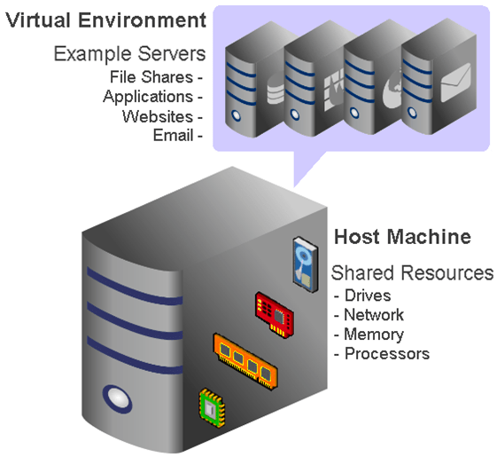

**Pre Virtualization World**

* In the old system, the number of servers would continue to mount since every new application required its own server and operating system.

**App - 1     App - 2       App - 3**

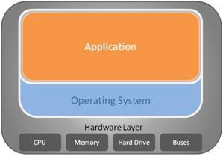       

* As a result, expensive hardware resources were being purchased, but not used.

* Each server would only use about 12% of its resources. Almost 88% of server resources were completely unutilized.

* To over this problem Virtualization came into play. Virtualization allows multiple operating systems to run concurrently on a single Bare-metal or Dedicated Server where you can deploy multiple applications.

* Virtualization is possible because of a software layer called a **HYPERVISOR**.

**Virtualization World**

Once the VMs have been built on top of the Hypervisor:

* Applications and operating systems can be added to each VM.

* Every app and operating system placed on the server lives in a separate VM, which means if an app or operating system goes down on one VM, none of the other apps or operating systems on the other VMs are affected.

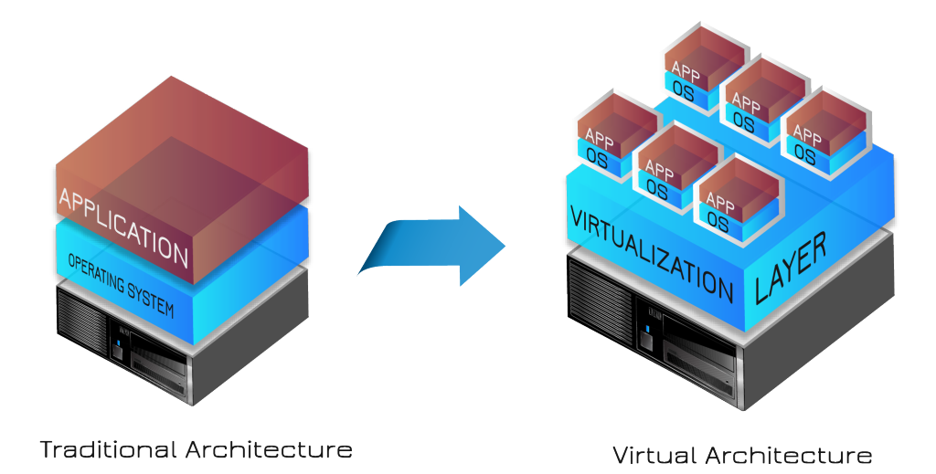

**Why Containerization**

* It comes down to Application Architectures
  + **Monolithic Architecture**
  + **MicroService Architecture**

* The core concept behind Microservices is that certain bulky applications can be broken down into smaller pieces making them much easier to build, maintain and update.

* In contrast, the traditional ‘monolithic’ approach dictates that all components of an application must be developed as one big singular piece.

**Monolithic Architecture vs MicroService Architecture**

|  |  |
| --- | --- |
| **Monolithic** | **Microservice** |
| Gets bigger and bigger over iterations, and becomes difficult to manage and takes really long to startup, if the application is too big. | The size will remain substantially smaller, as each component is dissected to smaller services. |
| Continuous deployment becomes difficult, as a small change to a component in the application, requires redeployment of the entire application. | Continuous deployment is possible here, as each service can be deployed independent of each other. |
| Scaling of application requires entire application scaling(ie: to launch multiple instances of the big monolithic application to serve the need), even though only one small part of the application is resource intensive. | Scaling of individual component is possible here, as each different component is de-coupled to different services, and can be scaled up individually. |

**What is Containerization**

* Containerization also known as **Operating-system-level virtualization** refers to an operating system feature in which the kernel allows the existence of multiple isolated user-space instances. Such instances, called containers

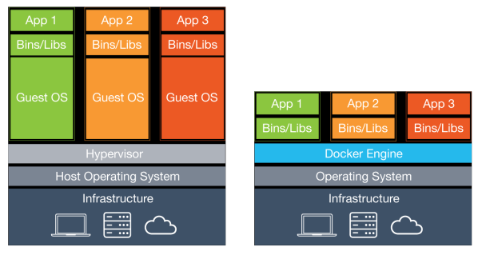

* Whereas in case of containers we just launch the application along with it's runtime, that's the reason why we say containers are lightweight, there is no overhead of booting, initializing and starting the system process which is required in VM.

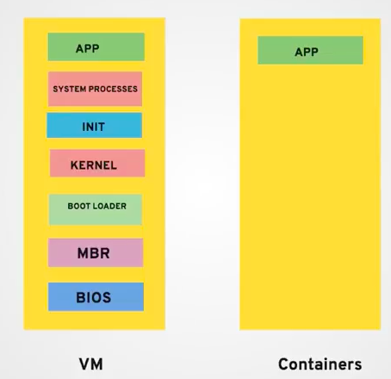

**Container**

* LXC (Linux Containers) is an operating-system-level virtualization method for running multiple isolated Linux systems (containers) on a control host using a single Linux kernel.

* The Linux kernel provides the cgroups functionality that allows limitation and prioritization of resources (CPU, memory, block I/O, network, etc.)

* As the name suggests cgroups[ Control Group ] controls the resource utilization. Control groups allow Docker Engine to share available hardware resources to containers.

**Docker**

* Docker is a computer program that performs operating-system-level virtualization also known as Containerization.

* It is developed by [Docker, Inc.](https://en.wikipedia.org/wiki/Docker,_Inc.)

* Docker is primarily developed for Linux but now supports for Windows and Unix as well

* Docker provides centralized platform to execute your application. It wraps software components into a complete standardized unit which contains everything require to run. Whether it is code, runtime environment, tools or libraries. It guarantees that the software will always run as expected.

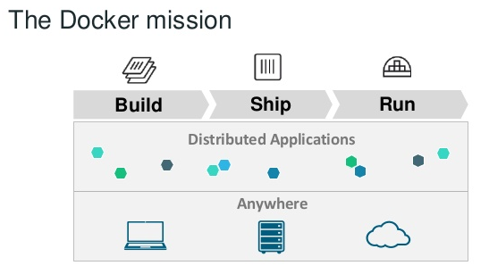

**Container vs Virtual Machine**

|  |  |
| --- | --- |
| **Virtualization** | **Containerization** |
| Hardware Based Virtualization Multiple Guests OS's share Host Resources | OS Based Virtualization  Multiple Containers over same OS |
| Heavy weight in Nature  Additional OS managed resources for each Guest | Light weight in Nature  Kind of App services sharing OS resources |
| Slow Provisioning  Requires Guest initialization plus OS startup time | Fast Provisioning  As simple as starting new application service |
| More Secured  Fully isolated hence more secured | Less secured  Process level isolation hence less secured |

**Features Of Docker**

* **Easy and Faster Configuration**
  + This is a key feature of docker that helps us to configure the system easily and faster.
  + We can deploy our code in less time and effort. As Docker can be used in a wide variety of environments, the requirements of the infrastructure are no longer linked with the environment of the application.
* **Increase productivity**
  + By easing technical configuration and rapid deployment of application. No doubt it has increase productivity. Docker not only helps to execute the application in isolated environment but also it has reduced the resources.
* **Application Isolation**
  + It provides containers that are used to run applications in isolation environment. Each container is independent to another and allows us to execute any kind of application.

* Docker has the ability to reduce the size of development by providing a smaller footprint of the operating system via containers.

* With containers, it becomes easier for teams across different units, such as development, QA and Operations to work seamlessly across applications.

* You can deploy Docker containers anywhere, on any physical and virtual machines and even on the cloud.

* Since Docker containers are pretty lightweight, they are easily scalable.

**Docker Architecture**

* Docker uses a Client-Server architecture. The Docker Client talks to the Docker Daemon which communicates with the Docker Registry.

* **Docker Daemon/Engine** is the part which does the magic and knows how to talk to the kernel, make the system calls to create, operate and manage containers, which we as users of docker don't have to worry about. Docker Daemon does the heavy lifting of building, running, and distributing your Docker containers. The daemon receives the commands from the Docker client.

* **Docker Client** is the primary way that many Docker users interact with Docker. When we use commands such as docker run, the client sends these commands to docker daemon, which carries them out. Communication between docker client and docker engine happens over REST api.

* **Docker Registry** is used to store Docker images. Docker provides the Docker Hub a registry that anyone can use. Docker is configured to look for images on Docker Hub. When we use the docker pull or docker run commands, the required images are pulled from docker hub.

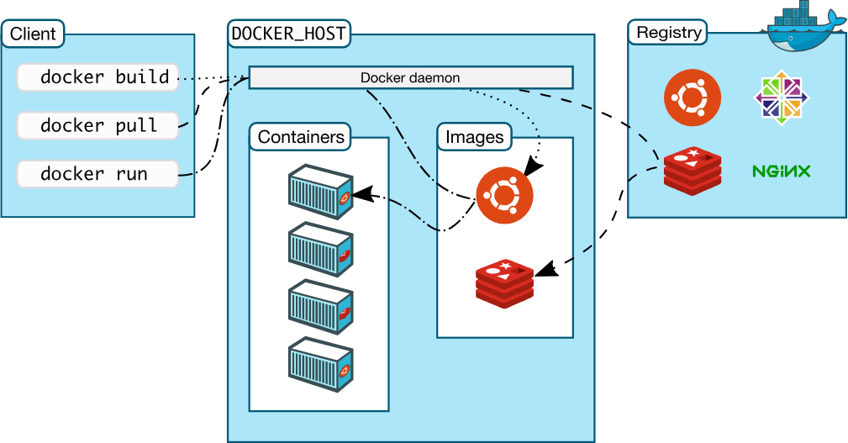

**Image**

* Image is a file which describe how the container should behave. It's like a template of the container.

* An image is an immutable file Dockerfile. Images are created with the build command, and they’ll produce a container when started with run.

* Images themselves are never started, they are never “running”.

* Images are stored in a Docker registry such as hub.docker.com

* Read Only

**Container**

* A Container is an running instance of Docker image

* To use a programming metaphor, if an image is a class, then a container is an instance of a class, a runtime object.

* Containers run the actual applications.

* A container includes an application and all of its dependencies.

* Read Write

**Setting Up Docker**

* We can install docker on any operating system whether it is Linux, Windows or MAC

* But Docker is natively built for LINUX

* [Installation Script](https://get.docker.com/)
  + curl -fsSL get.docker.com -o get-docker.sh
  + sh get-docker.sh
  + To run the containers without sudo access, add the current user to docker group
    - usermod -aG docker user-name

Ex: usermod -aG docker ninja

* docker version { only client is up, we need to start the daemon}
* sudo systemctl start docker
* docker version
* docker info

* Once docker is up and running, test the installation by running the simple Docker image
  + docker images (or) docker image ls
  + docker ps (or) docker container ls
  + docker pull hello-world
  + docker run hello-world

To generate this message, Docker took the following steps:  
 1. The Docker client contacted the Docker daemon.  
 2. The Docker daemon pulled the "hello-world" image from the Docker Hub.  
 3. The Docker daemon created a new container from that image which runs the  
    executable that produces the output you are currently reading.  
 4. The Docker daemon streamed that output to the Docker client, which sent it  
    to your terminal.

* docker images

**Working With Containers**

* Let's start running the containers
  + docker ps
  + You can run containers in Interactive & Detached/Background Modes
  + Run a CentOS container in Interactive Mode
    - docker run -it centos
      1. The above command will pull the CentOs image
      2. Run the centos image as a container
      3. Then will start a bash shell inside that container
         * -i asks to keep the input open
         * -t asks the container to assign a terminal to it
         * which is why we have the bash shell opened after the run command completes
  + Once you exit from container, the container is stopped

* Let's start running the containers
  + docker ps
  + Run a Ubuntu container in Detached/Background Mode
    - docker run -dt ubuntu
    - docker ps
    - docker ps -a
    - Startup time for Container is very less coz no need of loading boot process
  + In interactive mode you would get into the container but in detached it's different
    - docker exec -it <container-id> bash
    - exit

**Managing Containers**

* Let's manage the containers
  + docker ps
  + docker ps -a
  + To start the container

Docker start<container-id> or <container-name>

* To stop the container
  + docker stop <container-id>  or <container-name>
  + docker rm <container-id>  or <container-name>
* To name the container
  + docker run -dt --name container1 ubuntu
  + docker run -dt --name container2 --hostname web ubuntu

**Docker Image Layers**

* A Docker image is built up from a series of layers. Each layer represents an instruction in the image’s Dockerfile.
* The layers are stacked on top of each other. When you create a new container, you add a new writable layer on top of the underlying layers.
* All changes made to the running container, such as writing new files, modifying existing files, and deleting files, are written to this thin writable container layer
* The major difference between a container and an image is the top writable layer. All writes to the container that add new or modify existing data are stored in this writable layer. When the container is deleted, the writable layer is also deleted. The underlying image remains unchanged.
* Because each container has its own writable container layer, and all changes are stored in this container layer, multiple containers can share access to the same underlying image and yet have their own data state.

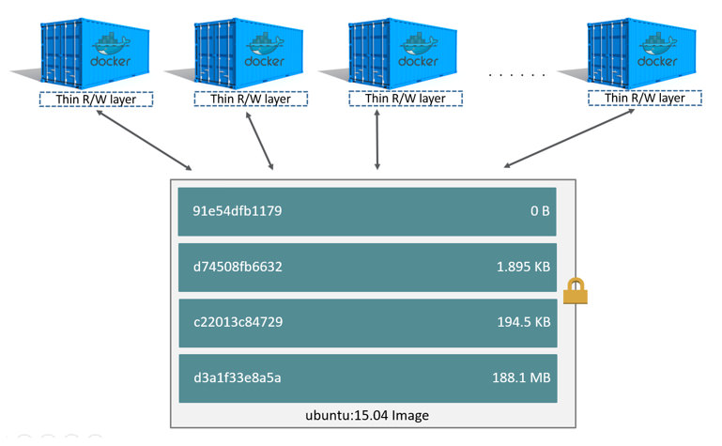

**Writable Container Layer**

* Let's run a new container and setup apache
  + docker ps
  + docker run -dt --name apache1 ubuntu
    - docker run -dt --name apache ubuntu
    - docker exec -it apache bash
    - apt-get update -y
    - apt-get install -y apache2
    - service apache2 start
  + Browse the website
    - elinks container-ip

**Container LifeTime & Persistent Data**

* Docker containers themselves are non-persistent by nature.

* So the data inside the containers is also Non-persistent/Ephemeral meaning temporary, once a container is removed the data associated with the container is also lost. Let’s say that you are running a container which is generating the data inside container, now if that container is removed then the data associated with the container is lost

* Now, even if the container is removed and in the future you launch another container, you would like that data to still be there. In other words, the fundamental thing that we are trying to get over here is to separate out the container lifecycle from the data

* Ideally If you want persistency for the data on the Docker container, volumes are the way to go. So we want to keep data separate so that the data generated inside container is not destroyed or tied to the container lifecycle and can thus be reused. This is done via Volumes

**Working With Volumes**

* Some of the practical examples of the volume usage are: Running any database containers

* Mounting a bunch of config files while running your application

* There are three main use cases for Docker Volumes:
  + To keep data around when a container is removed
  + To share data between the host filesystem and the Docker container
  + To share data with other Docker containers

* By Docker Volumes, we are essentially going to look at how to manage data within the docker containers

**Features Of Volumes**

* A data volume is a specially designed directory in the container.

* It is initialized when the container is created. By default, it is not deleted when the container is stopped. It is not even garbage collected when there is no container referencing the volume.

* Data volumes can be shared across containers too.

**Mounting Volume**

* Without Volume
  + docker run -dt --name c1 ubuntu
  + mkdir ravi
  + touch sample.txt
  + echo "Hello there!!!"
  + docker stop c1
  + docker rm c1 { data is lost }
* With Volume
  + docker volume ls
  + docker run -dt --name c2 -v x: /ravi ubuntu

Syntax: docker run -dt --name <name of container> -v <name of vol>:<path inside container> ubuntu

* docker volume ls
* docker rm c2
* docker volume ls
* docker volume inspect <volume-id>

**Types Of Volumes**

* **Anonymous Volume**
  + This volume is useful, when you would rather have Docker handle where the files are going to be stored
  + It can be difficult to manage if you have multiple anonymous volumes
    - docker run -v /path/in/container

* **Named Volume**
  + This type of volume is similar to an anonymous volume. Docker manages where on disk the volume is created, but you give it a volume name, so that managing becomes easy
    - docker run -v name:/path/in/container

* **Host Volume / Bind Mount**
  + This type of volume is managed by user, as the data is stored wherever the user wants
    - docker run -v /path/on/host:/path/in/container

**Anonymous Volume**

* Anonymous Volume
  + This volume is useful, when you would rather have Docker handle where the files are going to be stored
  + It can be difficult to manage if you have multiple anonymous volumes
    - docker run -v /path/in/container

* Take MySQL as an example to showcase the problem associated with Anonymous vols
  + Run Multiple MySQL containers
    - docker run --name mysql1 -e MYSQL_ROOT_PASSWORD=my-secret-pw -d mysql
    - docker run --name mysql2 -e MYSQL_ROOT_PASSWORD=my-secret-pw -d mysql
    - docker run --name mysql3 -e MYSQL_ROOT_PASSWORD=my-secret-pw -d mysql

**Named Volumes**

* Named Volume
  + This type of volume is similar to an anonymous volume. Docker manages where on disk the volume is created, but you give it a volume name, so that managing becomes easy
    - docker run -v name:/path/in/container

* Take MySQL as an example to showcase the named volumes
  + Run Multiple MySQL containers
    - docker run --name mysql1 -e MYSQL_ROOT_PASSWORD=password -v mysql1:/var/lib/mysql -d mysql
    - docker run --name mysql2 -e MYSQL_ROOT_PASSWORD=password -v mysql2:/var/lib/mysql -d mysql
    - docker run --name mysql3 -e MYSQL_ROOT_PASSWORD=password -v mysql3:/var/lib/mysql -d mysql
  + docker volume ls

**Host Volumes**

* Host Volume / Bind Mount
  + This type of volume is managed by user, as the data is stored wherever the user wants
    - docker run -v /path/on/host:/path/in/container

* This time we will mount an existing host folder in the Docker container

* This is very interesting concept and is very useful if you are looking to do some development where you regularly modify a file and expect the container to take note or even sharing the changes across different containers. It helps, how to use docker for local development.

* While creating a Host volume you would give full path rather than just a name.

**Wordpress Setup**

* To build a Wordpress Application via containers

* docker run -d --name wp-db -e MYSQL_ROOT_PASSWORD=mypassword -e MYSQL_DATABASE=wordpress -v wp-db:/var/lib/mysql mysql:5.7

* docker run --name wp --link wp-db:mysql -p 8080:80 -d -v wp-data:/var/www/html wordpress

 Here -p stands for customized port

**Docker - Compose**

* Compose is a tool for defining and running multi-container Docker applications

* With Compose, you use a YAML file to configure your application’s services. Then, with a single command, you create and start all the services from your configuration.

* With Compose, you define a multi-container application in a single file, then spin your application up with a single command which does everything that needs to be done to get it running.

* Using Compose is basically a three-step process:
  + Define your app’s environment with a **Dockerfile** so it can be reproduced anywhere.
  + Define the services that make up your app in **docker-compose.yml** so they can be run together in an isolated environment.
  + Run **docker-compose up** and Compose starts and runs your entire app.

**Compose Installation**

* Docker Compose relies on Docker Engine for any meaningful work, so make sure you have Docker Engine installed

* Run this command to download the latest version of Docker Compose:
  + sudo curl -L https://github.com/docker/compose/releases/download/1.21.2/docker-compose-$(uname -s)-$(uname -m) -o /usr/local/bin/docker-compose
  + sudo chmod +x /usr/local/bin/docker-compose
  + docker-compose --version

**Wordpress Setup with Compose**

# mkdir wp

# cd wp

# vi **docker-compose.yml**

version: '3'

services:

  db:

    image: mysql:5.7

    volumes:

      - db_data:/var/lib/mysql

    environment:

      MYSQL_ROOT_PASSWORD: password

      MYSQL_DATABASE: wordpress

      MYSQL_USER: wordpress

      MYSQL_PASSWORD: wordpress

  wordpress:

    links:

      - db

    image: wordpress

    volumes:

      - wp_data:/var/www/html

    ports:

      - "8000:80"

    environment:

      WORDPRESS_DB_HOST: db:3306

      WORDPRESS_DB_USER: wordpress

      WORDPRESS_DB_PASSWORD: wordpress

volumes:

   db_data:

   wp_data:

# docker-compose up -d

# docker-compose down

* docker-compose up -d
* docker-compose ps
* docker-compose images
* docker-compose stop
* docker-compose start
* docker-compose restart

**Creating Custom Images**

* Now will see, how to build our own Docker images. Docker can build images automatically by reading the instructions from a Dockerfile.

* A Dockerfile is a text document that contains all the commands a user could call on the command line to assemble an image.

* Let us first start with the the overall flow, which goes something like this:
* You create a Dockerfile with the required instructions.
* Then you will use the docker build command to create a Docker image based on the Dockerfile that you created

* The docker build command builds an image from a Dockerfile.
  + <https://github.com/ravi2krishna/Node-Js-Sample-App>

CHEF

When it comes to learning chef

* You bring your business and problems
* You know about your infrastructure, you knew the challenges you face within your infrastructure and you know how your infrastructure works
* Chef will provide a framework to solve those problems

**The Best way to learn chef is to use chef**.

In chef terminology is very important

**COMPLEXITY**

===========

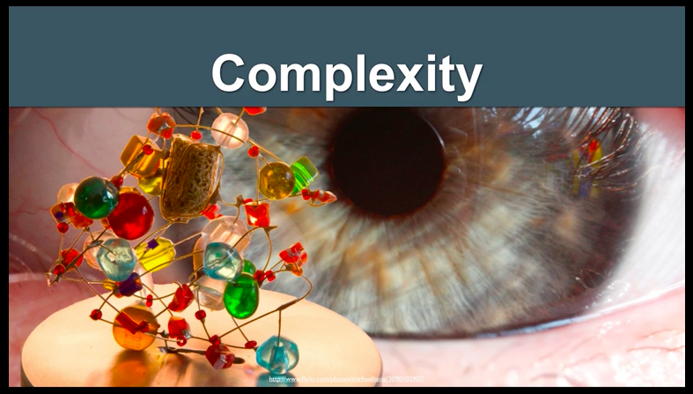

**System administrators** will have a **lot of complexity** to manage.

This complexity can be from many **items** (**Resources**) across the infrastructure.

We call these items as **resources**.

**Resources**

=========

The **resources** in your infrastructure can be **files**, **directories**, **users** that you need to manage, packages that should be installed, services that should be running and list goes on.

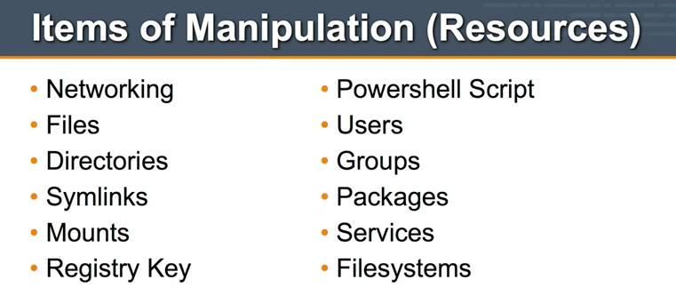

**Let’s look at typical application**

==========================

You usually start configuring and installing that **application** on a single server(node).

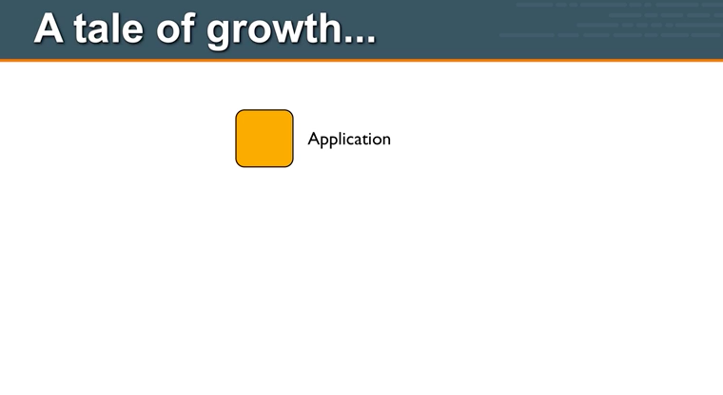

To set up this node we may need to install packages, manage their configurations, installing a database, installing web server, installing application server and lots of things to make this application up and running.

Now overtime you wanna take this application and make it **available to the public/client**.

So you are going to have a **database server**, so maybe now we are going to have multiple environments like staging, dev, qa or even production i.e multi tier environment.

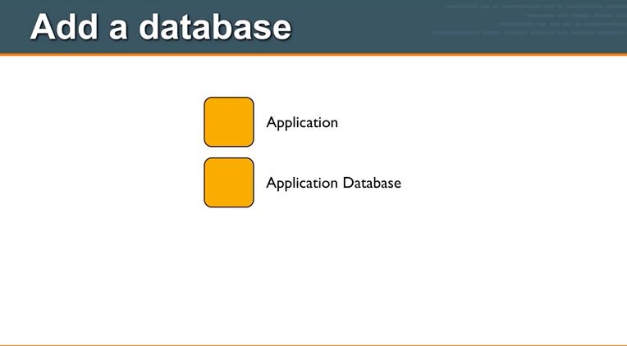

We have one server that handles all the Application requests and a separate server for Database.

Of course once we have a database server, **we want to make sure we don’t lose data**, so we decide to **make database server redundant**. We want to **prevent failure and loss of the data.**

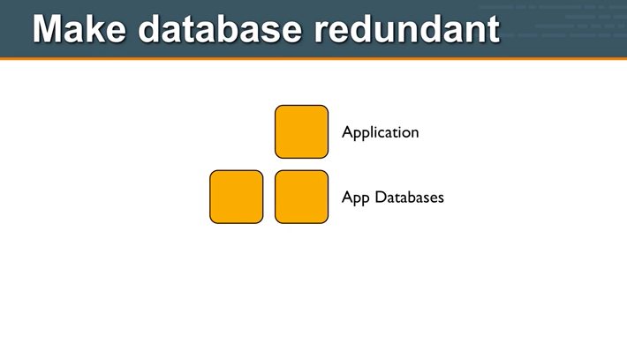

We may as well make the Application server redundant as well.

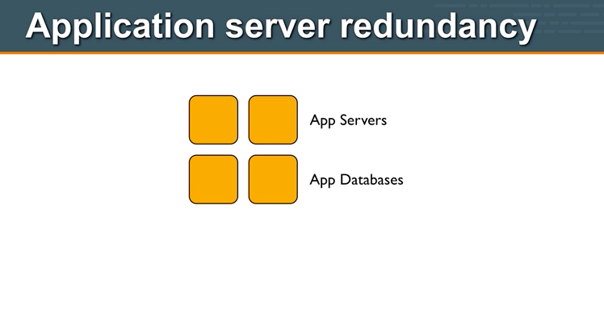

So now we are up to 4 Servers.

========

But of course as time goes on, load increases on our application, and we need to scale out the no of application servers that we have and in order to do that we need to put a load balancer in front of our app servers, so that requests can be evenly distributed.

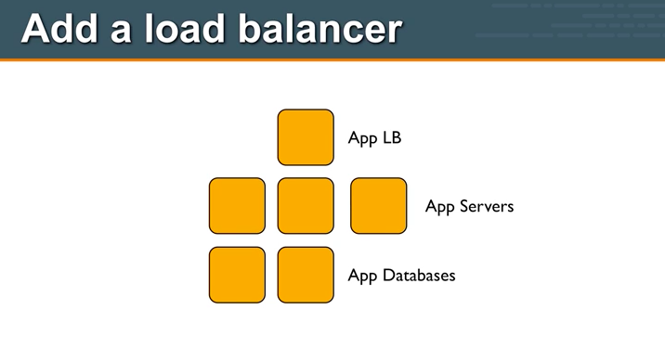

============

Eventually we gonna reach web scale, this application has grown and grown and getting bigger and bigger and we are now at **web scale**. Look at all these servers now we have to manage.

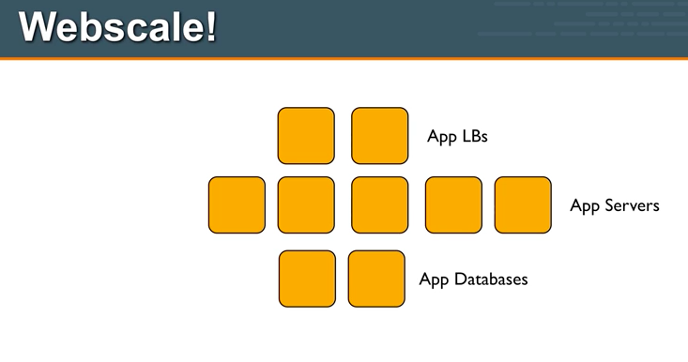

========

Now we ran into another problem, our database just isn’t keeping up with the demands from our users, so we decided to add a caching layer.

Now i got even more servers and more complexity to infrastructure.

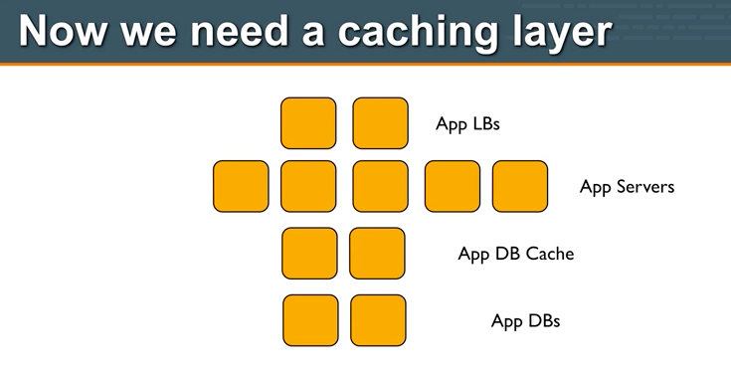

==========

As if this no of servers are not complex enough, and of course each infrastructure has its own topology. There are connections between the load balancer and Application servers.

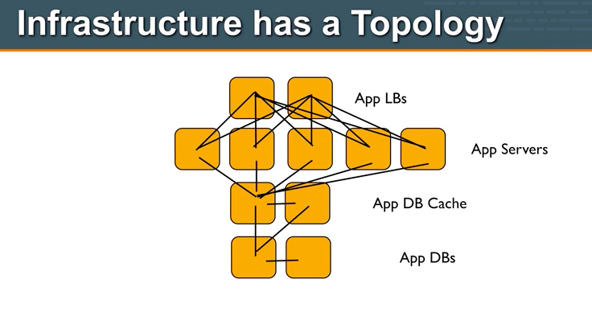

The load balancers need to know which application servers to talk to, which application server they are sending requests to.

The Application server in turn needs to know about the database server.

The Database cache servers need to know what are the backend database servers which they need to do caching.

All of this just adds up more and more complexity to your infrastructure.

=========

And your complexity is only going to increase and its increasing quickly.

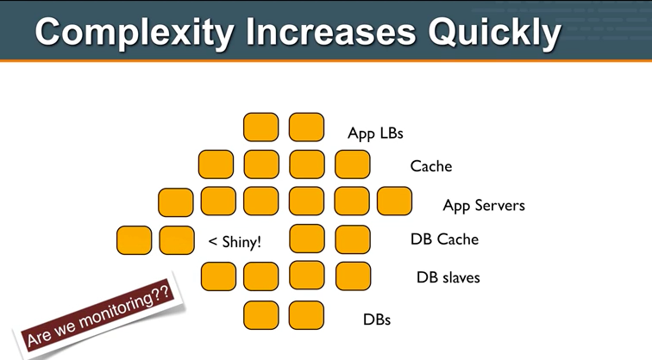

============

So chef solves this problem for you.

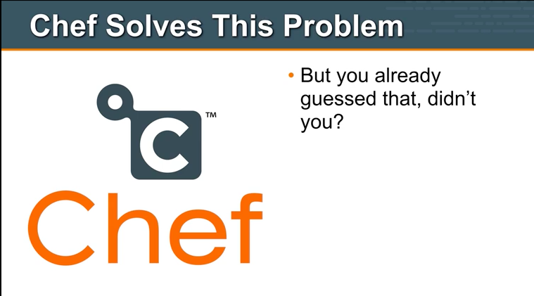

========

**So how can we manage complexity with chef ??**

Chef gives us a no of items/tools with which we can manage this complexity, we are going to look at this

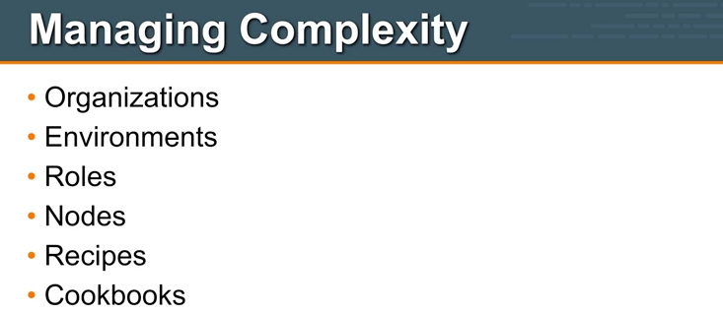

We are going to look at organizations, and how organizations can help you manage complexity.

So let’s start with top level, let’s see Organizations:

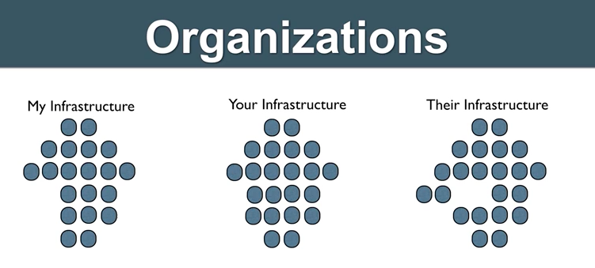

If you think about organizations, let’s take digital lync itself it has its own infrastructure and TCS has its own infrastructure etc etc

=====

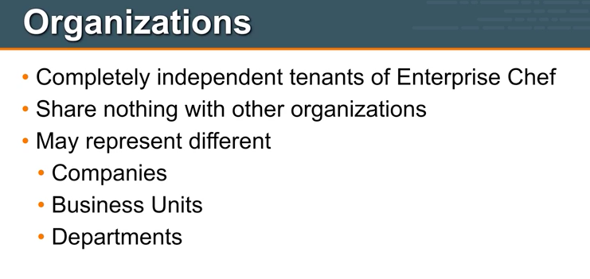

Organizations are independent tenants on enterprise chef.

Nothing is shared across the organizations, your organizations may represent different companies take Tata group as example.

=======

The next layer down is environments.

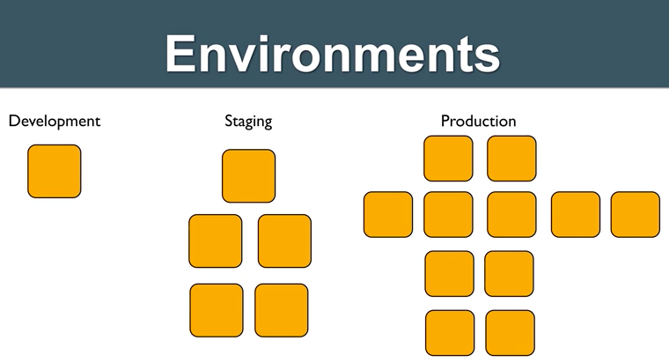

========

Next comes Roles

Roles is a way of identifying or classifying different types of servers that you have within your infrastructure.

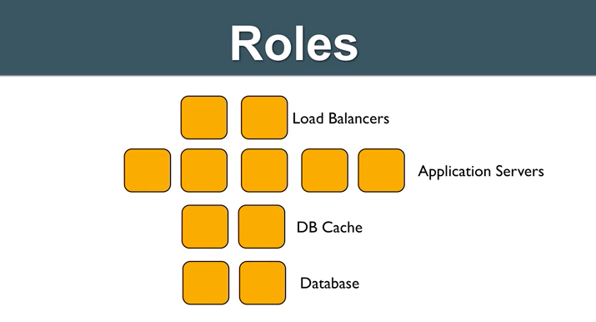

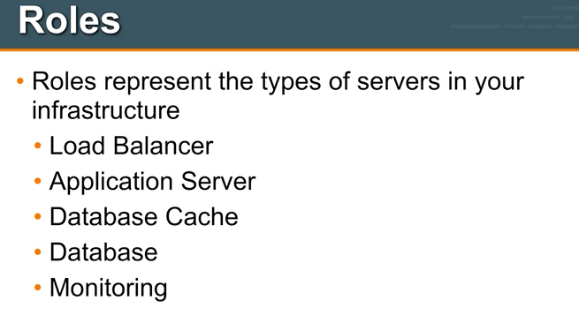

Within your infrastructure you have multiple instances of servers that are in each one of these roles, you may have multiple application servers, multiple database servers etc

You will specify this as roles in chef.

===========

Roles allow you to define policy, they may include list of chef configuration files that should be applied to the servers or nodes that are within that role.

We call this list of chef configuration files that should be applied we call this a Run list.

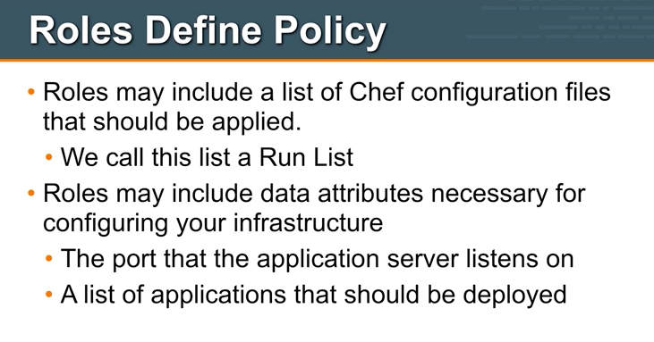

================

Stepping down from roles then we look at nodes

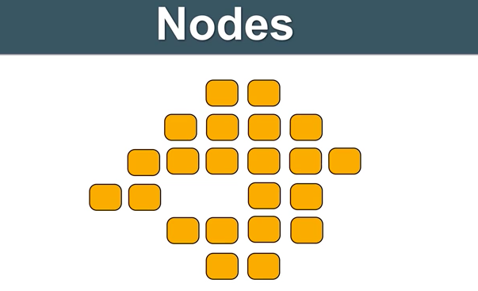

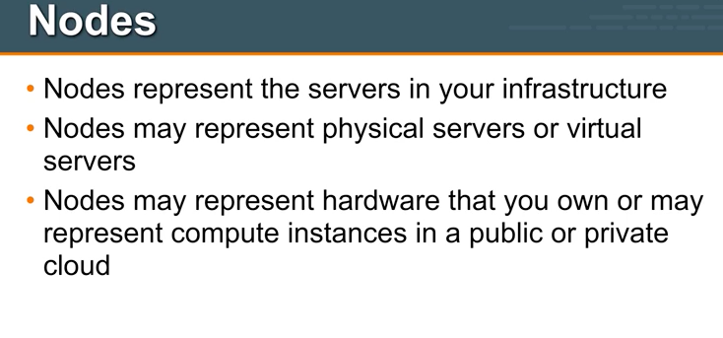

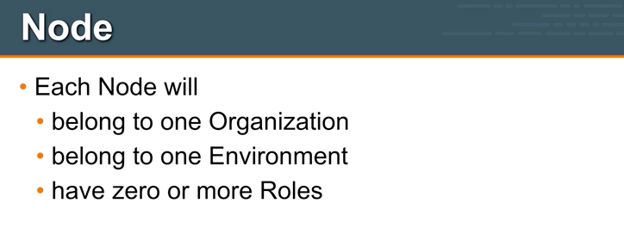

Belong to Environment : Server can be either in dev or testing or staging or production

Roles : Each node may have zero or more roles, so a node maybe a database server or an application server or it can have both roles the same node can have both database and the application servers.

===========

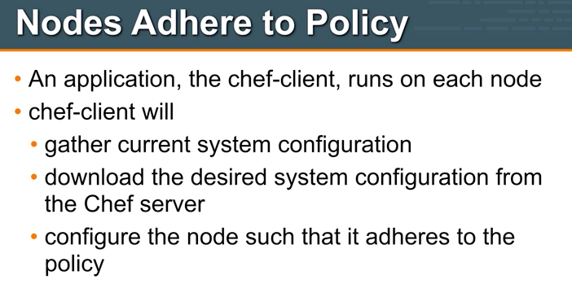

Chef client will do all of the heavy lifting, it will make updates, it will configure the node, such that it adheres to the policy that is specified on the chef server.

========

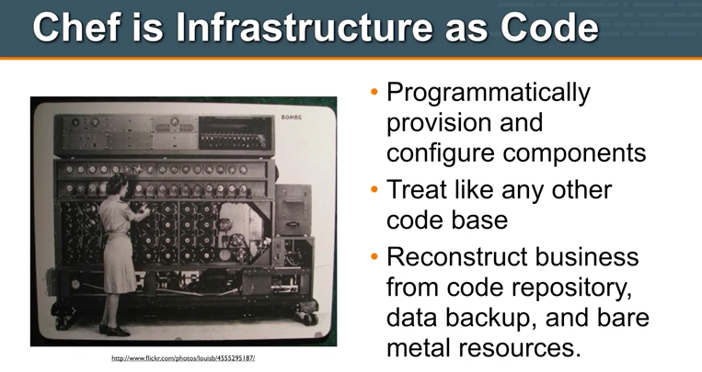

By capturing your infrastructure as code, you can reconstruct all of your business applications from three things a code repository, a backup of your data and the bare metal resources or compute resources that are required to run your applications.

This puts you in a really really nice state and it’s a great way to manage your complexity of your infrastructure, with these three simple things i can rebuild my applications.

================

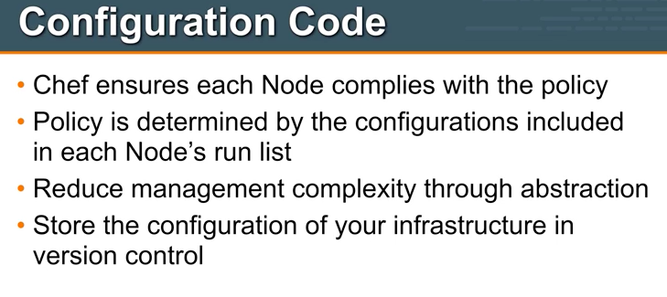

Store the configuration of infrastructure in version control:

So gone are the days when you have a server that was hand crafted lovingly by a system administrator and that system administrator is the only person in your organization that knows all of the knobs, dials, tweaks, tricks, packages etc that have been placed onto that server, now we can take the knowledge of that system administrator has and move it into a framework that can be stored in a Source code repository.

Framework that allows for abstraction so that you can build up bits and pieces and transform the way you manage your infrastructure.

============

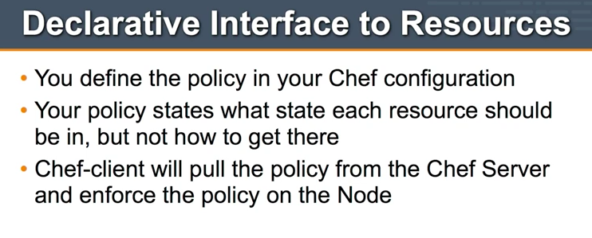

With chef you can define policies that your infrastructure should follow,

Your policy states what each resource should be in, but not how to get there

For example we will in our chef configuration file, we will say that a package should be installed but we will not need to specify how to install that particular package, chef is smart enough to sort that out.

So for example if you want to install a package on a debian based system you may use apt package manager to install that package, # apt-get install <pkg-name> and

If you are running on a redhat based distribution such as centos then apt will not work here we would rather use yum package manager # yum install <pkg-name>

Chef abstracts all of that away from you so that you can write configuration files that will work across the various platforms.

========

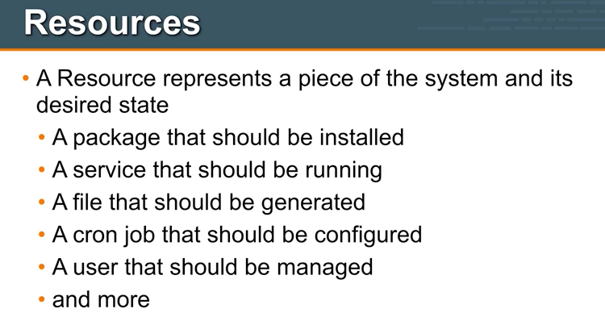

========

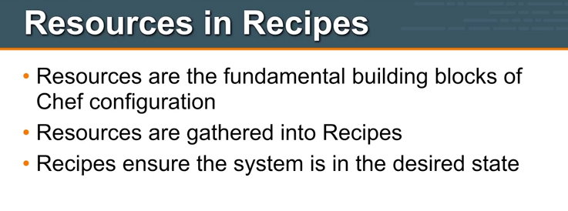

You will take resources and gather them together into recipes.

=========

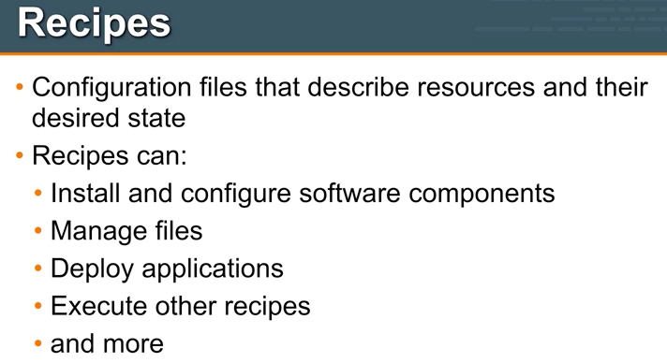

Recipes are the real work forces within chef.

So resources are the building blocks and will take those building blocks and we would gather them together into recipes that would help bring our systems in line with policy.

Let’s see some example recipe code

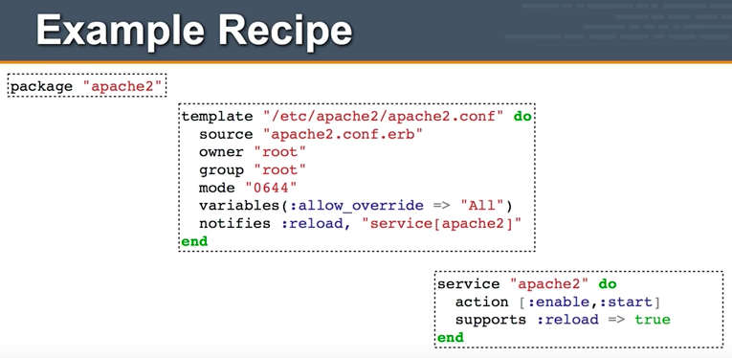

I will walk through you what happens when the chef client encounters this recipe code

So **Chef-client** is an application that runs on the **nodes** within your infrastructure.

It will gather it’s policy, where its run list from the chef server and it will inspect current system configuration and it will then execute through this recipes or walk through these recipes and ensure the node is in desired state or the node complies with policy.

The first resource this recipe includes is a package resource and this package is named apache2, when the chef client sees this, it knows that the package named apache2 should be installed on this particular server/node, if it is not installed the chef-client will go ahead and installs that for you.

Again we are not telling the chef-client, how to install apache2, it’s smart enough to figure that out on its own.

So our policy states that the package apache2 should be installed, if this is the case already, then the chef-client will  move on to the next resource in our recipe.

If that package is not yet installed, chef-client will take care to install it and then move  on to next resource in our recipe.

With chef we are going to take this recipes and package them up into **cookbooks**.

=========

So a **cookbook** is a container that we will use to describe, configuration data and configuration policies about our infrastructure.

A cookbook may certainly contain recipes, but it can also include templates, files etc

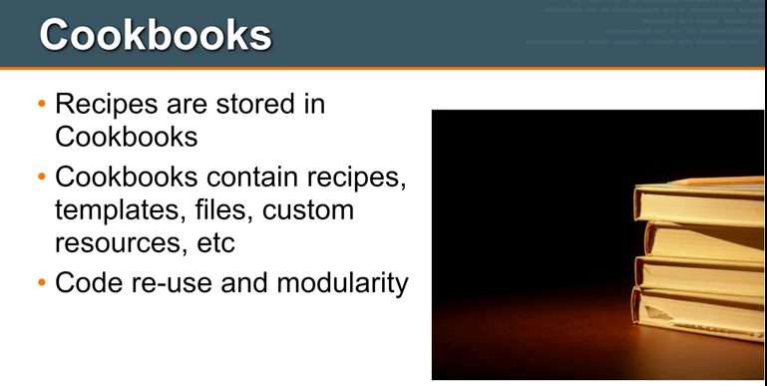

So the recipe we just looked at had **template resource** in it, the template resource itself had a source file apache2.conf.erb, that source file is stored as part of the same apache2 cookbook.

This cookbooks allow code reuse and modularity.

========

Let’s look what happens at very very high level, when the chef-client runs on the node.

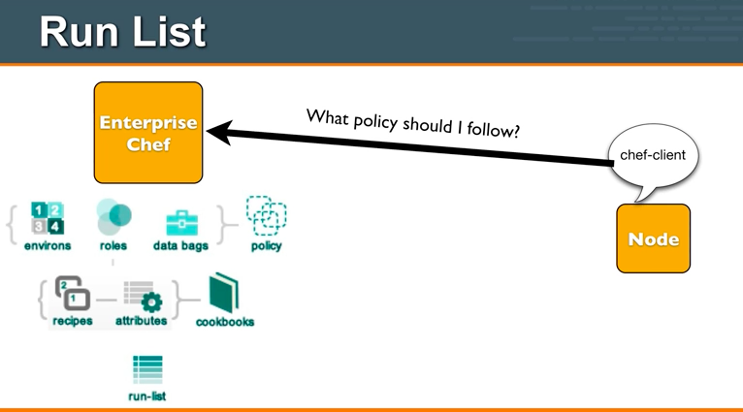

So node is a server in our infrastructure, on the node we have an application called chef-client, this is typically configured to execute on a regular interval maybe every 15-30 min using cron job.

When chef-client executes it will ask the enterprise-chef(chef-server), what policy should i follow, all of our policy is described on the chef-server, our policy includes things like our environments, our roles and our cookbooks.

So the joining of a node, to a set of policies, we call that as a **run-list.**

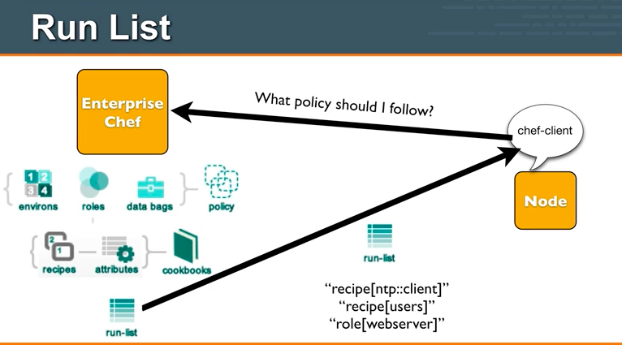

So the chef-client will download all of the necessary components, that make up the runlist and will move those down to the node, so you’ll see here the run-list includes the recipe ntp-client, recipe to manage users, and the role to make this node a web server.

==========

Once the run-list has been downloaded to the node,the chef-clients job is to look at each of the recipes within that run-list and ensure that policy is enforced on that particular node, so it brings the node inline with policy.

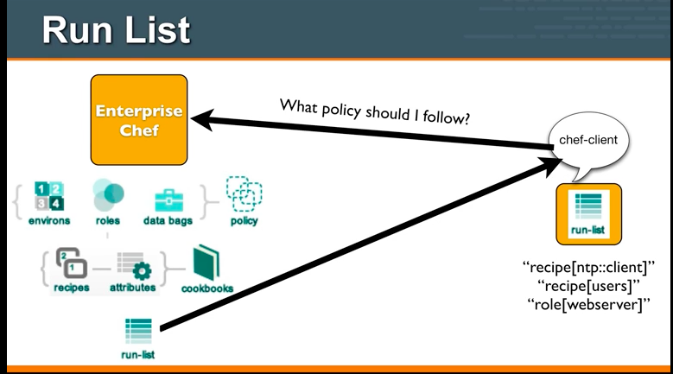

=========

So run-list is, how we specify policy for each node within our infrastructure.

The run-list is a collection of policies that node should follow.

Chef-client will obtain this run-list from the chef server.

Then chef-client ensures the node complies with the policy in the run-list.

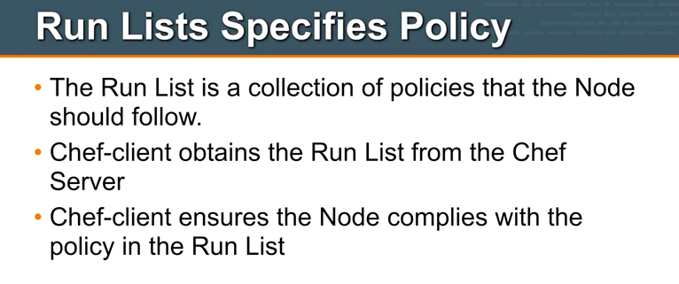

=====

So with Chef this is how you manage complexity:

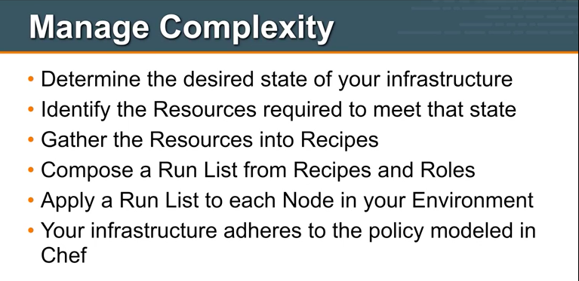

The first thing you will do, is to determine the desired state of your infrastructure.

One we done that, you will identify the resources required to meet that state, what resources are required to meet that state, what resources are required users, services, packages etc.

You gather up each of these resources into recipe.

Again the run-list is the thing that gets applied to the node, you apply a run-list to each node within your environment and as the chef client runs on those nodes, your infrastructure will adhere to the policy modeled in the chef.

This is a great way to launch new servers to add the capacity to your infrastructure, this is how you add new capacity to an existing infrastructure.

Adding new capacity to an existing infrastructure is not, the only challenge that we face, the other challenge we face is **Configuration Drift.**

=======

Configuration drift happens when your infrastructure requirements change.

No infrastructure has static list of requirements, the requirements are certainly going to change over time.

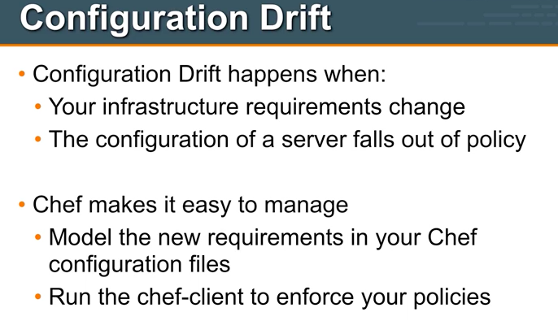

Additionally a server within your infrastructure may fall out of line with policy, perhaps a system administrator logged into a server and changed the port number that an application was listening to, maybe that shouldn’t have happened it's outside the policy, how do we address that, well chef makes it very easy to manage this, we are going to model the new requirements that we have in chef configuration files and then re-run the chef-client, so when chef-client runs it will enforce that each node within your infrastructure is following the current and accurate policy as stored on chef server, so overtime you can manage change across the infrastructure and you can enforce this policies across the infrastructure.

**CHEF SETUP**

In open source we can manage up to 25 nodes freely.

* On **workstation** side we use chef development kit (**chefdk**)
* **Chef-server** we need **chef-server-core** and **chef-manage**
* On **nodes** we use **chef-client**

**So we totally need three systems to workout.**

**Workstation Chef-Server   Node**

MACH1     MACH2 MACH3

Chef is a powerful automation platform that transforms infrastructure into code. Whether you’re operating in the cloud, on-premises, or in a hybrid environment, Chef automates how infrastructure is configured, deployed, and managed across your network, no matter its size.

This diagram shows how you develop, test, and deploy your Chef code.

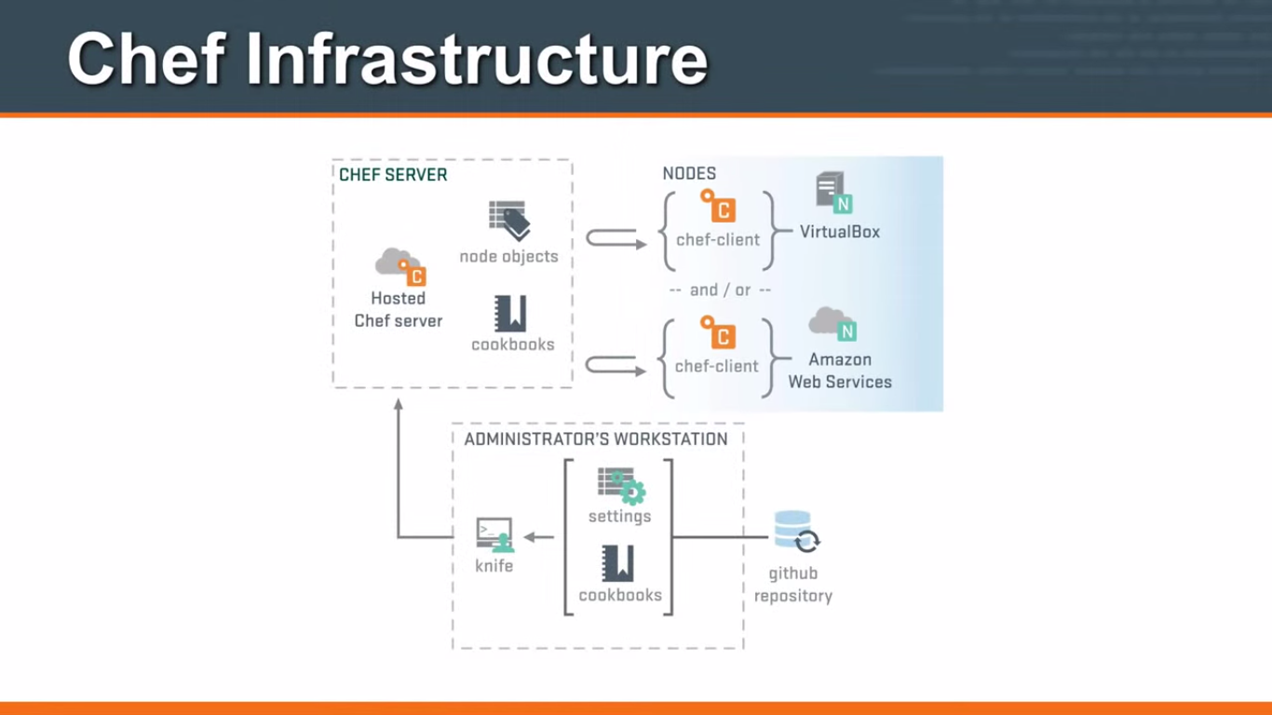

* The **Chef DK** workstation is the location where users interact with Chef. On the workstation users author and test cookbooks and interact with the Chef server using the knife and chef command line tools.

* **Chef client** nodes are the machines that are managed by Chef. The Chef client is installed on each node and is used to configure the node to its desired state.

* The **Chef server** acts as a hub for configuration data. The Chef server stores cookbooks, the policies that are applied to nodes, and metadata that describes each registered node that is being managed by Chef. Nodes use the Chef client to ask the Chef server for configuration details, such as recipes, templates, and file distributions.

**Chef-Server Setup**

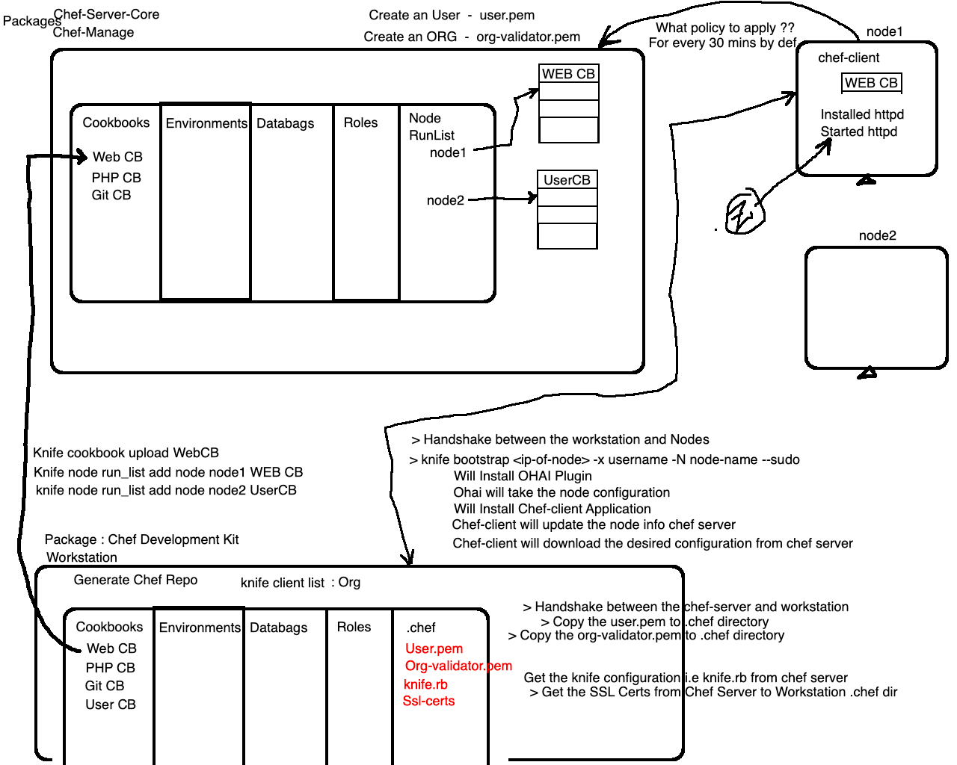

Let’s get the Chef-server from<https://downloads.chef.io/chef-server>

# wget <link-of-rhel-7-distro-rpm>

# sudo rpm -ivh chef-server.rpm

Once we installed it, we need to configure it by using command:

**# sudo chef-server-ctl reconfigure**

Above command will set up all of the required components, RabbitMQ, PostgreSQL DB, SSL Certificates etc.

Once it is done successfully, it means server has been set successfully.

status of chef server we can use:

**# sudo chef-server-ctl status**

which is going to give all the services which are running in the background.

Now let’s access the chef-server by ip add[**https://ip_address_machine**](https://ip_address_machine)

Now **let’s setup the web interface** to **manage chef-server**, to **get the GUI** we need to install another package which is **chef-manage**.

# sudo chef-server-ctl install chef-manage

**This installation of chef-manage will glue the chef-manage to chef-core** means it will integrate chef-manage with your chef-core.

# sudo chef-manage-ctl reconfigure

Next accept the license agreement and go on with further steps **say q for quit and yes**.

Once the installation is successful use the ip of machine to see the web interface:

[**https://ip_address_machine**](https://ip_address_machine)

**Creating User**

We need to create an admin user. This user will have access to make changes to the infrastructure components in the organization we will be creating.

Below command will **generate the RSA private key** automatically and should be saved to a safe location.

**# sudo chef-server-ctl user-create --help**

**# chef-server-ctl user-create <USER_NAME> <FIRST_NAME> <LAST_NAME> <EMAIL> 'PASSWORD' -f PATH_FILE_NAME**

**# sudo chef-server-ctl user-create admin ravi krishna admin@digital.com password -f /etc/chef/admin.pem**

pem file is your private key which will authenticate you while logging into the server and the corresponding public key will be stored in the server. We should not share this pem file coz now anyone with this pem file can login into the server.

Now you have created the user successfully.

**Creating Organization**

It is the time for us to create an organization to hold the chef configurations.

**# sudo chef-server-ctl org-create --help**

**# chef-server-ctl org-create short_name 'full_organization_name' --association_user user_name --filename ORGANIZATION-validator.pem**

**# sudo chef-server-ctl org-create dl "Digital-lync-academy" --association_user admin -f /etc/chef/dl-validator.pem**

That’s it this is how we will be creating organization name.

Let’s access the web interface now.

[**https://ip_address_machine**](https://ip_address_machine)

Once we logged in we can see **Nodes**, but we didn’t setup any node so will see this in later part.

We can see the **organization**, on the top right corner.

**Setting Up Workstation**

Setting up workstation is very important coz even if you don’t know how to set up chef-server it’s okay coz in real time chef-server is already set-up but work station we need to set up yourself.

* Create a new centos machine for workstation
* Login to the workstation machine
* Download chef-dk on workstation (laptop/desktop/vm)
  + Install the chef-dk through rpm
  + https://downloads.chef.io/chefdk
  + # **wget <link-of-chef-dk>**
  + **# sudo rpm -ivh chefdk-1.3.43-1.el7.x86_64.rpm**
* **# cd ~** { workstation }
* Generate Chef-Repo using “**chef generate repo**” command.
  + **# chef generate repo chef-repo**
  + This command places the basic chef repo structure into a directory called “**chef-repo**” in your home directory.
* In chef server we created two pem files one is user and another is organization, now we need to **bring this two pem files into the workstation**

* Now we need to create a directory **.chef** in chef-repo where we put RSA keys,
  + # **cd** ~/**chef-repo**
  + **# mkdir .chef**
  + **cd .chef**
* Copy the RSA keys to the workstation **~/chef-repo/.chef**
  + **Make the handshake b/w chef-server & workstation**
  + **# scp /etc/chef/*.pem user@workstation:~/chef-repo/.chef/**
    - **Run the above in chef-server**

* Knife is a command line interface for between a local chef-repo and the Chef server. To make the knife to work with your chef environment, we need to configure it by **creating knife.rb** in the “**~/chef-repo/.chef/**” directory.
  + Goto Web interface of chef-server → Click **Administration →** Select **Organization (dl) →** Click on **settings** wheel(extreme right) → Click on the **Generate Knife Config**
  + Copy the file contents and paste it in **~/chef-repo/.chef/knife.rb**

* **Testing knife:** test the configuration by running **knife client** list command. Make sure you are in **~/chef-repo/** directory.
  + **# cd ~/chef-repo/**
  + **# knife client list**
  + **# knife ssl check**
  + To resolve this issue, we need to fetch the Chef server’s SSL certificate on our workstation
  + **# knife ssl fetch**
    - The above command will add the Chef server’s certificate file to trusted certificate directory.
* Once the SSL certificate has been fetched, run the previous command to test the knife configuration.

**# knife client list {** output then verification completed successfully **}**

**Setting Up Node / Bootstrapping new node**

Bootstrapping a node is a process of installing chef-client on a target machine so that it can run as a chef-client node and communicate with the chef server.

From the workstation, you can bootstrap the node with elevated user privileges.

# setup new machine

**#** Make **handshake between workstation to node1** using sudo privileges

Now if you login into Chef-server, you cannot see any node as we didn’t bootstrap any node as of now.

To bootstrap the node we need to use a utility called **knife.**

**knife** is a command-line tool that provides an interface between a local chef-repo and the Chef server. knife helps users to manage:

* Nodes
* Cookbooks and recipes
* Roles, Environments, and Data Bags
* Resources within various cloud environments
* The installation of the chef-client onto nodes
* Searching of indexed data on the Chef server

Knife is configured using a **knife.rb** configuration, which contains configuration.

A knife.rb file:

* Is loaded every time this executable is run
* Is not created by default

To acquire knife.rb file, go to chef management console and select the organization then options and click **generate knife configuration**, this will download the knife.rb to local machine, now copy this content to .chef directory with name knife.rb.

Use the knife bootstrap subcommand to run a bootstrap operation that installs the chef-client on the target system. The bootstrap operation must specify the IP address or FQDN of the target system.

To bootstrap node we need following details of the node:

* Node IP
* Node hostname
* User with sudo access

# knife bootstrap 192.168.33.92 -N node1 -x ravi --sudo

The above bootstrap command runs the following:

* It runs **ohai** process and collects the node info
* Uploads the node info to chef server
* Registers the node with chef server
* Runs any cookbooks if defined

**Cookbook**

A cookbook is the fundamental unit of configuration and policy distribution. A cookbook defines a scenario and contains everything that is required to support that scenario:

* Recipes that specify the resources to use and how they are to be applied
* Attribute values
* File distributions
* Templates
* Extensions to Chef

Everything will do it on workstation.

* Create cookbook on workstation
* Then will upload this cookbook on server
* Then will associate the cookbook with node
* Then will execute that cookbook on that particular node

To generate cookbook use the following command

* chef generate cookbook file-test **[ makes sure to run this command under cookbooks dir ]**
* The no.1 directory you need to check is **recipes** under the cookbook which we have **default.rb** where you will **write your code**, **write your work**

**1 default.rb**

**=========**

So what will you write in recipe?? What is recipe ??

Recipe is collection of resources with desired state.

So your resource can be a file, directory, package etc.

**2 metadata.rb**

**===========**

Metadata.rb has the information about version no of cookbook, dependencies, organization info and so on all the information related with cookbook will be here.

If this cookbook is dependent on other bookbook then this info is also stored here.

# sudo vim cookbooks/file-test/metadata.rb (change Maintainer etc)

Let’s start creating our resources :

# vim cookbooks/file-test/recipes/default.rb

So here we will be defining resources in ruby language, now it’s not necessary that you should be master in ruby lang to understand this, coz structure is very easy to understand.

**default.rb**

**========**

**file '/tmp/sample.txt' do**

**content 'This file is created with CHEF'**

**owner 'root'**

**group 'root'**

**mode '644'**

**#action :create**

**end**

**Every resource has got a default action, the action here for file is to create.**

# knife cookbook test file-test

Now we created the cookbook but we need to upload this cookbook to server.

# knife cookbook list

{when i execute this command, it fetches list of cookbooks from server}

Now if we check the same in web interface [Policy are cookbooks], i don’t have file-test cookbook, so will upload the cookbook.

# knife cookbook upload file-test

Uploaded successfully, let’s confirm it.

# knife cookbook list

Now let’s check the same in web interface

Now we need to associate this cookbook with a node.

First let’s see what nodes are available

# knife node list

More info about node

# knife node show <node-name>

# knife node show node1

Our focus will be on run list:

# knife node show node1

There is nothing in **Run List**

Goto web interface → Select node1 → Click on Edit run list { nothing }, let’s add one

**Adding node to run list**

# knife node run_list add <node-name> <cookbook-name>

**# knife node run_list add node1 file-test**

Again i’ll go with show, previously we had empty run list

**# knife node show node1  { we can see file-test in run-list }**

**Now let’s move to node machine**

Run the command **# sudo chef-client**

This command makes node to talk to server and asks server, do you have any runlist for me ?? Then it will run all the cookbooks mentioned in run_list, then it starts executing them.

# sudo chef-client

1. Runs the ohai process
2. It will upload the latest host info to server
3. It will get the list of runlist and its dependencies
4. Downloads the cookbooks as mentioned in run_list
5. Execute the run_list

**RESULT** : **you will get resource with desired state**

If we run the command for the second time # sudo chef-client

Nothing is updated, because the resource is already in its desired state.

Let’s do one thing, forcefully damage the system (someone made changes to sample file content)

# vi /tmp/sample {made changes which corrupted the system}

Now let’s run the **# sudo chef-client** again

Now you can see that the file was not in desired state, bring it back to desired state.

Now if you open and see the file content # vim /tmp/sample.txt it’s back to original all the old tampered data is gone away.

**That’s the desired state, if you define the desired state, it will make sure that it has the desired state.**

Let’s tamper the permissions **# chmod 777 sample.txt**

Now if i run **# sudo chef-client** then the file permissions will be back to normal desired state.

**Now that’s what chef is trying to do, whatever you define, it will try to control and make sure it stays that way, but if it’s already there in desired state then it will not make any changes and this is called IDEMPOTENCY.**

**That means if the state is already achieved then it will not disturb the state.**

**Now imagine that you have 10000 systems, so you don’t have to worry about any of the system. You will write the recipe and will execute them that’s it.**

Now let’s say you want to edit some content in sample.txt then you will be doing that on recipe, then it will automatically reflect on your node machines.

**Web cookbook**

**will install web server that is httpd**, and will make sure that httpd package is up and running then will create one index.html and will see everything is working fine as expected. Let’s do it one by one.

So we will create cookbook in **workstation (under cookbooks directory)**

**# chef generate cookbook webtest**

**# vi webtest/metadata.rb** (change maintainer and maintainer email)

Now lets update the recipes

**# vi webtest/recipes/default.rb**

On the command line we generally do

# yum -y install httpd

# systemctl start httpd

# systemctl enable httpd

# echo “WELCOME” > /var/www/html/index.html

Now we need to install the package, here in chef we have a **resource** with name package:

# package ‘httpd’ do

action :install {by default}

# end

By default the action is install, but we want more information like what we can do more with package, so chef has excellent documentation, lets go and check the document and see what more we can do with the package.

# docs.chef.io/resource_package.html

We can install the **package** like this,

**package ‘httpd’ do**

**action :install**

**end**

Or simply you can say

**package ‘httpd’**

coz the default action is install

Now if you want to remove the package you can figure it out from document (actions)

**package ‘httpd’ do**

**action :remove**

**end**

Now i need to start the **service**, so i will use the second resource module,

Now let’s go to document section again and see resource_service

<https://docs.chef.io/resources.html> { **select service**}

service ‘httpd’ do

action  [:start, :enable] now i can specify two actions also

end

**Or**

**service ‘httpd’ do**

**action  :start**

**end**

**service ‘httpd’ do**

**action  :enable**

**end**

Now the third thing is we need to go with **index.html,** so i’ll use the same resource **file**

**file ‘/var/www/html/index.html’ do**

**content “<h1>Welcome to APACHE - By CHEF</h1>”**

**owner ‘root’**

**group ‘root’**

**mode ‘644’**

**end**

Now need to save the changes then test it and upload it.

**# knife cookbook test webtest** { good no syntax error }

Or

# **cookstyle webtest**

# **knife cookbook upload webtest** { we can check this in web interface }

# knife node show node-name {show what’s already attached to this node}

**# knife node show node1**

# knife node run_list add <node-name> <cookbook-name>

**# knife node run_list add node1 webtest**

Now if i say show node then i should see two recipes

**# knife node show node1**

Let’s go and confirm it on server side as well

# go to **Nodes** section → Select Node → Click Settings (gear) → Edit run list

We can see two run_lists

Now we have done the association, now our task is to execute the chef-client on the node, that will install httpd service and starts the service and it will set index page.

**Login back to node machine**

**# sudo chef-client**

Now i’m always running the chef-client manually, i want to do it automatically, for that to happen we need to setup a cron job.

**Chef Attributes**

An attribute is a specific detail about a node. Attributes are used by the chef-client to understand:

* The current state of the node
* What the state of the node was at the end of the previous chef-client run
* What the state of the node should be at the end of the current chef-client run

Attributes are defined by:

* The state of the node itself
* Cookbooks
* Roles
* Environments

During every chef-client run, the chef-client builds the attribute list using:

* Data about the node collected by Ohai
* The node object that was saved to the Chef server at the end of the previous chef-client run
* The rebuilt node object from the current chef-client run, after it is updated for changes to cookbooks (attribute files and/or recipes), roles, and/or environments, and updated for any changes to the state of the node itself

Chef gets the attributes by **ohai,**

**# ohai | wc -l** { almost gets 4000 parameters }

An automatic attribute is a specific detail about a node, such as an IP address, a host name, a list of loaded kernel modules, and so on. Automatic attributes are detected by Ohai and are then used by the chef-client to ensure that they are handled properly during every chef-client run. The most commonly accessed automatic attributes are:

|  |  |
| --- | --- |
| Attribute | Description |
| node['platform'] | The platform on which a node is running. This attribute helps determine which providers will be used. |
| node['platform_version'] | The version of the platform. This attribute helps determine which providers will be used. |
| node['ipaddress'] | The IP address for a node. If the node has a default route, this is the IPV4 address for the interface. If the node does not have a default route, the value for this attribute should be nil. The IP address for default route is the recommended default value. |
| node['macaddress'] | The MAC address for a node, determined by the same interface that detects the node['ipaddress']. |
| node['fqdn'] | The fully qualified domain name for a node. This is used as the name of a node unless otherwise set. |
| node['hostname'] | The host name for the node. |
| node['domain'] | The domain for the node. |

How to access these attributes inside the recipe ??

node[‘platform’]

Node[‘hostname’]

Let’s write something that works across different platforms.

Now we know that in centos the package name, service name is different from ubuntu.

Now i’ll create some variables(**attributes**), that chef will be able to use, and i’ll call this variable's/attributes with **package_name**, **service_name**

Create attributes directory under web-test where we put default.rb  
 **# mkdir cookbooks/webtest/attributes**

# **vi cookbooks/webtest/attributes/default.rb**

# Creating attributes for multi os

case node[‘platform’]

when “centos”,”rhel”

default[“package_name”]=”httpd”

default[“service_name”]=”httpd”

when “ubuntu”,”debain”

default[“package_name”]=”apache2”

default[“service_name”]=”apache2”

end

Now change the **default.rb in recipes** to,

package node[“package_name”] do

action :install

end

service node[“service_name”] do

action  :start

end

service node[“service_name”] do

action  :enable

end

**Roles**

**Roles help you configure multiple cookbooks to node at once.**

**Normally we are going and running one cookbook at a time which would be cumbersome task to avoid this and add multiple cookbooks at once we use roles.**

So far we have been just adding recipes directly to a single node.

In practise, Roles make it **easy to configure many nodes identically** without repeating yourself each time.

Let’s create our first role,

The node we are working on so far is a **web server,** so let’s go and create a web server role, login into the **workstation machine**

**#** chef generate cookbook cb1

**#** chef generate cookbook cb2

**#** chef generate cookbook cb3

# vim cb1/recipes/default.rb

file ‘/opt/cb1.txt’ do

content ‘This is cookbook 1’

end

file ‘/opt/cb2.txt’ do

content ‘This is cookbook 2’

end

file ‘/opt/cb3.txt’ do

content ‘This is cookbook 3’

end

# knife cookbook upload cb1

# knife cookbook upload cb2

# knife cookbook upload cb3

# cd chef-repo/roles

# vi web.rb

name ‘web’ { each role will have a name }

description ‘Web Servers’ { each role will have a description }

run_list ‘recipe[cb1]’, ‘recipe[cb2]’ { each role may have a run list }

# knife role from file web.rb

# knife role list

# knife role show web

# knife node run_list add NODE_NAME 'role[web]'

Go to chef server and check roles, now we got new role.

And click on node, say edit run list, and you can see **available roles.**

# sudo chef-client

**Environments**Using environments combined with roles we can execute cookbook on multiple nodes. I can add multiple nodes to environment and can execute cookbooks on those multiple nodes.

Let’s see how they can be used.

# knife environment list

The **_default** environment is read-only and sets no policy at all, you can’t modify any configuration under this environment.

Similar to roles

# vim environments/dev.rb

name ‘dev’  
description ‘My Dev Env’

# knife environment from file dev.rb  
# knife environment list

By default the nodes are part of _default environment, now will put our server in dev env

# knife node environment_set node1 dev

# knife node show node1

**To group all the nodes with one command:**

# knife exec -E 'nodes.find("chef_environment:dev") {|n| puts n.run_list << "role[web-server]" unless n.run_list.include?("role[web-server]"); n.save }'

# sudo chef-client

**Databag**

A data bag is a global variable that is stored as JSON data and is accessible from a Chef server. A data bag is indexed for searching and can be loaded by a recipe.

A data bag item may be encrypted using shared secret encryption. This allows each data bag item to store confidential information (such as a database password) or to be managed in a source control system (without plain-text data appearing in revision history).

The **knife data bag** subcommand is used to manage arbitrary stores of globally available JSON data.

Use the create argument to add a data bag to the Chef server.

To generate the encrypted passwords use the following perl script

# perl -e 'print crypt("password","\$6\$salt\$") . "\n"'

# cd cookbooks

# chef generate cookbook user-test

# vim user-test/recipes/default.rb

group 'redhat' do

 action :create

end

user 'redhat' do

 uid '2000'

 password '$1$hPx7gY1X$pDm6ir7zJ2jirr4rriJTZ0$1$aISz6I6w$Q1X/dWJ7F2DBWzKZdABon.$1$oviO3aG4$DdUI5iFi6kSwXwWDo5qhc.'

 group 'redhat'

action :create

end

# knife cookbook test user-test

# knife cookbook upload user-test

# knife node show node1

# knife node run_list add node1 user-test

Go back to node1 and check whether user redhat is created or not.

**In node1 machine**

# id redhat

# sudo chef-client

# id redhat

Now we have copied and pasted password in recipe, but never do it, coz recipes are easily accessible.

They are also cached in /var/chef/cache/cookbooks/user-test/recipes/default.rb

The other way you have to assign the passwords is through **Databags**.

We store passwords in databags and databags are safely kept on chef server.

Let’s see how to work with databags:

**Creating databag and upload it via file**

# knife data bag list

# knife data bag create redhat_password

# vi chef-repo/data_bags/redhat.json

{

  “Id” : “redhat”,

  “password” : “$1$hPx7gY1X$pDm6ir7zJ2jirr4rriJTZ0$1$aISz6I6w$Q1X/dWJ7F2DBWzKZdABon.$1$oviO3aG4$DdUI5iFi6kSwXwWDo5qhc.”

}

# knife data bag from file redhat_password redhat.json

# knife data bag list

# knife data bag show redhat_password

# knife data bag show redhat_password redhat

# vi cookbooks/user-test/recipes/default.rb

          redhat_password = data_bag_item(‘redhat_password’,’redhat’)

group 'redhat' do

 action :create

end

user 'redhat' do

 uid '2000'

 password redhat_password[‘password’]

 group 'redhat'

 action :create

end

In node machine:

# sudo cat /var/chef/cache/cookbooks/user-test/recipes/default.rb

Complete Project Setup

**Project Architecture**

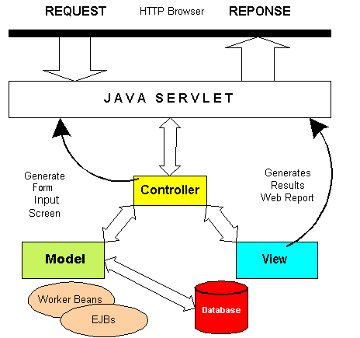

* **Model - Model represents an object or JAVA POJO carrying data.**
* **View - View represents the visualization of the data that model contains.**
* **Controller - Controller acts on both model and view. It controls the data flow into model object and updates the view whenever data changes.**

**Git**

**===**

# sudo yum -y install git

# git --version

**Java**

**====**

# sudo yum -y install java-1.8.0

# sudo yum -y install java-1.8.0-devel

# java -version

**Maven**

**======**

# sudo yum -y install maven

# mvn --version

**Nexus**

**======**

# wget <nexus-2-link.tar>

**#** wget [**http://www.sonatype.org/downloads/nexus-latest-bundle.tar.gz**](http://www.sonatype.org/downloads/nexus-latest-bundle.tar.gz)

# cd nexus/nexus-2.x/bin

# ./nexus start

**{** if any problem change ownership to devops to both dirs of nexus**}**

# netstat -ntpl | grep 8081

{ be patient it takes some time to start }

#<http://ip-addr:8081/nexus>

{ allow port 8081 through firewall }

**# login and give default creds admin & admin123**

**ERROR**: **Change the permissions of two nexus directories with logged in username**

**Sonarqube [Requires java 1.8+]**

**=========**

**Install MySql 5.6+**

# wget http://repo.mysql.com/mysql-community-release-el7-5.noarch.rpm

# sudo rpm -ivh mysql-community-release-el7-5.noarch.rpm

# sudo yum -y install mysql-server

# sudo systemctl start mysqld

# sudo mysql_secure_installation  
# sudo mysql -u root -p

# CREATE DATABASE sonar;

# CREATE USER 'sonar' IDENTIFIED BY 'sonar';

# GRANT ALL ON sonar.* TO 'sonar'@'localhost' IDENTIFIED BY 'sonar';

# FLUSH PRIVILEGES;

# Download Sonarqube

# Change the config in conf/sonar.properties & Start the server

# sonar.jdbc.username=sonar

# sonar.jdbc.password=sonar

# uncomment sonar.jdbc.url of MySQL 5.6

# uncomment sonar.web.host=0.0.0.0

# uncomment sonar.web.port=9000

# [http://serverAddress:9000](http://serveraddress:9000)

# username and password is admin & admin

**Jenkins**

**=======**

# sudo wget -O /etc/yum.repos.d/jenkins.repo<https://pkg.jenkins.io/redhat-stable/jenkins.repo>

# sudo rpm --import<https://pkg.jenkins.io/redhat-stable/jenkins.io.key>

# sudo yum -y install jenkins

# sudo systemctl start jenkins

# sudo systemctl enable jenkins

# sudo firewall-cmd --zone=public --add-port=8080/tcp --permanent

# sudo firewall-cmd --reload

**Tomcat**

**=======**

Grab the binary archive for tomcat 7 from maven tomcat  
# Download tomcat 7 tar and extract

**# sudo vi tomcat-users.xml { gui tomcat manager }**

Copy this in **<tomcat-users>** tags

*<role rolename="manager-gui"/>*

*<user username="tomcat" password="tomcat" roles="manager-gui"/>*

*<user username="tomcat1" password="tomcat1" roles="manager-script"/>*

**# change the port number of tomcat**

**# sudo vi server.xml { change port in** Connector **}**

Allow port through **firewall**

**# Download tar of tomcat7 and extract → cd tomcat/bin → ./startup.sh**

**Starting the Project  
================**

# Go to github.com and check the project Info  
# Copy project URL  
<https://github.com/ravi2krishna/spring-hibernate-maven-webapp.git>

**JOB - 1**

Freestyle Job [ **01 - Validate and Compile** ]

→ Discard Old builds

Max no of builds 3

→ Source code management

GitHub url

→ Build

**Invoke top-level Maven targets**

**Goals : validate compile**

**Make Sure to change the settings in pom.xml → Remove Nexus Elements**

**JOB - 2**

Freestyle Job [ **02 - Unit Testing** ]

→ Discard Old builds

Max no of builds 3

→ Source code management

GitHub url  
→ Build

**Invoke top-level Maven targets**

**Goals : test  
  
But we can’t see how many test cases ran and how many were failed/succeeded**

**→** Go to workspace → target → surefire-reports → index.html, testng-results.xml

**→ At the end Post-build Actions  
 Publish JUnit test result report**

**Locations : **/target/surefire-reports/*.xml**

→ Run the build again for 2-3 times and you can see the test graph  
→ Click on **Latest Test Result** ⇒ On left side click on **History**

**→ Refresh the Job page to view updated changes**

**JOB - 3**

Freestyle Job [ **03 - Cobertura Code Coverage** ]

→ Discard Old builds

Max no of builds 3

→ Source code management

GitHub url  
→ Build

**Invoke top-level Maven targets**

**Goals : cobertura:cobertura -Dcobertura.report.format=xml**

**→ Now if you see console output :  
 → Cobertura: Loaded information on 10 classes.  
 → Cobertura Report generation was successful.**

**→ But we can’t see any reports, so let’s go and work with plugin now  
 → Even if we see in Post-build actions nothing is found  
 → Install Cobertura plugin**

**→ At the end Post-build Actions  
 Publish Cobertura Coverage Report**

**Locations : **/target/site/cobertura/coverage.xml**

**→ Refresh the Job page to view updated changes**

**JOB - 4**

Freestyle Job [ **04 - Documentation** ]

→ Discard Old builds

Max no of builds 3

→ Source code management

GitHub url  
→ Build

**Invoke top-level Maven targets**

**Goals : javadoc:javadoc**

**→ Now if you see console output :  
 → All the documentation is being generated in target/site/apidocs**

**→ Even if we see in Post-build actions nothing is found  
 → Install Javadoc Plugin**

**→ At the end Post-build Actions**

**Publish Javadoc**

**Locations : target/site/apidocs**

**→ Refresh the Job page to view updated changes**

**JOB - 5**

Freestyle Job [ **05 - Sonar Analysis - Code Analysis** ]

→ Discard Old builds

Max no of builds 3

→ **Source code management**

GitHub url  
→ **Build Environment →** There is no sonar here

→ **Manage Jenkins → Global Tool Config**

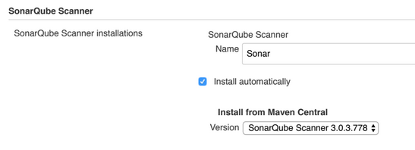

**→ Install Sonarqube Scanner for jenkins**

**→ Now go to the Manage Jenkins → Configure System → SonarQube servers**

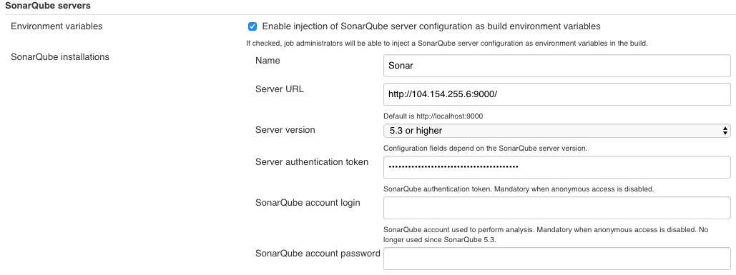

**→ Job Configure** → **Build Environment** ✅**Prepare SonarQube Scanner env**

→ **Build**

**Invoke top-level Maven targets**

**Goals : clean compile sonar:sonar**

**JOB - 6**

Freestyle Job [ **06 - Packaging and Nexus Release** ]

→ **Source code management**

GitHub url

→ **Build**

**Invoke top-level Maven targets  →  Advanced**

**Goals : clean package deploy  
 Settings File  
 Settings file in filesystem  
 File path - settings.xml**

**JOB - 7**

Freestyle Job [ **07 - Tomcat Deployment** ]

→ Discard Old builds

Max no of builds 3

→ Source code management

GitHub url

**→ Install Copy Artifact Plugin**

→ **Build** **Invoke top-level Maven targets**

**Goals : clean package**

**→ Install Deploy to container plugin**

**→ At the end Post-build Actions**

**Deploy war/ear to a container**

WAR/EAR files - **/*.war

Context path    - /SpringProject

**Containers**

Tomcat 7.x

Credentials tomcat1/****** (Tomcat) Add

Tomcat URL<http://104.197.89.223:7070>

Final Tasks

* Implement QA Environment on Docker
* Implement Master & Slave Configuration to build jobs
* Create two branches qa & prod and deploy to two different environments.
* The QA env should start the app on 7777 port using docker
* The prod env should be configured with chef, prod server should start on port 8888 using chef
* Change the source code in file with QA and PROD Env /src/main/webapp/WEB-INF/views/allemployees.jsp
* Run the prod tomcat with Nginx reverse proxy

[**Class Room Notes**](https://docs.google.com/document/d/13fTG9qhZpcrYFT5T3VLj51EjPMbC_TPipb6HSo-QPZ4/edit?usp=sharing)

[**Python for Admins**](https://drive.google.com/open?id=1p91uEXWTqK1NJhzt_1xjxXMTZ-SxxAot)